

Student Name……………………………………

FURTHER MATHEMATICS

TRIAL EXAMINATION 1

2016

Reading Time: 15 minutes
Writing time: 1 hour 30 minutes

Instructions to students
This exam consists of Section A and Section B.
Section A contains 24 multiple-choice questions from the core.
Section A is compulsory and is worth 24 marks.
Section B begins on page 14 and consists of 4 modules each containing 8 multiple-choice questions. You should choose 2 of these modules and answer every question in each of your chosen modules. Each of the modules is worth 8 marks.
Section B is worth 16 marks.
There are a total of 40 marks available for this exam.
Students may bring one bound reference into the exam.
Students may bring into the exam one approved technology (calculator or software) and, if desired, one scientific calculator. Calculator memory does not need to be cleared. For approved computer-based CAS, full functionality may be used.
Unless otherwise stated, the diagrams in this exam are not drawn to scale.
Formula sheets can be found on pages 31and 32 of this exam.
An answer sheet appears on page 33 of this exam.

This paper has been prepared independently of the Victorian Curriculum and Assessment Authority to provide additional exam preparation for students. Although references have been reproduced with permission of the Victorian Curriculum and Assessment Authority, the publication is in no way connected with or endorsed by the Victorian Curriculum and Assessment Authority.

♥ THE HEFFERNAN GROUP 2016
This Trial Exam is licensed on a non transferable basis to the purchasing school. It may be copied by the school which has purchased it. This license does not permit distribution or copying of this Trial Exam by any other party.
SECTION A - Core

Data analysis

This section is compulsory.

Use the following information to answer Questions 1 and 2.

The dot plot below shows the number of classes at 14 primary schools across a region.

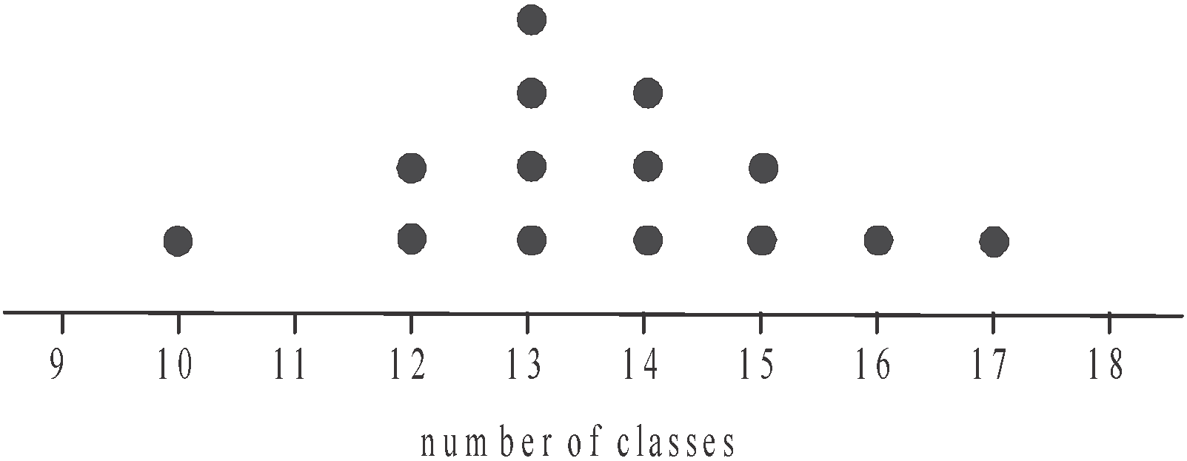

Question 1

The median number of classes is

- 13
- 13.5
- 14
- 14.5
- 15

Question 2

The mean and standard deviation respectively for this data are closest to

- 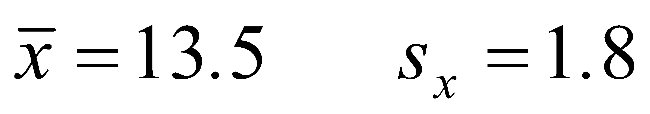
- 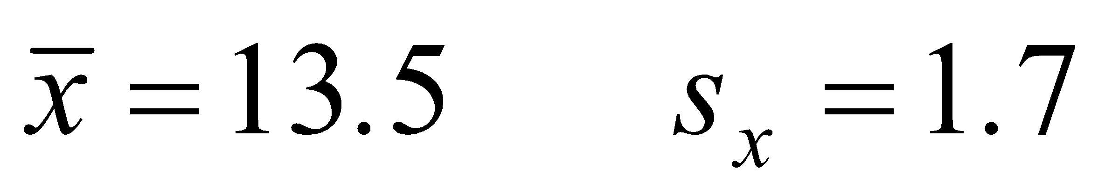
- 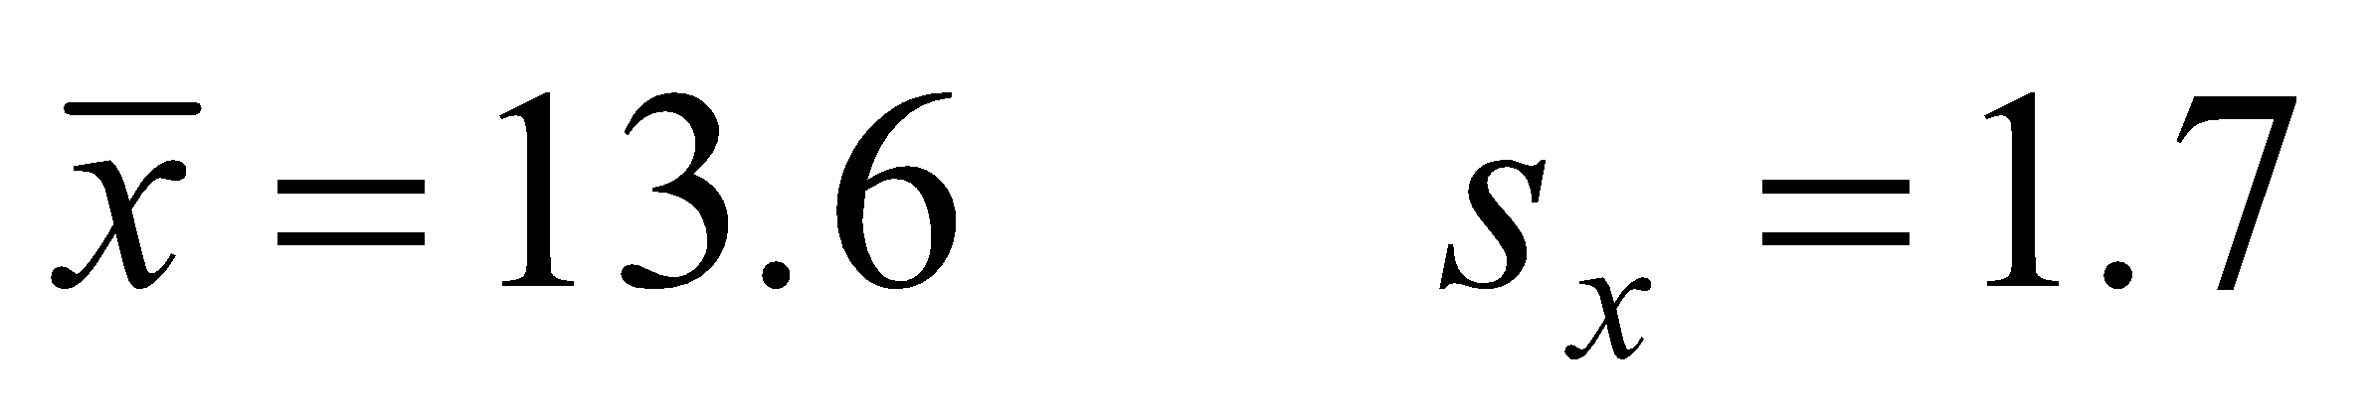
- 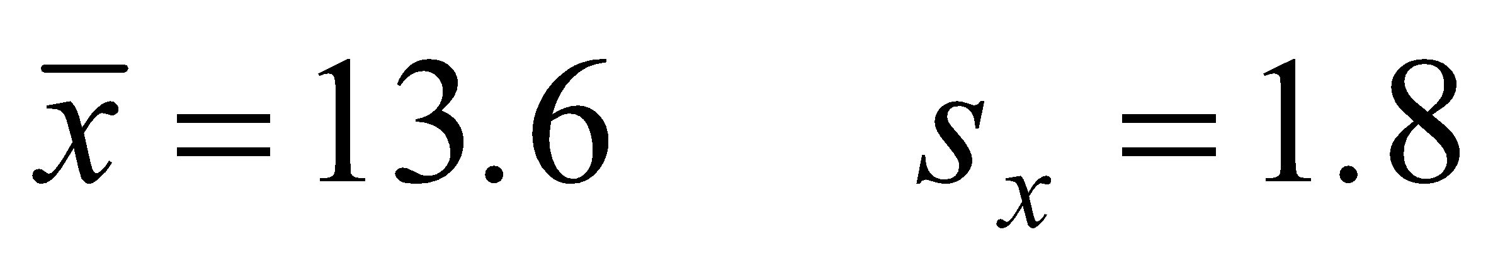
- 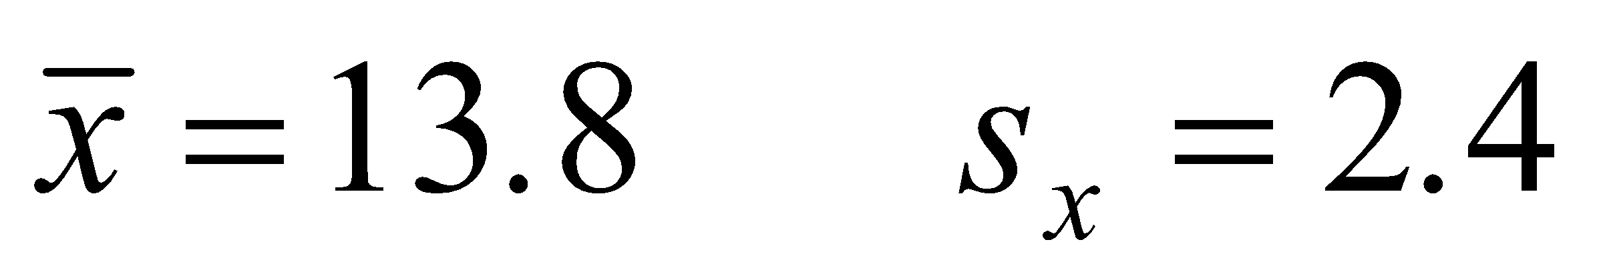

Question 3

The box plot below shows the distribution of the time, in minutes, that customers had to wait in a queue before speaking with a bank representative.

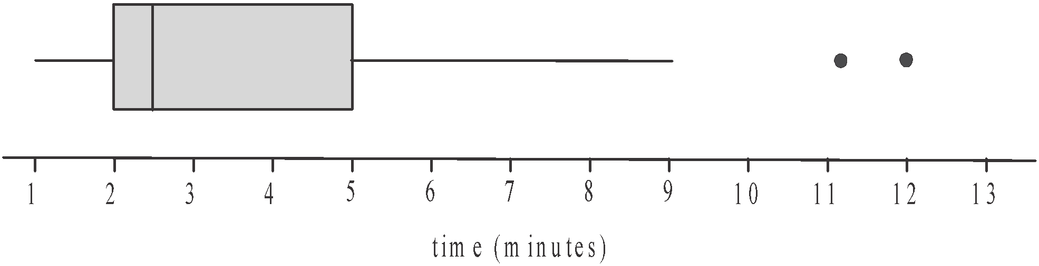

The shape of this distribution is best described as

- negatively skewed
- positively skewed
- symmetric
- negatively skewed with outliers
- positively skewed with outliers

Question 4

The heights (in cm) of a group of students is normally distributed with a mean of 122 cm and a standard deviation of 5 cm.
Yasmin is a student in this group and just 2.5% of the students in this group are shorter than her.
Yasmin’s height is

- 107 cm
- 112 cm
- 115 cm
- 117 cm
- 132 cm

Question 5

A random sample of property owners along a highway were asked to provide details relating to their property. Variables in the data collected included

- property number
- zoning type (1 = residential 2 = commercial 3 = other)
- land area (square metres)
- usual number of occupants
- postcode

These five variables can be described as categorical (nominal or ordinal) or numerical (discrete or continuous).
The number of each type of variable is summarized in table

Categorical variables |  | Numerical variables
Nominal | Ordinal | Discrete | Continuous
2 | 1 | 1 | 1

Categorical variables |  | Numerical variables
Nominal | Ordinal | Discrete | Continuous
1 | 2 | 1 | 1

Categorical variables |  | Numerical variables
Nominal | Ordinal | Discrete | Continuous
1 | 1 | 2 | 1

Categorical variables |  | Numerical variables
Nominal | Ordinal | Discrete | Continuous
1 | 1 | 1 | 2

Categorical variables |  | Numerical variables
Nominal | Ordinal | Discrete | Continuous
0 | 1 | 3 | 1

Question 6

The histogram below shows the distribution of the number of cars owned per capita for 70 countries. A log scale has been used to plot this distribution.

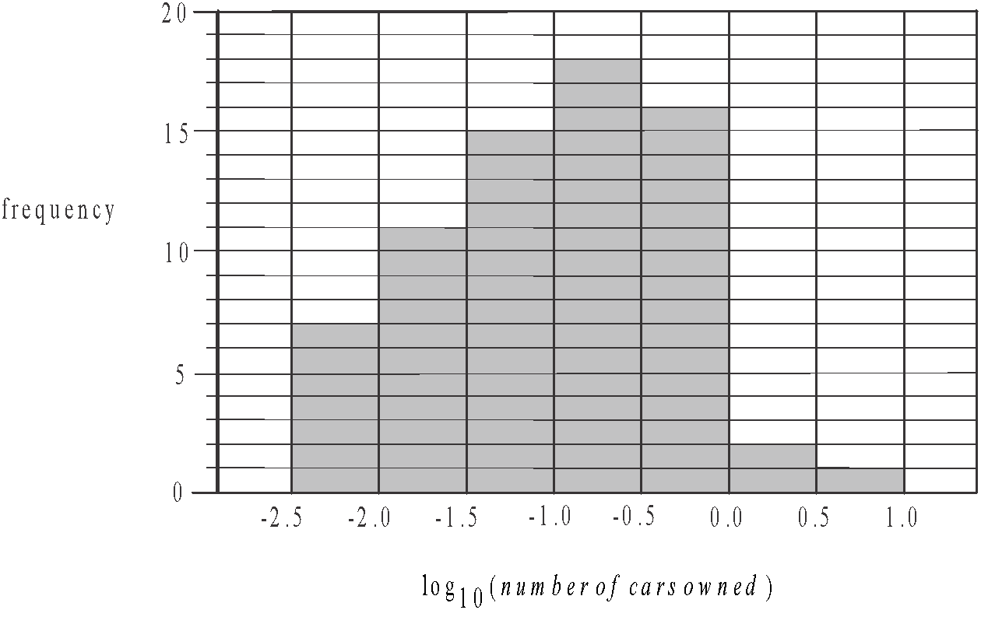

The percentage of these countries where the number of cars owned per capita is more than one is closest to

- 0%
- 1%
- 4%
- 27%
- 53%

Use the following information to answer Questions 7 and 8.

The parallel boxplots below show the distribution of the average daylight temperature (in °C) in 2015 for an inland town and a coastal town.

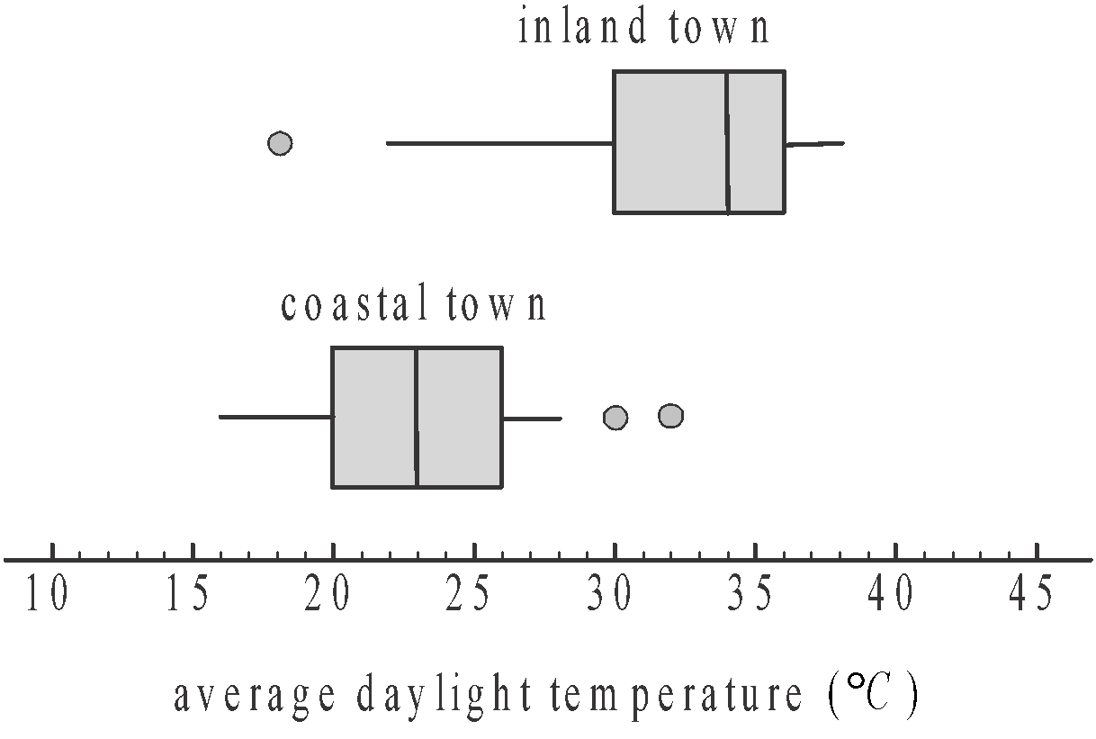

Question 7

The five-number summary for the average daylight temperature at the inland town is closest to

- 16, 20, 23, 26, 28
- 16, 20, 23, 26, 32
- 18, 22, 30, 36, 38
- 18, 30, 34, 36, 38
- 22, 30, 34, 36, 38

Question 8

Which one of the following statements is not true?

- The minimum average daylight temperatures for each of the towns were within 5° of one another in 2015.
- For more than half of the days in 2015, the inland town had a higher average daylight temperature than the coastal town.
- 75% of the days in 2015 in the inland town had average daylight temperatures of 30° or more.
- There was greater variation in the average daylight temperature in the inland town than in the coastal town.
- Average daylight temperatures are on average higher in the coastal town than the inland town.

Question 9

The table below shows the wingspan (in cm) and weight (in kg) of nine endangered birds caught by wildlife researchers.

wingspan  (cm) | 15 | 18 | 19 | 16 | 21 | 17 | 19 | 18 | 20
weight  (kg) | 1.2 | 1.7 | 1.8 | 1.6 | 1.9 | 1.5 | 1.8 | 1.9 | 2.1

The value of Pearson’s product moment correlation coefficient for this data is closest to

- 0.12
- 0.46
- 0.75
- 0.79
- 0.87

Question 10

A research project into dental hygiene found a negative correlation between the average time people spent brushing their teeth and the number of cavities they were found to have. It can be concluded from this that

- the more time people spend brushing their teeth means the less cavities they will have.
- the time people spend brushing their teeth has no effect on the number of cavities they will have.
- the people who tend to spend more time cleaning their teeth tend to have less cavities.
- getting people to brush their teeth for longer will reduce the number of cavities they have.
- people who brush their teeth for longer have more cavities.

Question 11

The time series plot below shows the annual turnover of a company over a decade.
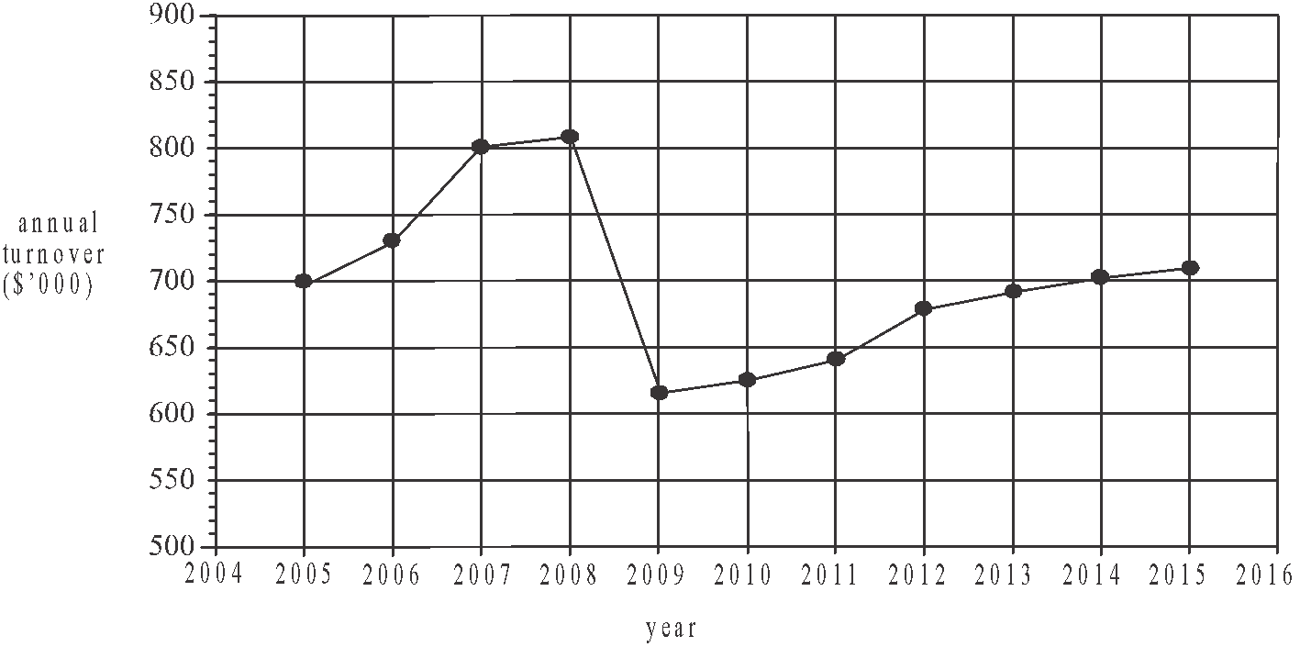

The time series plot shows

- seasonal variation
- a decreasing trend
- irregular fluctuations
- an outlier
- structural change

Question 12

The table below shows the amount of data (in gigabytes) used each month by a business over a five month period.

Month | May | June | July | August | September
Data used  (gigabytes) | 65.2 | 78.5 | 69.7 | 61.3 | 74.2

A two-point moving mean, with centring, is used to smooth this time series.
The smoothed value for the amount of data used by the business in July is

- 65.5
- 67.7
- 69.8
- 74.1
- 157.025

Question 13

The time series plot below shows the number of people who attend an annual music festival over a nine year period.
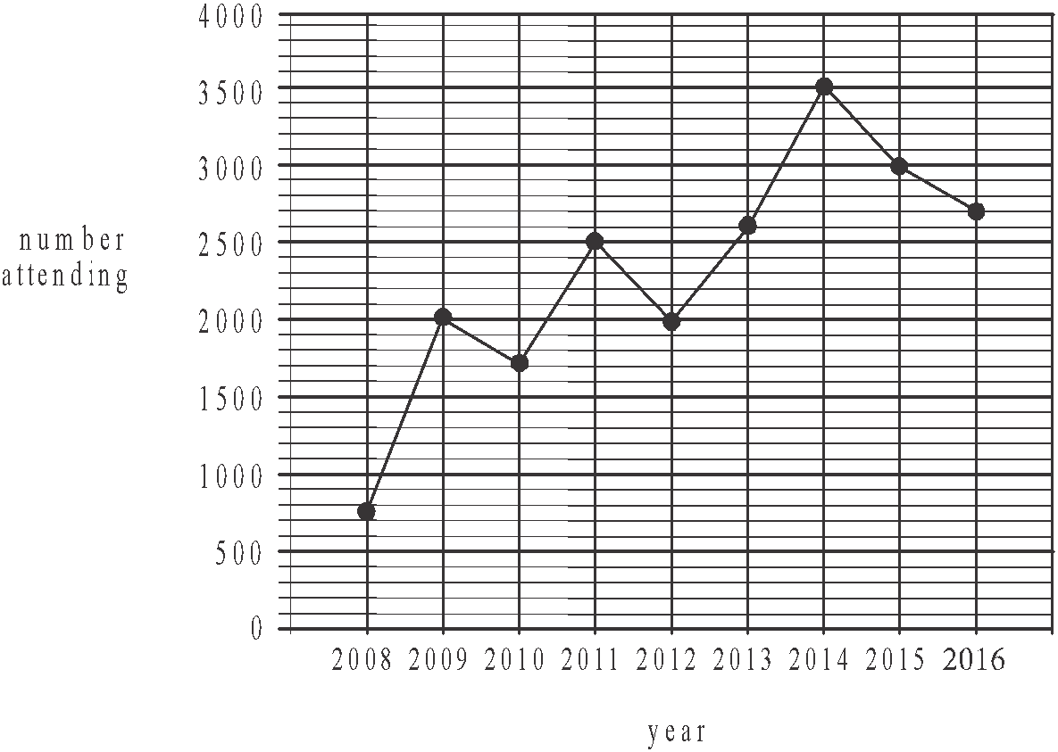

Five-median smoothing is used to smooth this data. The smoothed number of people attending the music festival in 2014 is

- 2600
- 2700
- 2760
- 3000
- 3500

Question 14

The seasonal indices for hospital admissions at a rural hospital in 2014 are shown below. The index for May is missing.

Month | Jan | Feb | Mar | Apr | May | Jun | Jul | Aug | Sep | Oct | Nov | Dec
seasonal index | 1.25 | 1.13 | 1.02 | 0.95 |  | 1.08 | 1.02 | 0.94 | 0.79 | 0.83 | 0.92 | 1.03

The seasonal index for May is

- 0.94
- 0.96
- 1.04
- 1.26
- 1.40
Question 15

The seasonal indices for sales at a plant nursery are shown in the table below.

Season | summer | autumn | winter | spring
Seasonal index | 0.95 | 1.06 | 0.87 | 1.12

Last year the deseasonalised sales at the nursery in autumn were $102 000.
The actual sales at the nursery in autumn last year were

- $63 750
- $96 226
- $102 460
- $108 120
- $163 200

Question 16

The quarterly seasonal indices for the revenue collected by a sporting club is shown in Table A below.

Table A
Quarter number | 1 | 2 | 3 | 4
Seasonal indices | 1.2 | 1.4 | 0.8 | 0.6

The quarterly revenue collected by the club last year is shown in Table B below.

Table B
Quarter number | 1 | 2 | 3 | 4
Revenue  ($) | 10 680 | 12 600 | 5 600 | 3 840

The revenue collected is deseasonalised and a least squares regression line is fitted. The equation of that line is closest to

Recursion and financial modelling

Question 17

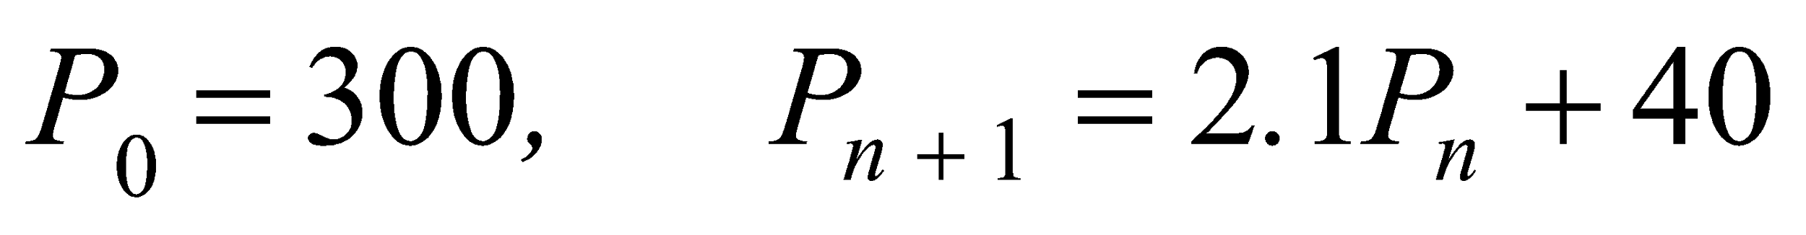

The term, of the sequence generated by the recurrence relation above, is

- 363
- 670
- 792.3
- 1447
- 3078.7

Question 18

A truck is depreciated by seven cents for every kilometre it travels.
The value of the truck V_{n} , in dollars, after travelling n kilometres is modelled by the recurrence relation
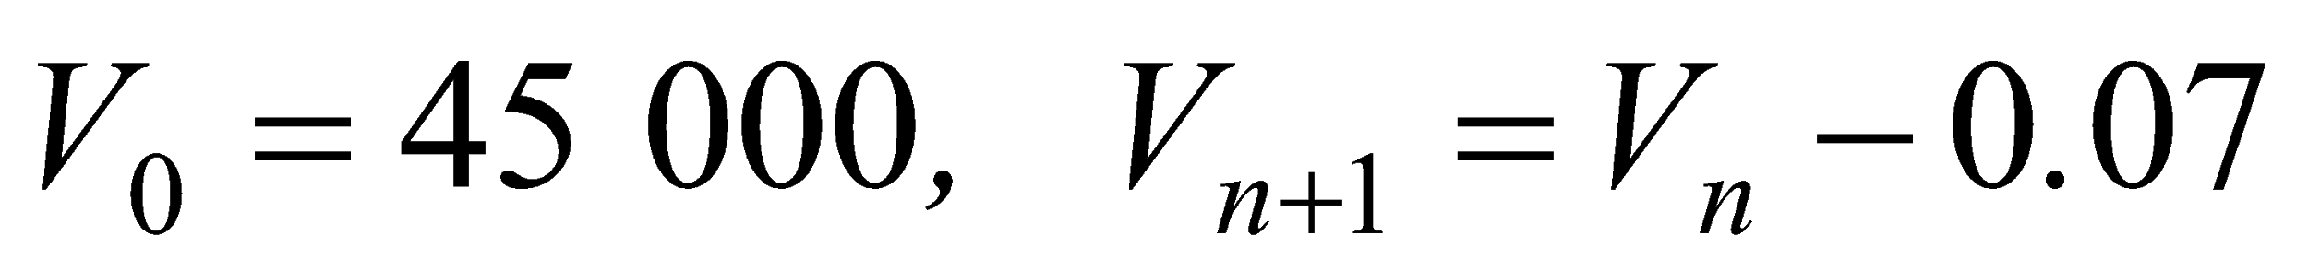.

A rule for the value of the truck, in dollars, after travelling n kilometres is

- 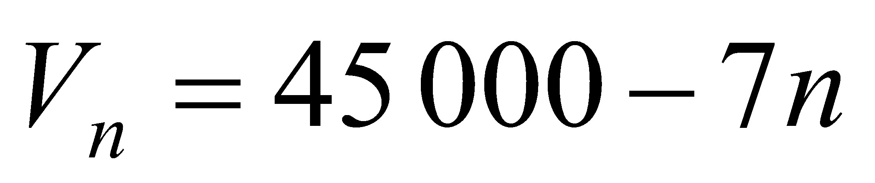
- 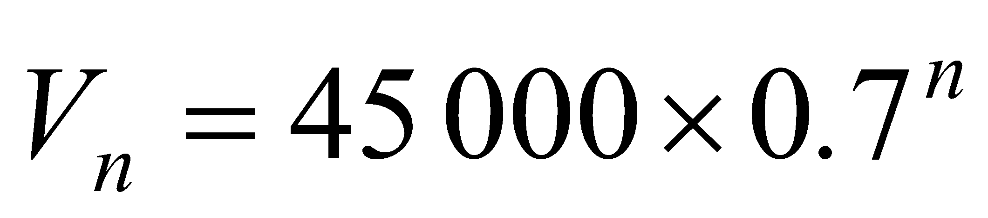
- 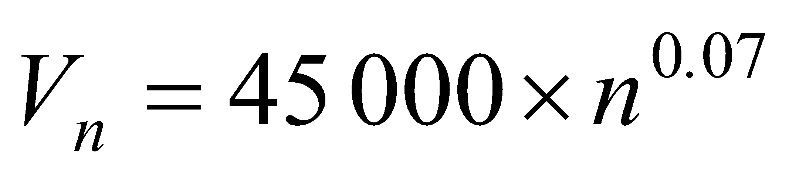
- 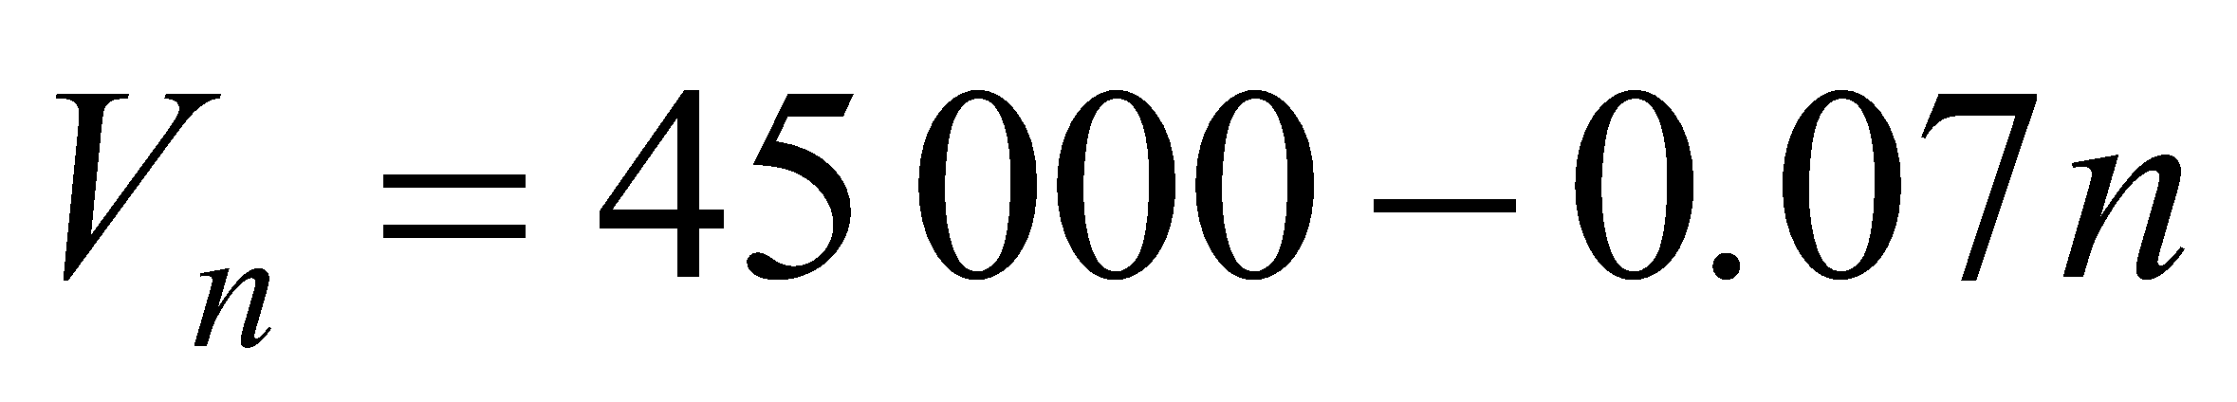
- 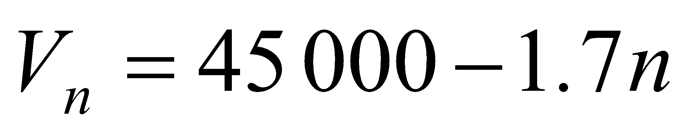

Question 19

Which one of the following recurrence relations generates a sequence whose terms show growth that is neither linear nor geometric?

- 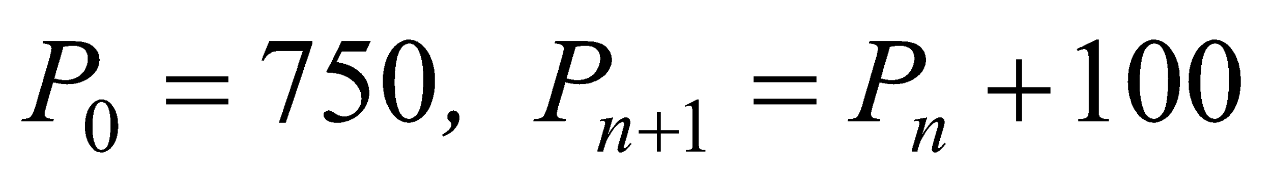
- 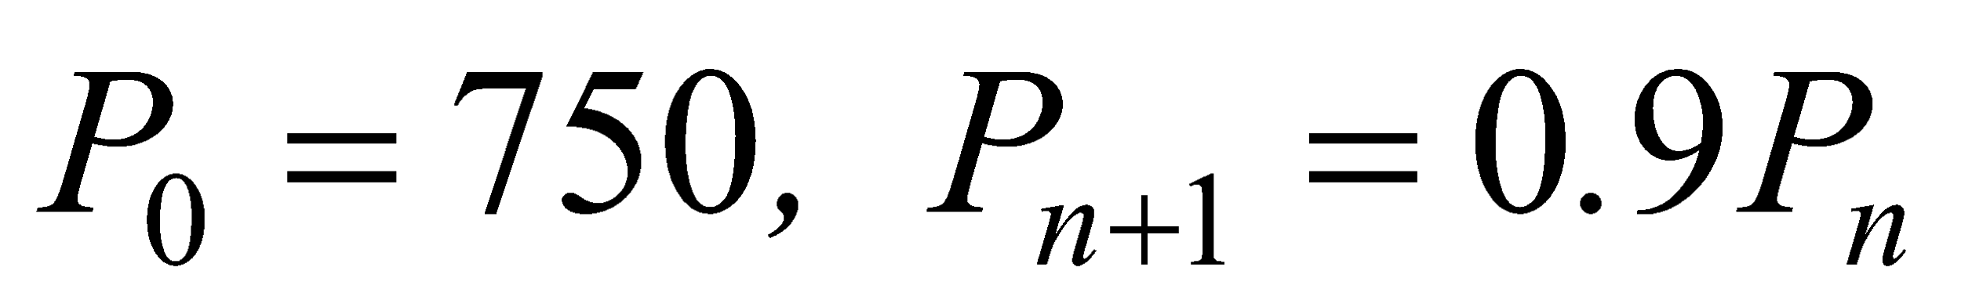
- 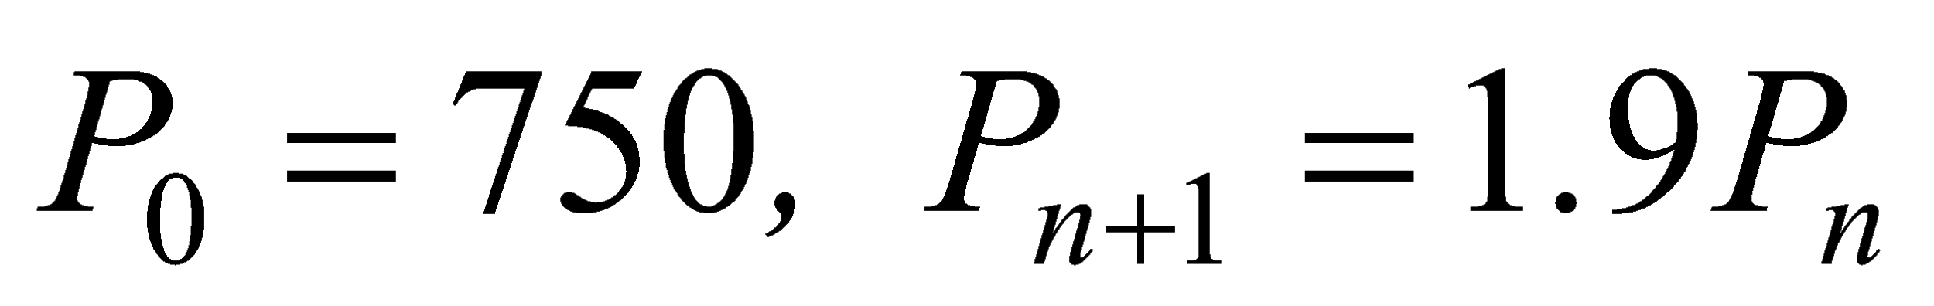
- 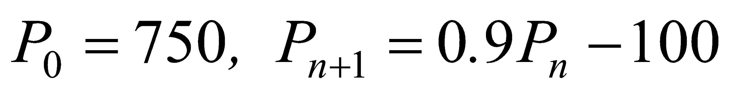
- 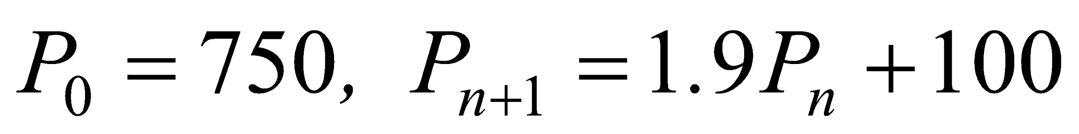
Question 20

Anita borrows $12 000 at an annual interest rate of 7.2% per annum compounding monthly.
A rule that can be used to find , the amount that Anita still owes on the loan after n months, is

- 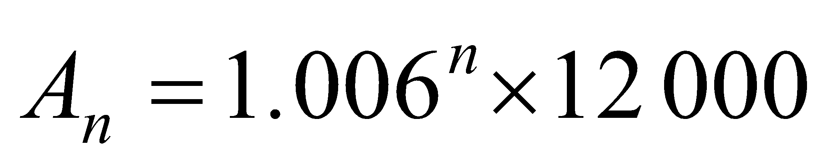
- 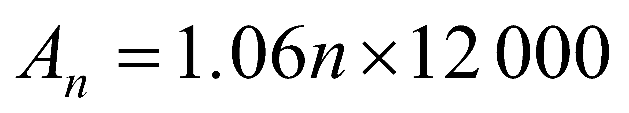
- 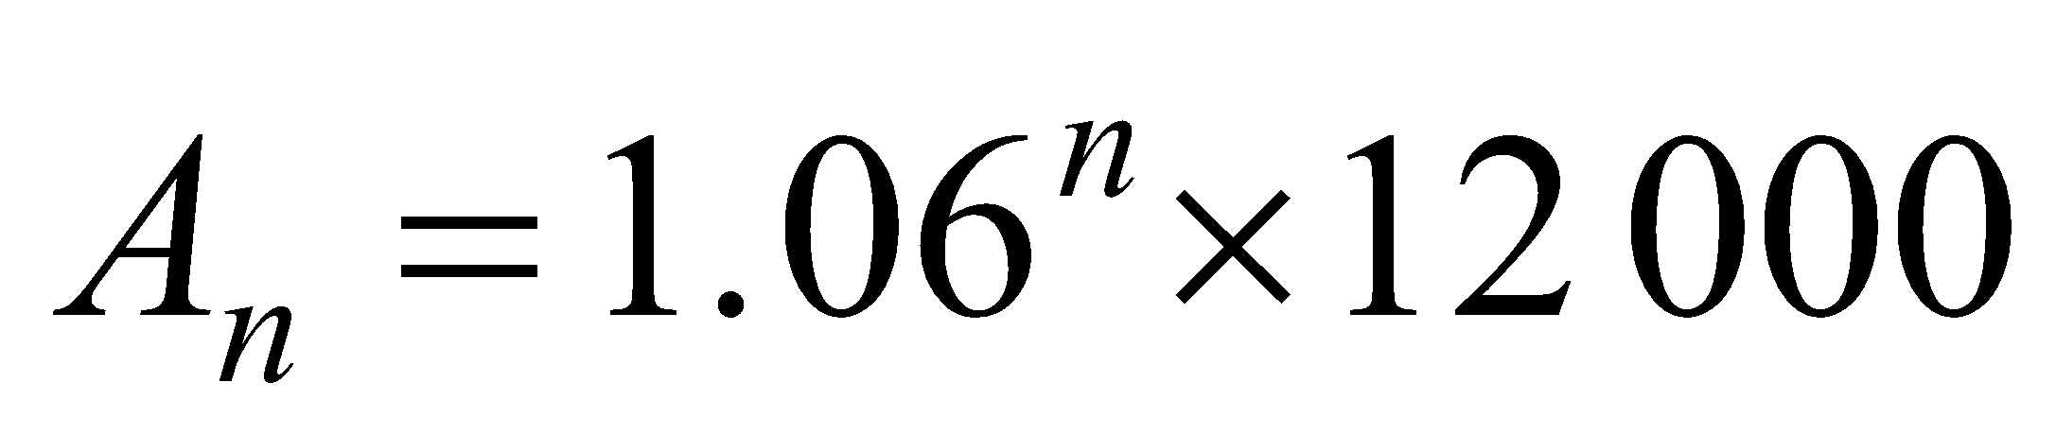
- 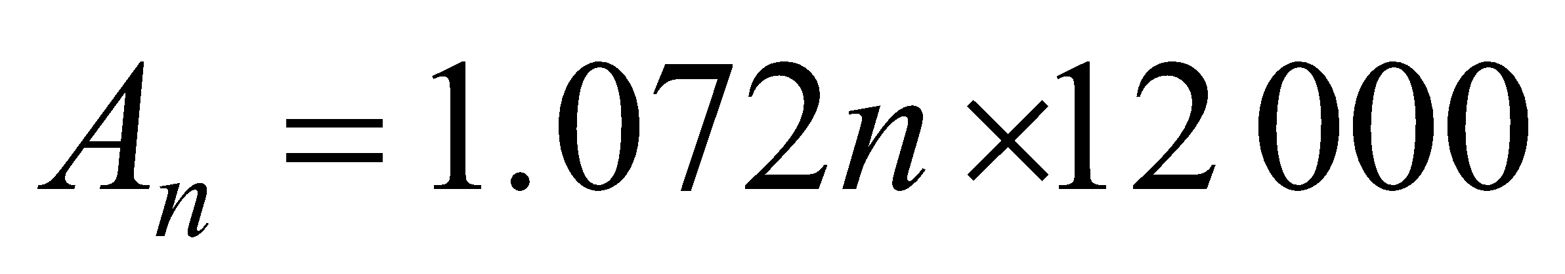
- 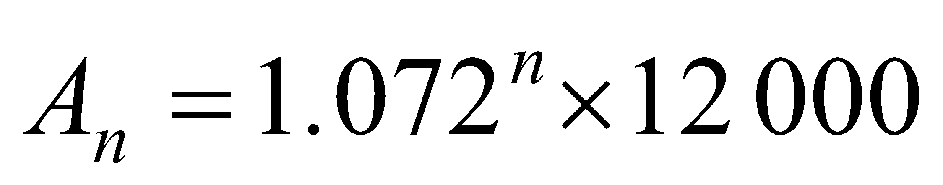

Question 21

Jane invests $25 000 that earns 7.8% per annum interest compounding quarterly.
The effective interest rate for Jane’s investment is closest to

- 7.80%
- 7.86%
- 7.91%
- 7.98%
- 8.03%

Question 22

The graph below shows the value of an investment over five years.

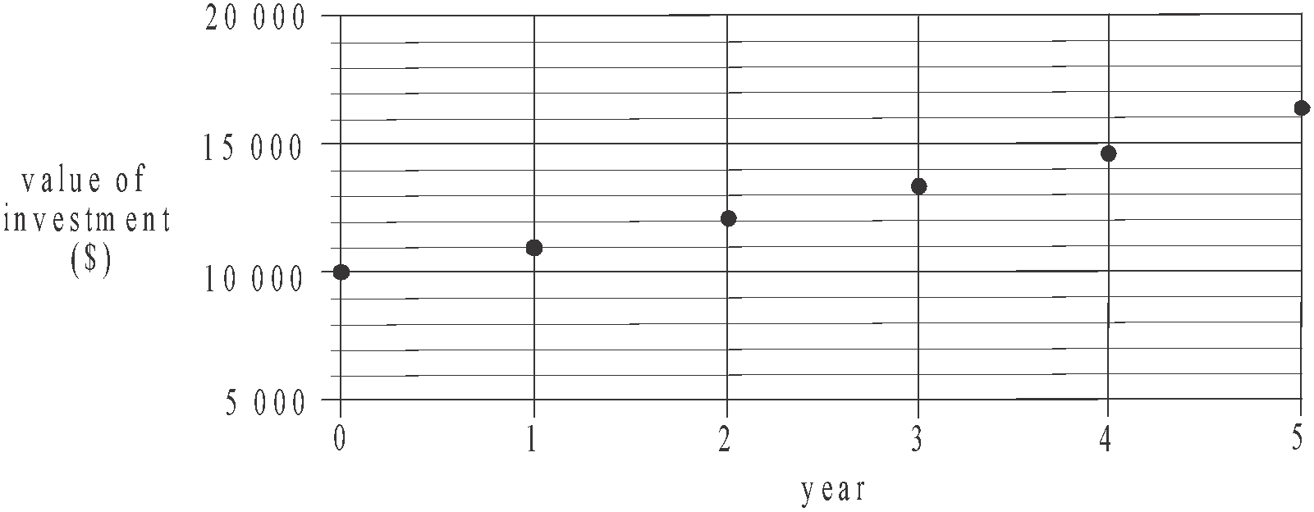

Let  be the value of the investment after n years.
A recurrence relation that could be used to model this investment is

- 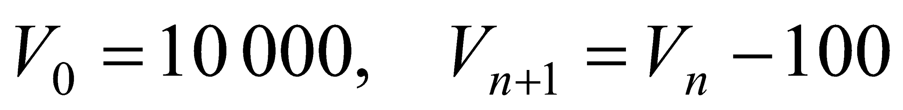
- 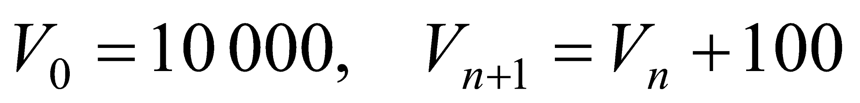
- 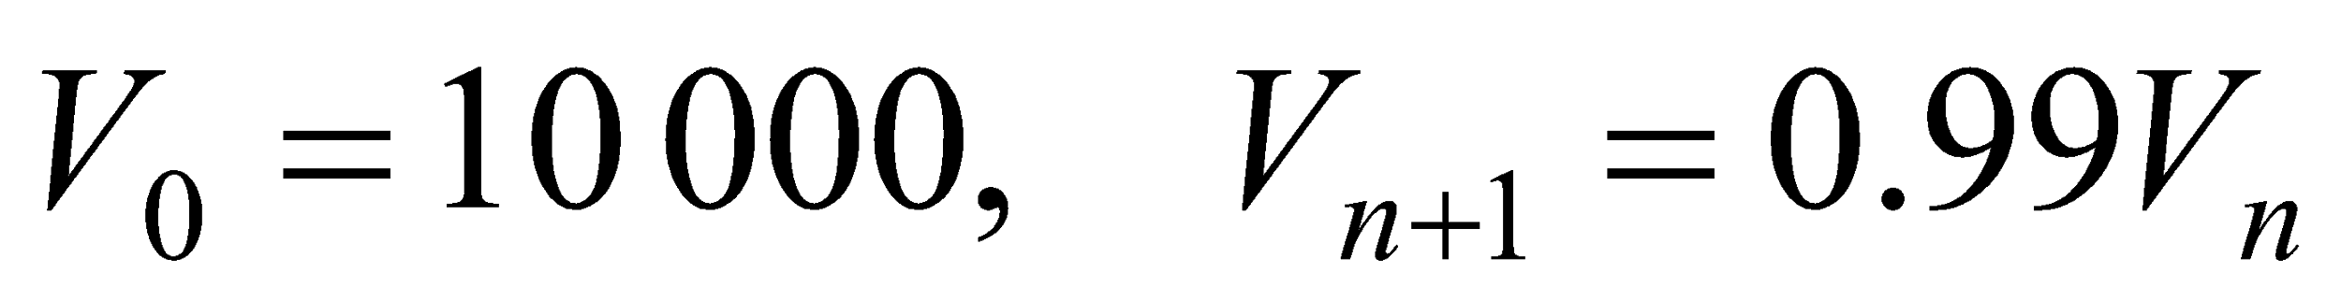
- 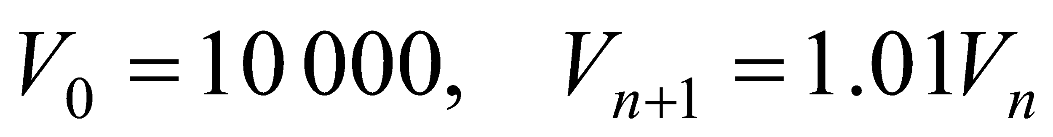
- 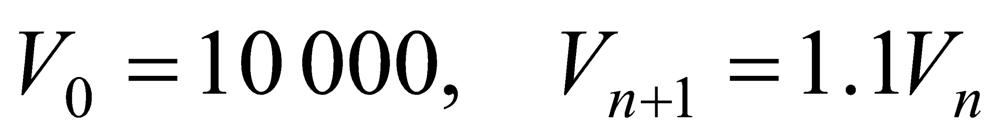
Use the following information to answer Questions 23 and 24.

Craig borrows $32 000 at a rate of 8% per annum.
He makes quarterly repayments of $4368.31 for two years in order to fully repay the loan.
An incomplete amortization table for this loan is shown below.

Payment Number | Payment | Interest  charged | Reduction in principal | Balance of loan
0 | 0 | 0.00 | 0.00 | 32 000.00
1 | 4368.31 | 640 | 3 728.31
2 | 4368.31 | 565.43 | 3 802.88 | 24 468.81
3 | 4368.31 | 489.38 | 3 878.93 | 20 589.88
4 | 4368.31 |  |  | 16 633.37
5 | 4368.31 | 332.67 | 4035.64 | 12 597.73
6 | 4368.31 | 251.95 | 4 116.36 | 8 481.37
7 | 4368.31 | 169.63 | 4 198.68 | 4 282.69
8 | 4368.31 | 85.65 | 4 282.66 | 0.03

Question 23

The balance of the loan after one repayment has been made is

- $26 992.69
- $28 234.40
- $28 271.69
- $35 728.31
- $37 008.31

Question 24

The reduction in the principal after payment number four is made is

- $3 872.47
- $3 956.51
- $3 957.29
- $3 982.41
- $4 016.27
SECTION B - Modules

Module 1: Matrices

If you choose this module all questions must be answered.

Question 1
The matrix S below shows the number of sick days taken by four employees Alan (A), Bert (B), Carrie (C), and Dan (D) in 2013, 2014 and 2015.
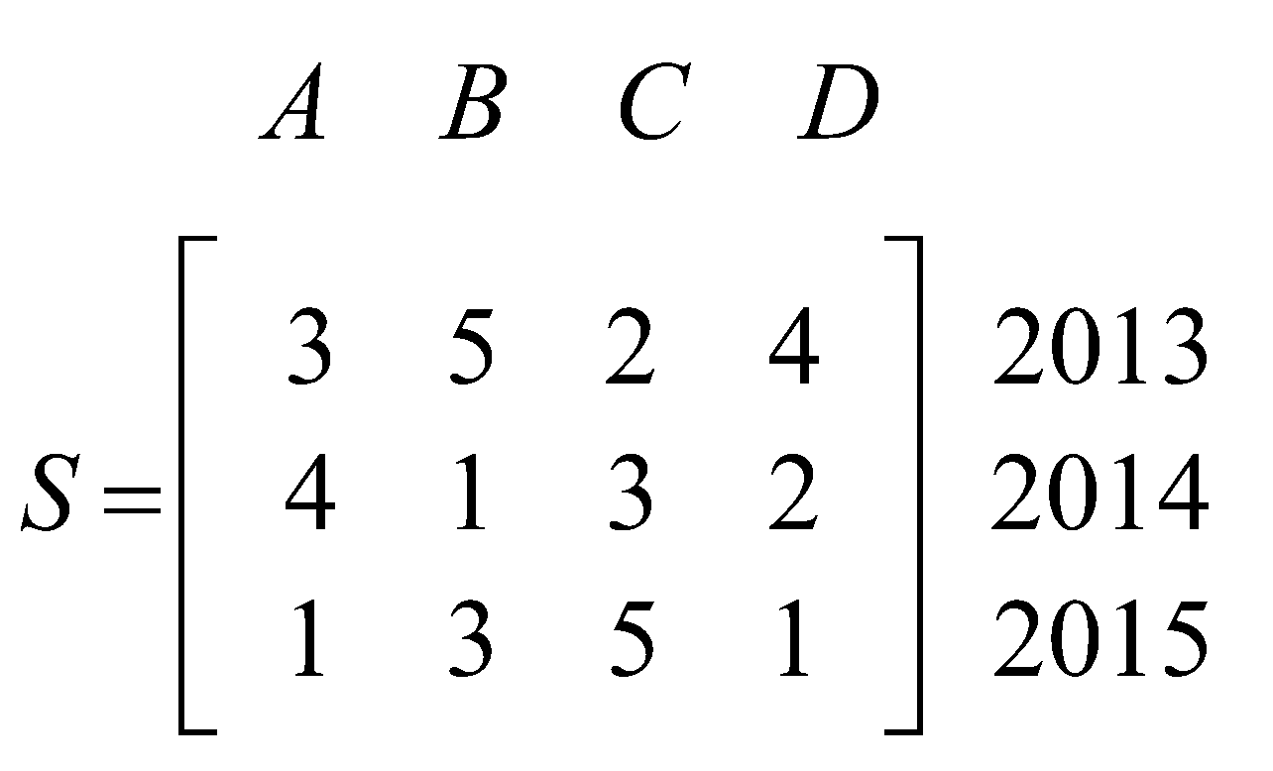
The term  represents the element in row i and column j of the matrix.
The number of sick days taken by Carrie in 2014 is represented by
- 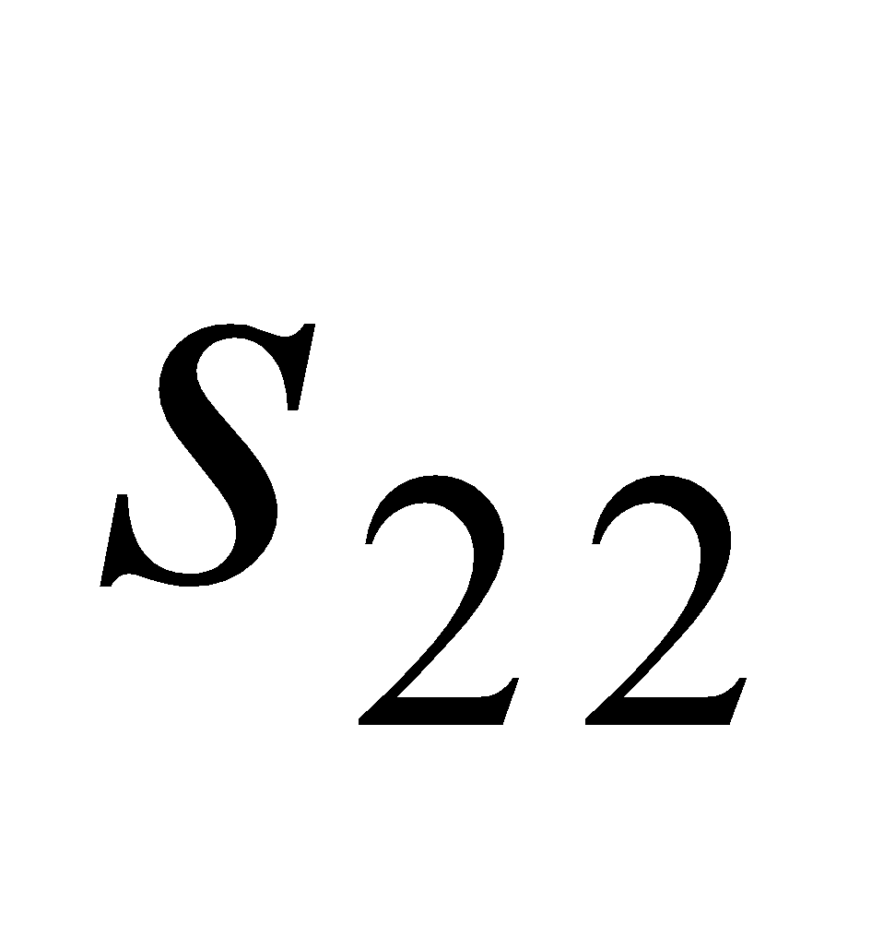
- 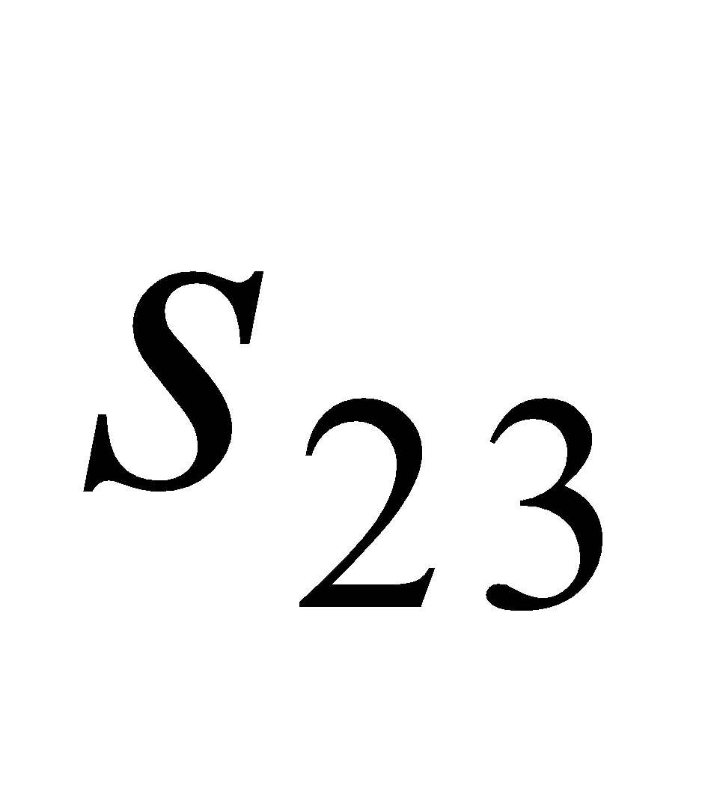
- 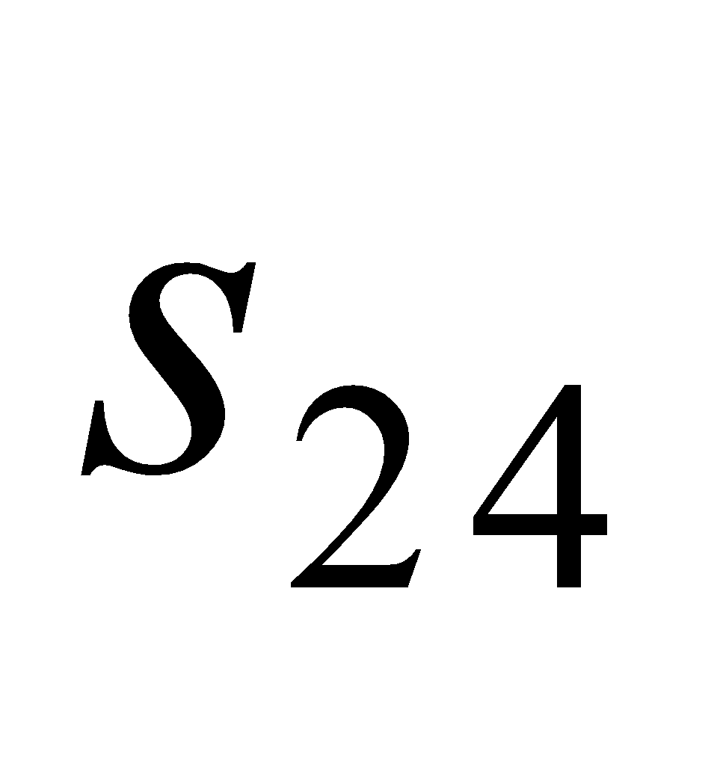
- 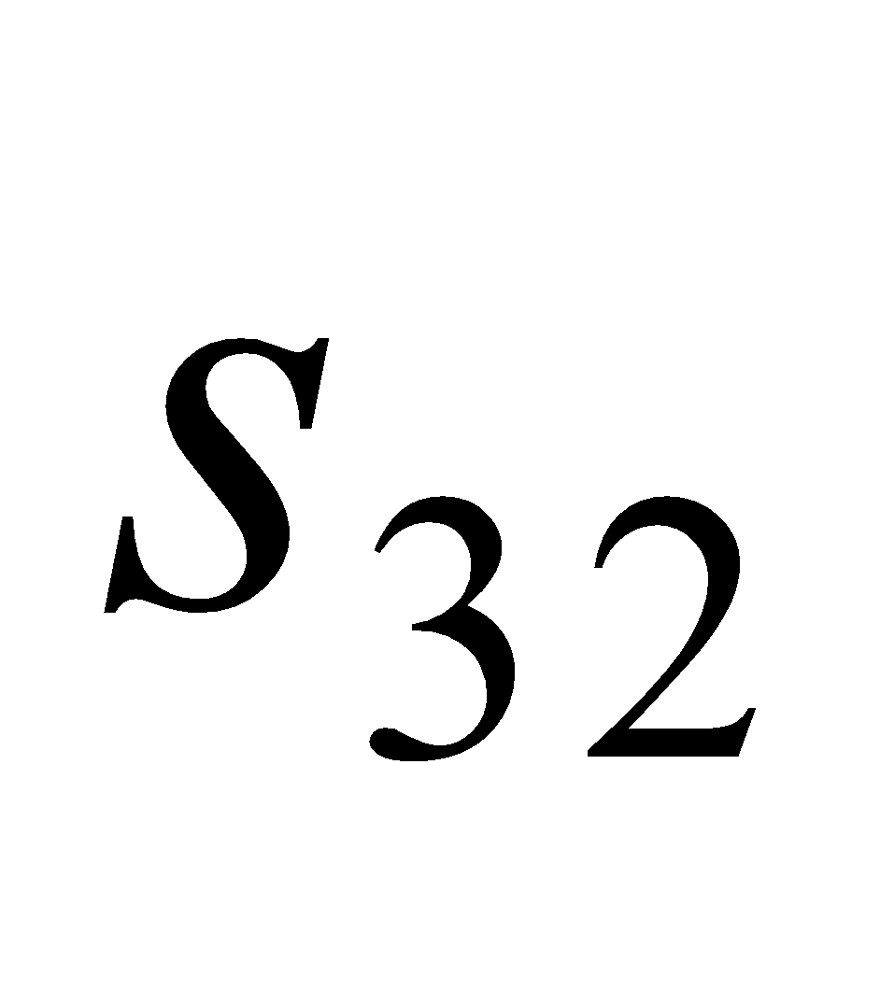
- 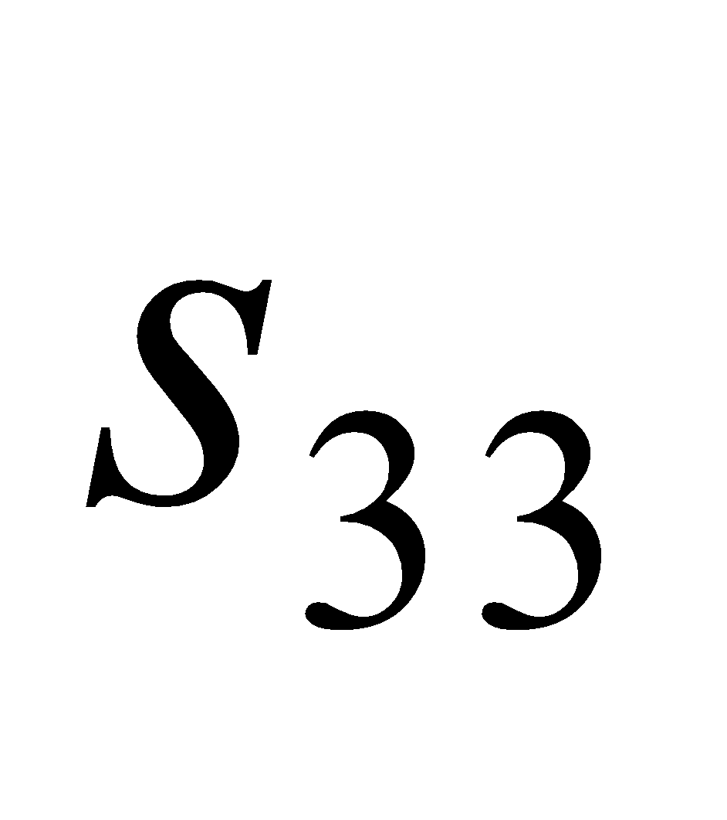

Question 2
The number of business owners and their employees attending the morning, afternoon and evening sessions of a short course are shown in the table below.
Attendees | Session
 | Morning | Afternoon | Evening
Business owners | 68 | 57 | 22
Employees | 241 | 168 | 35
The total number of people attending the morning session, the total number attending the afternoon session and the total number attending the evening session can be found by calculating
- 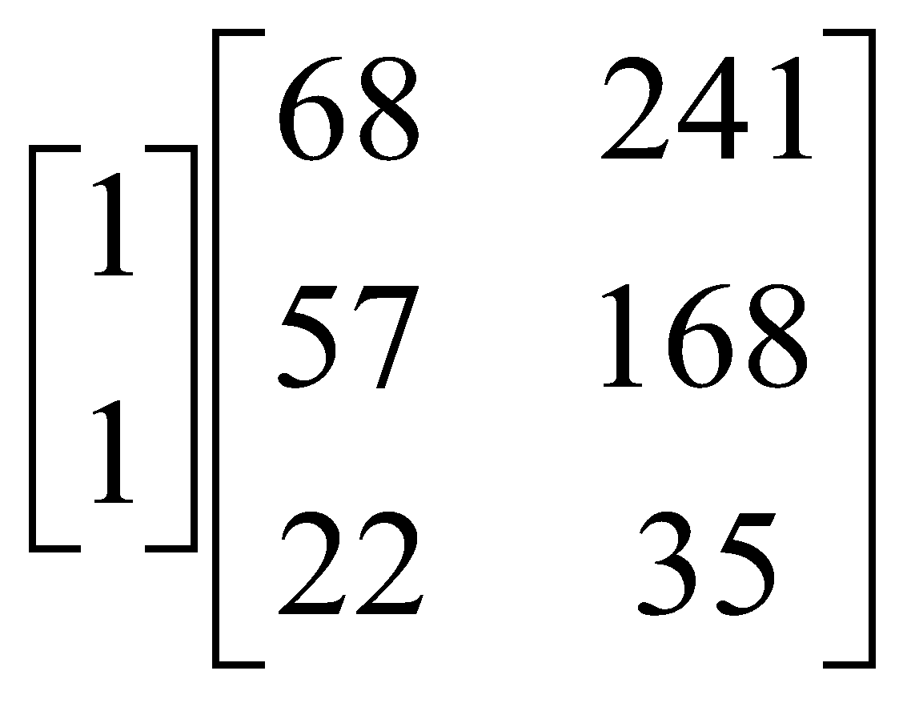
- 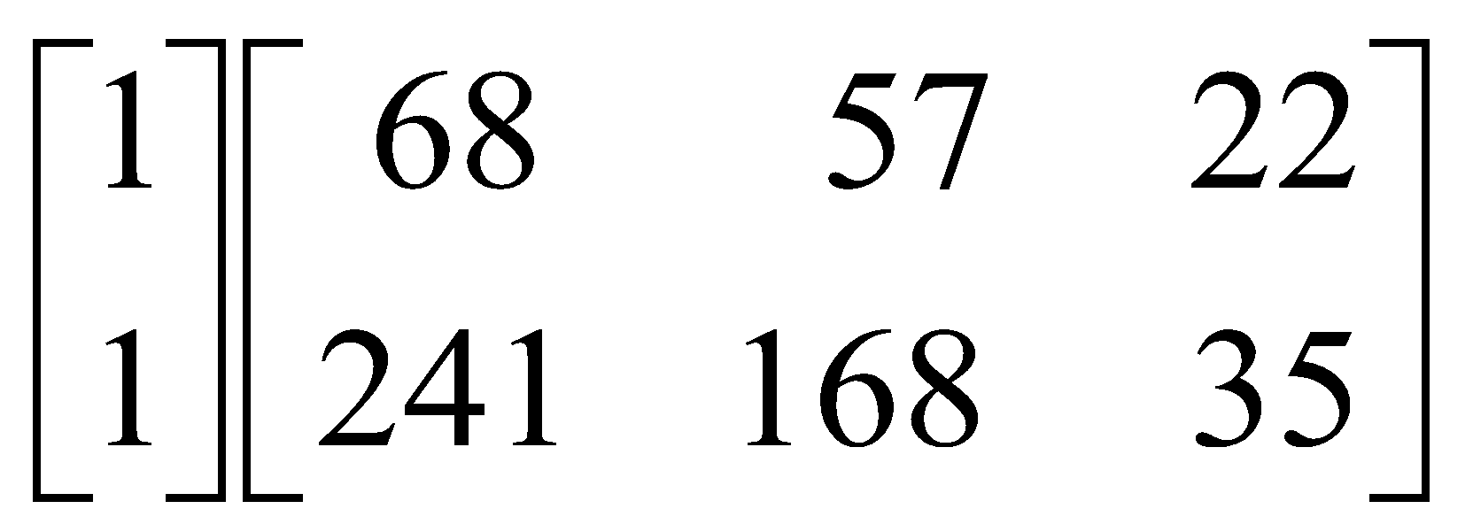
- 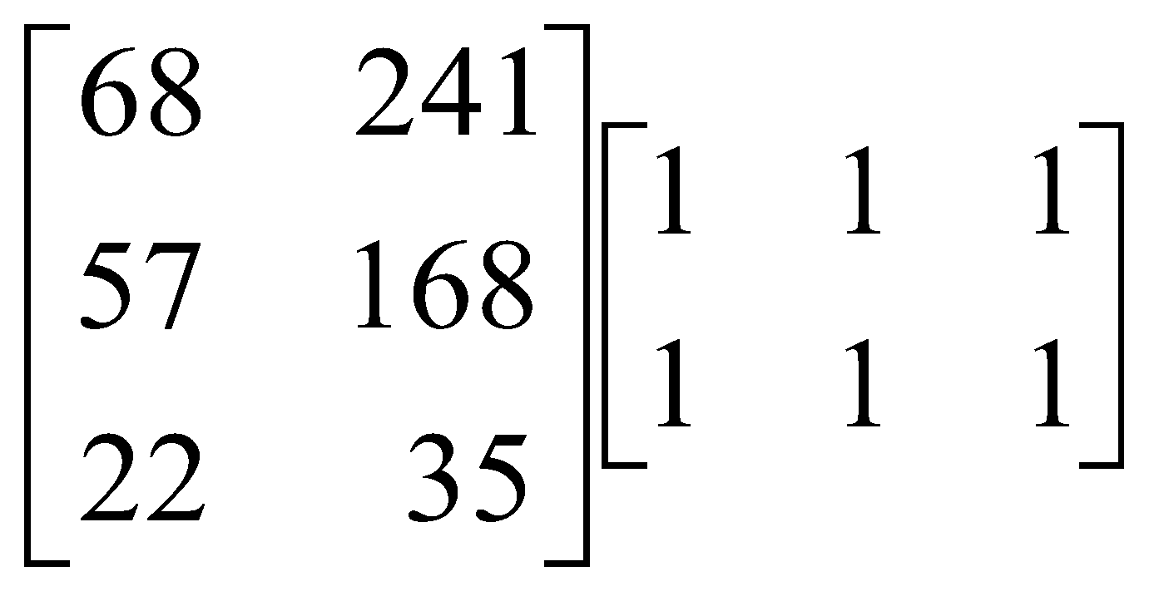
- 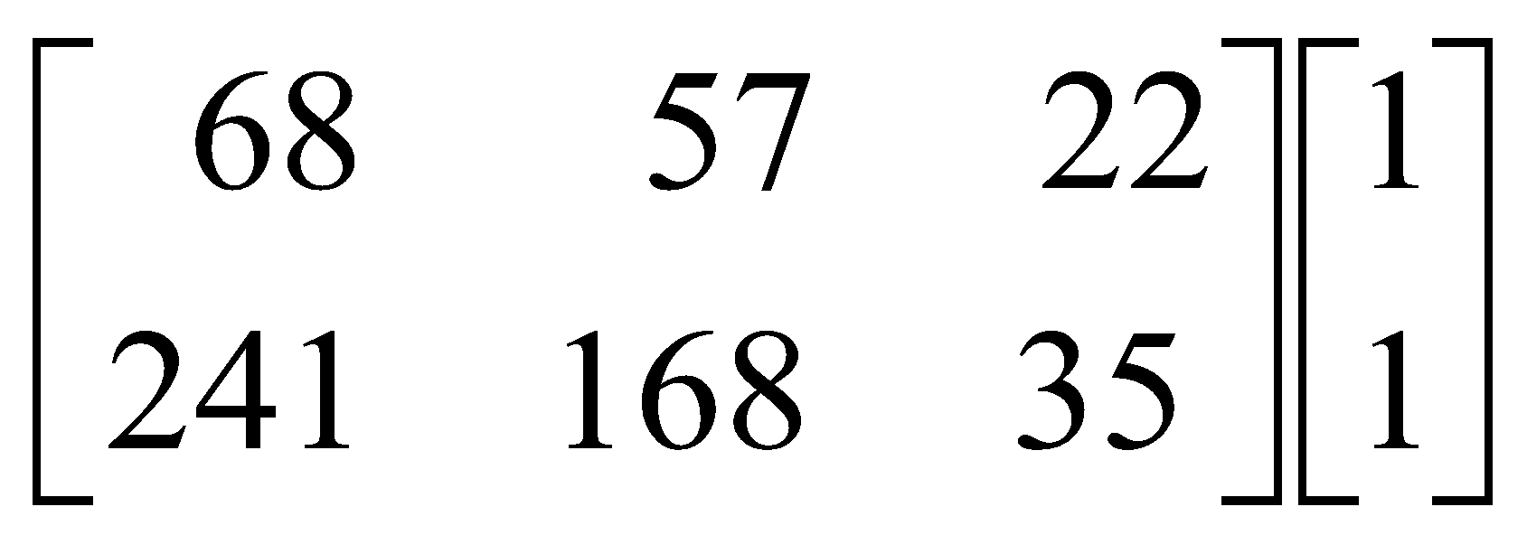
- 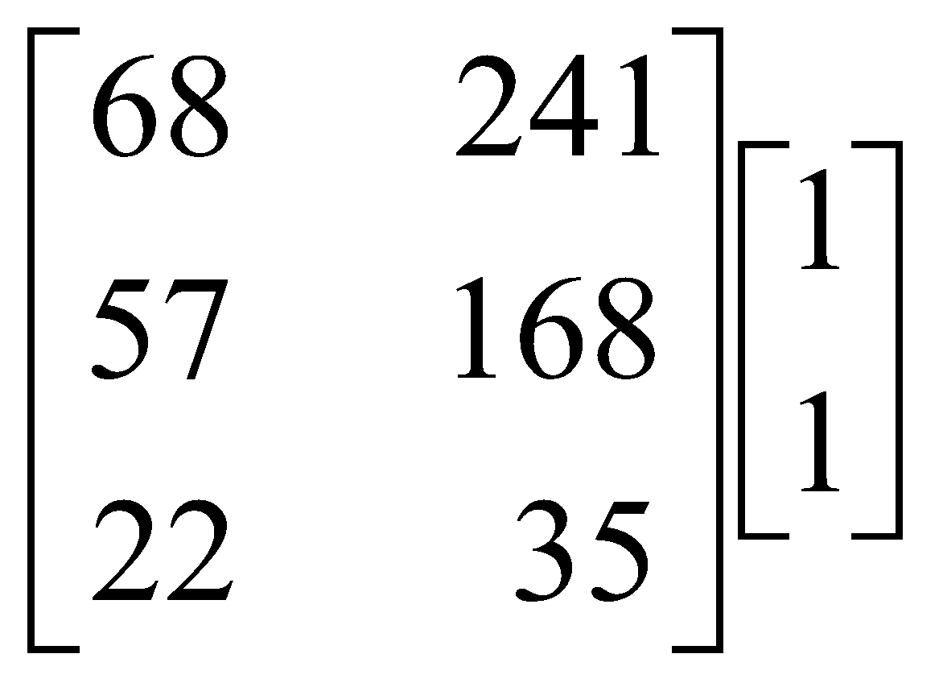
Question 3

A podiatry practice has two podiatrists Jane (J) and Sudhir (S) who jointly look after 260 patients who have regular monthly appointments.
The transition matrix T, below, shows the way patients change their preference for the two podiatrists from one month to the next.
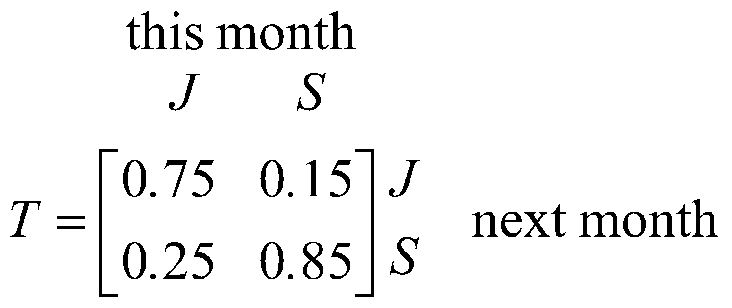

Jane and Sudhir joined the practice at the same time and they were each assigned 130 of these patients. Over the long term, the number of these patients who are expected to choose Sudhir for their monthly appointment is closest to

- 98
- 111
- 130
- 163
- 178

Question 4

Four sets of simultaneous linear equations are shown in the table below.

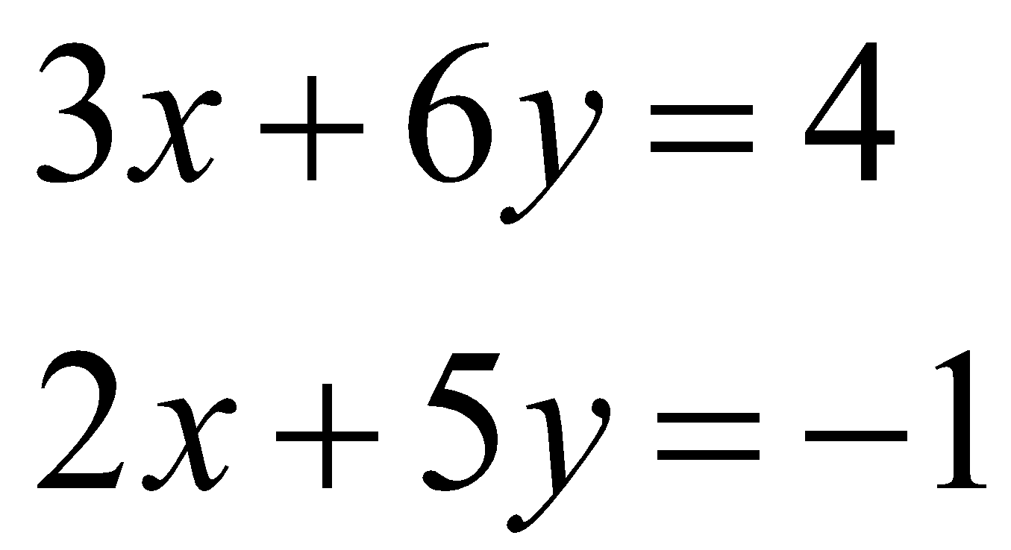 | 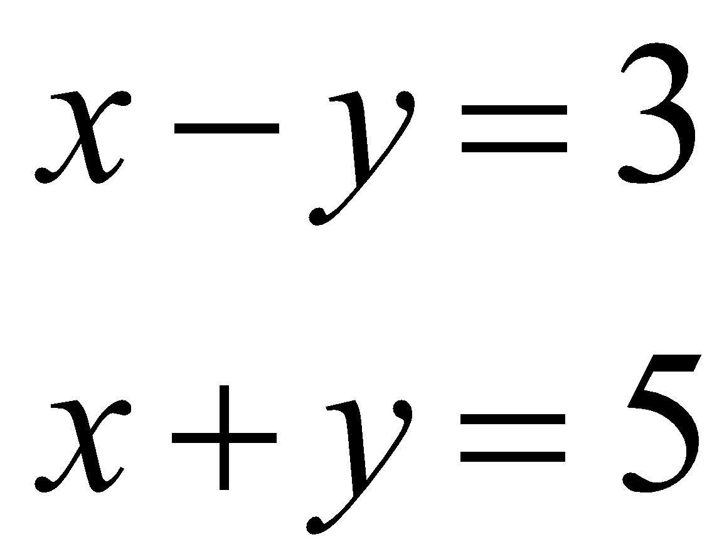 | 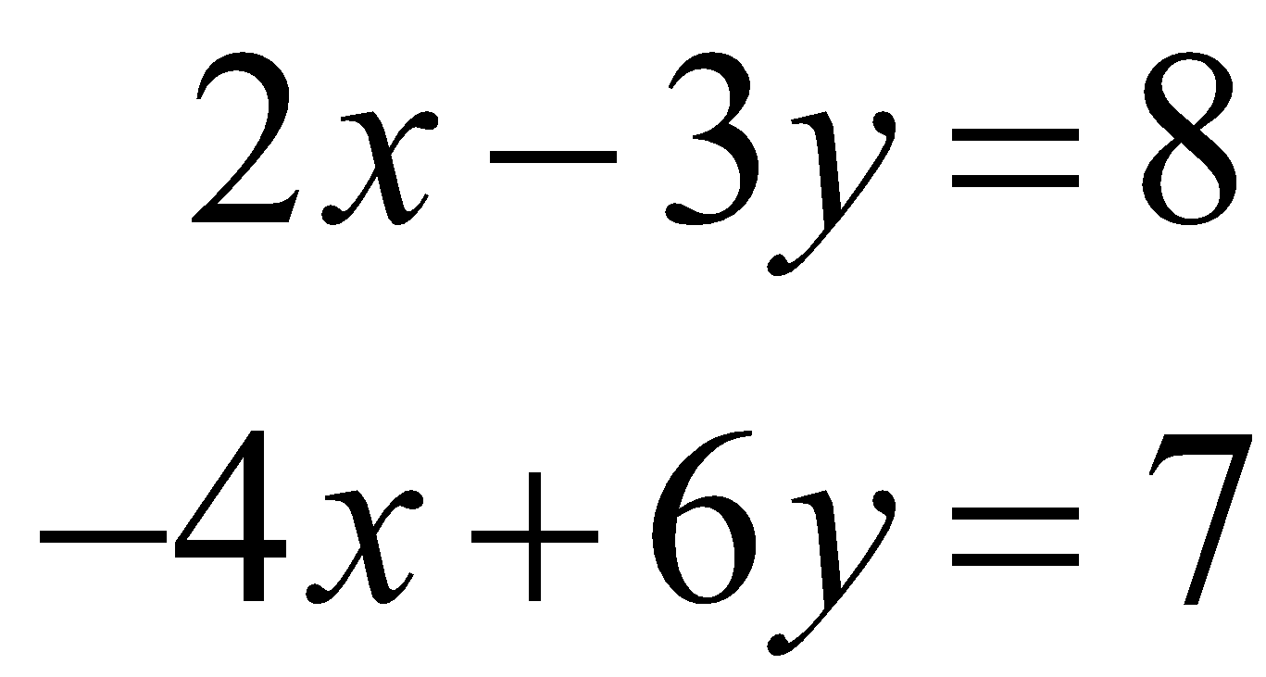 | 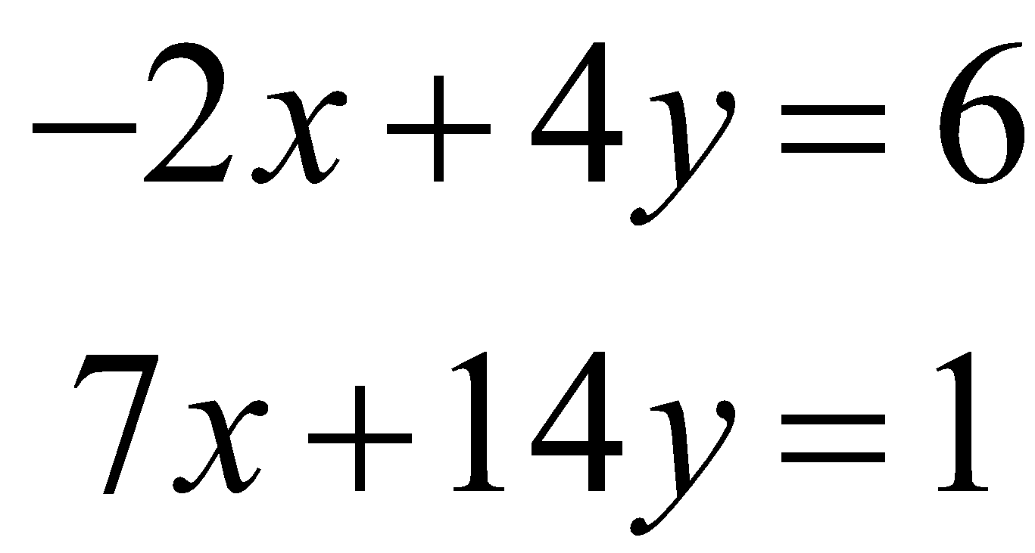

The number of these sets of equations that have a unique solution is

- 0
- 1
- 2
- 3
- 4

Question 5

A principal makes weekly visits to each of the five Year 6 classes, 6A, 6B, 6C, 6D and 6E.
He visits a different class each weekday. On Thursdays he visits 6B.
The transition matrix that ensures he visits 6E on Tuesdays is

- 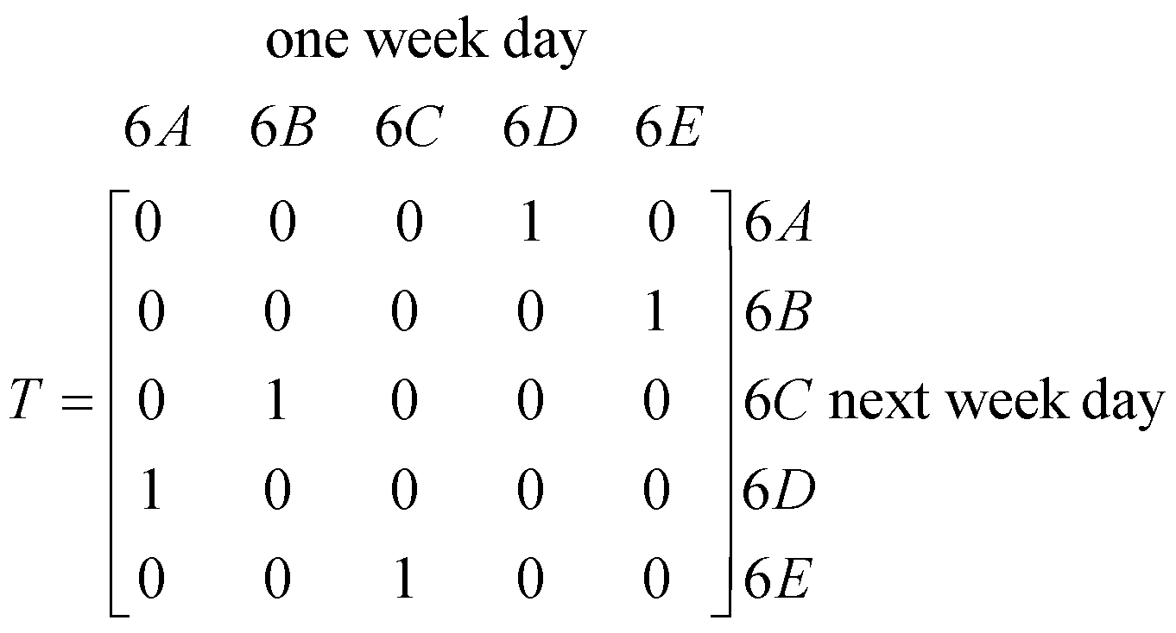

- 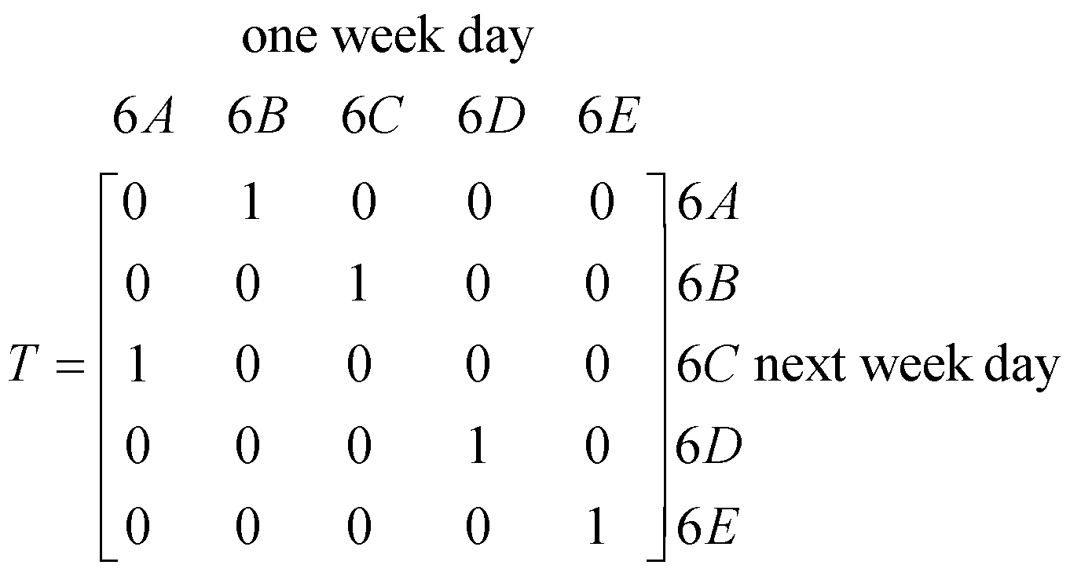

- 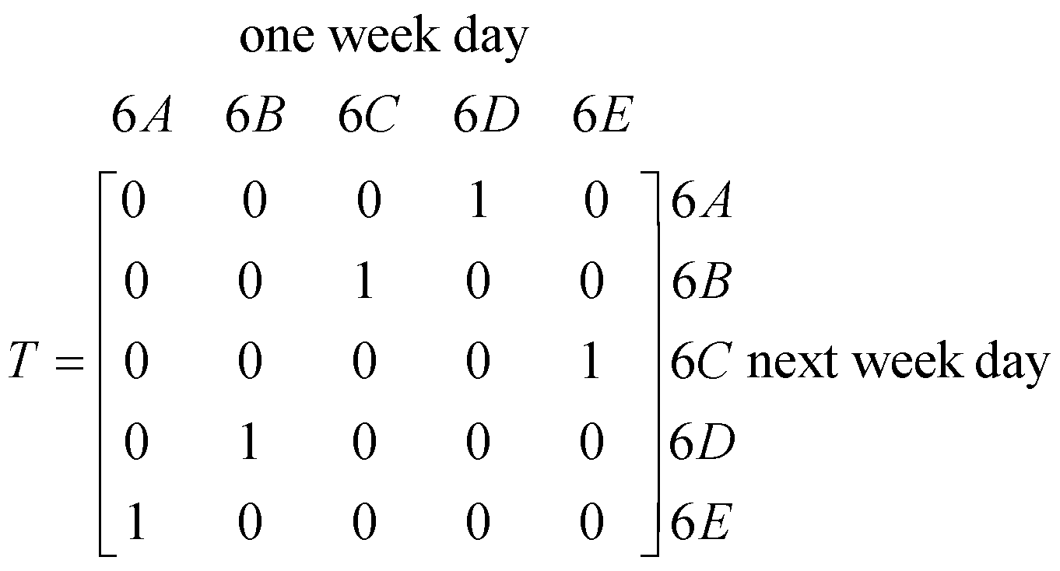
- 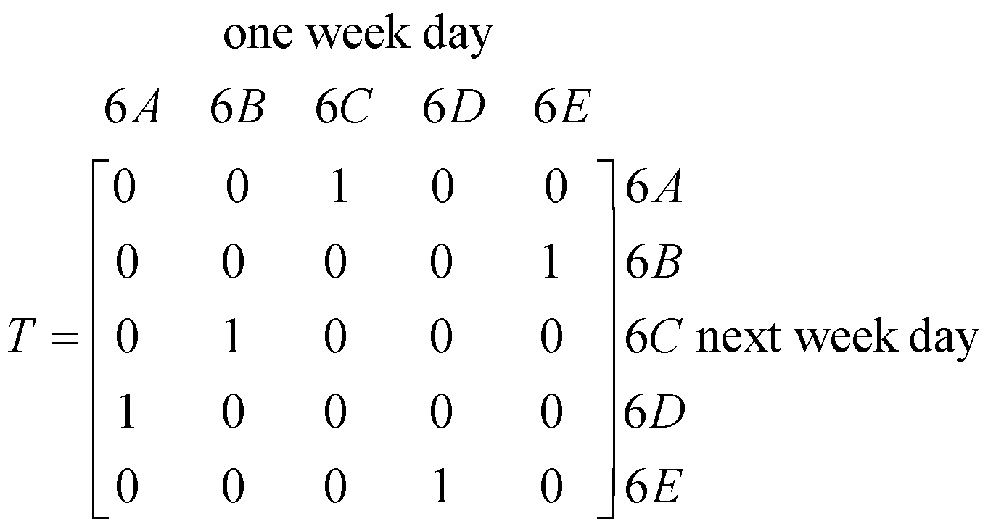

- 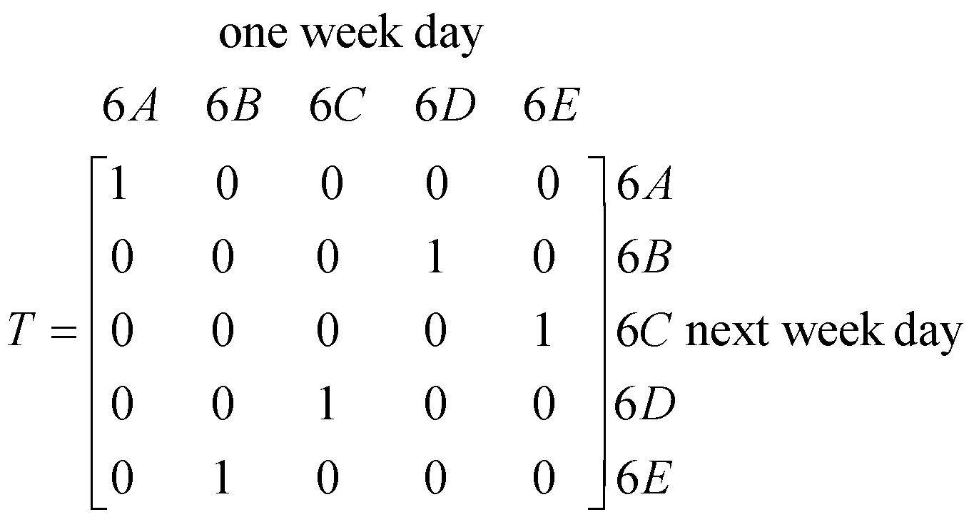
Question 6
Matrix P is a column matrix. Element  is the element in row i and column j of matrix P. The elements of this matrix can be found using the rule 
Matrix P could be
- 
- 
- 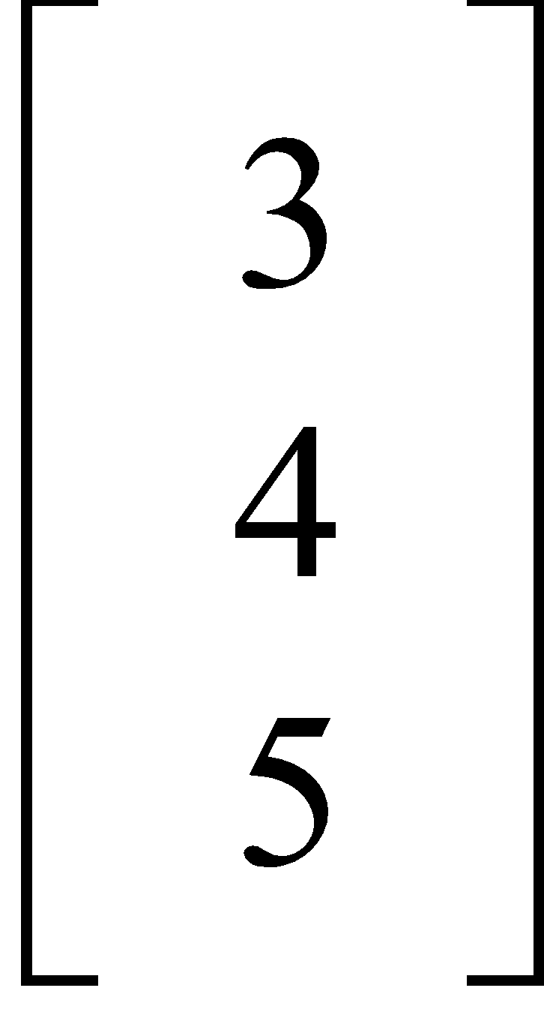
- 
- 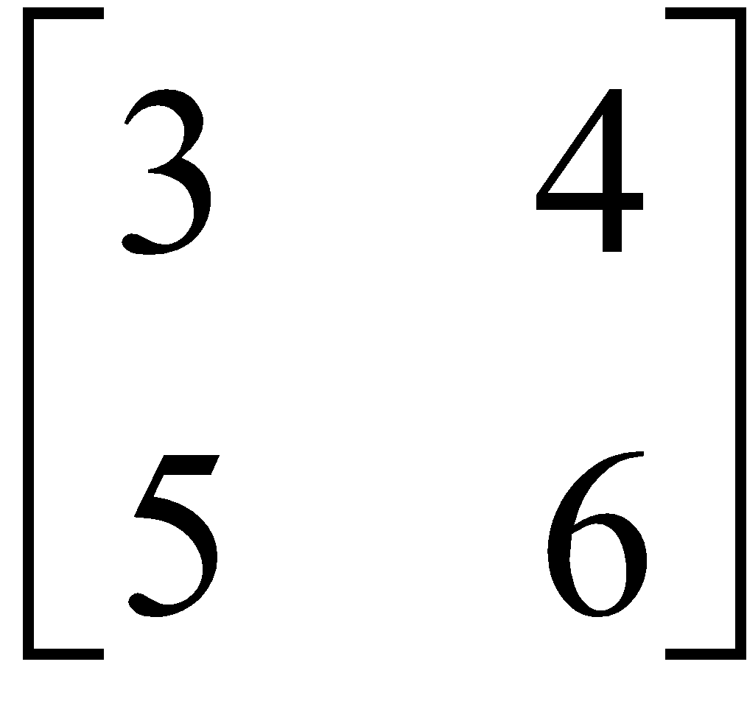

Question 7
A customer purchases 6 jumpers and 10 scarves for $512 at a merchandise store.
His friend purchases 7 jumpers and 12 scarves for $602. If each jumper costs $ j and each scarf costs $s, then the matrix can be found by evaluating
- 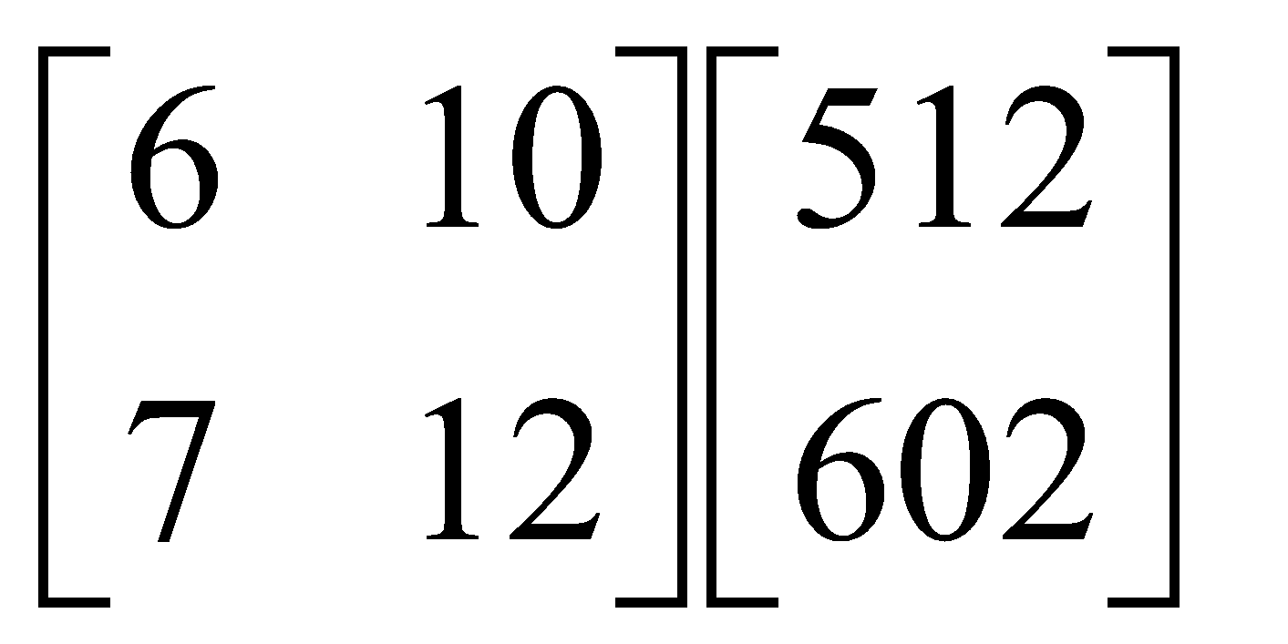
- 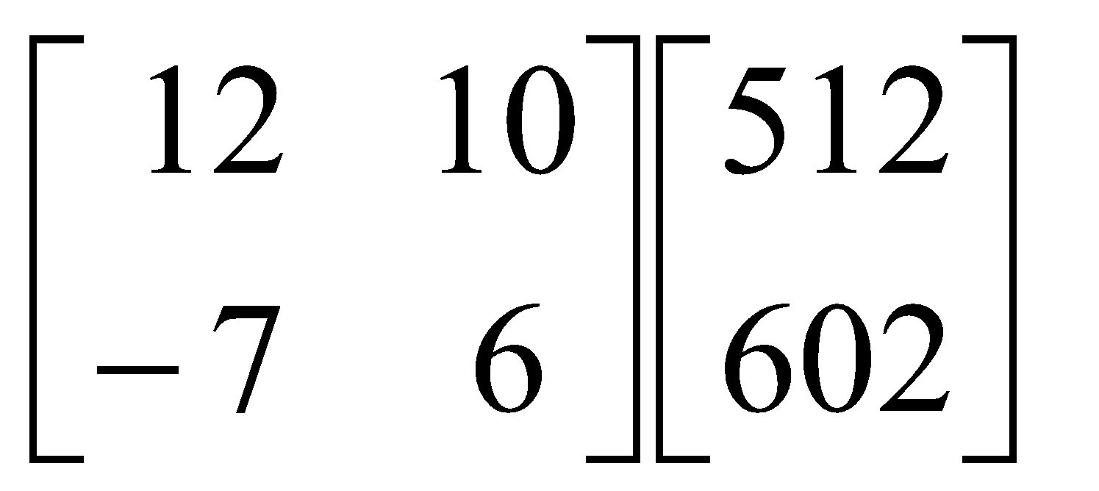
- 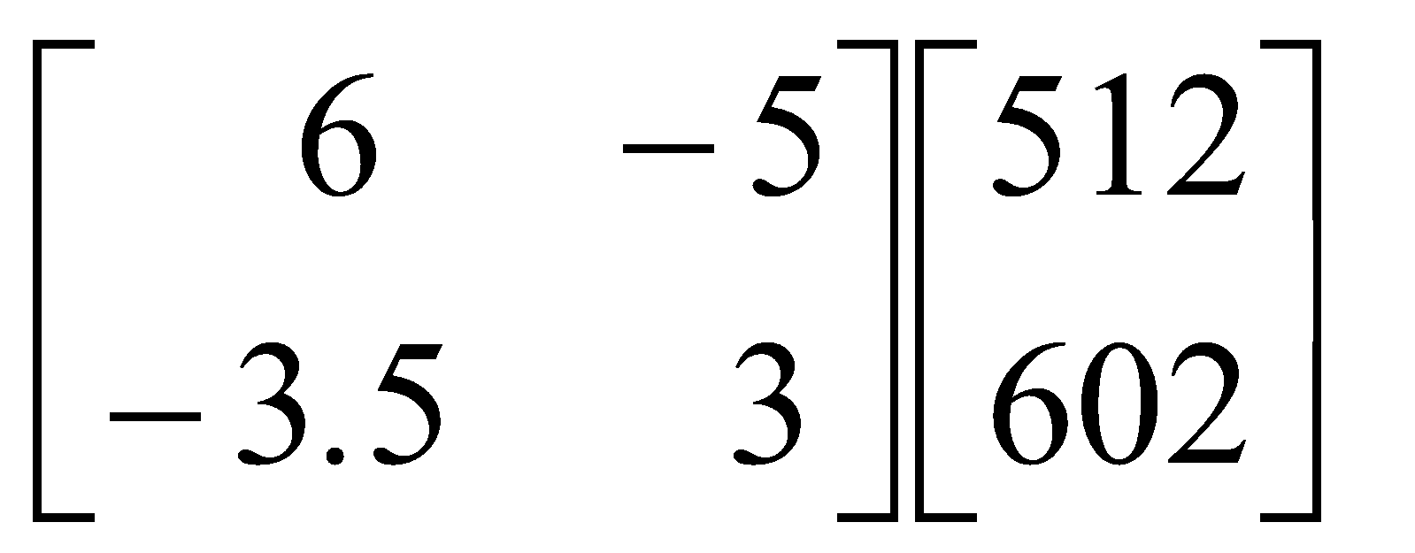
- 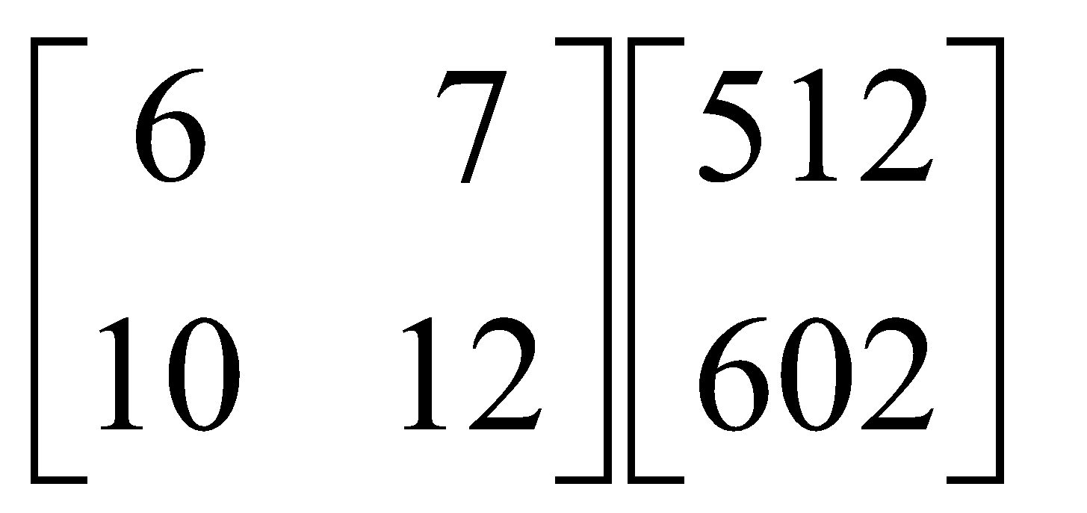
- 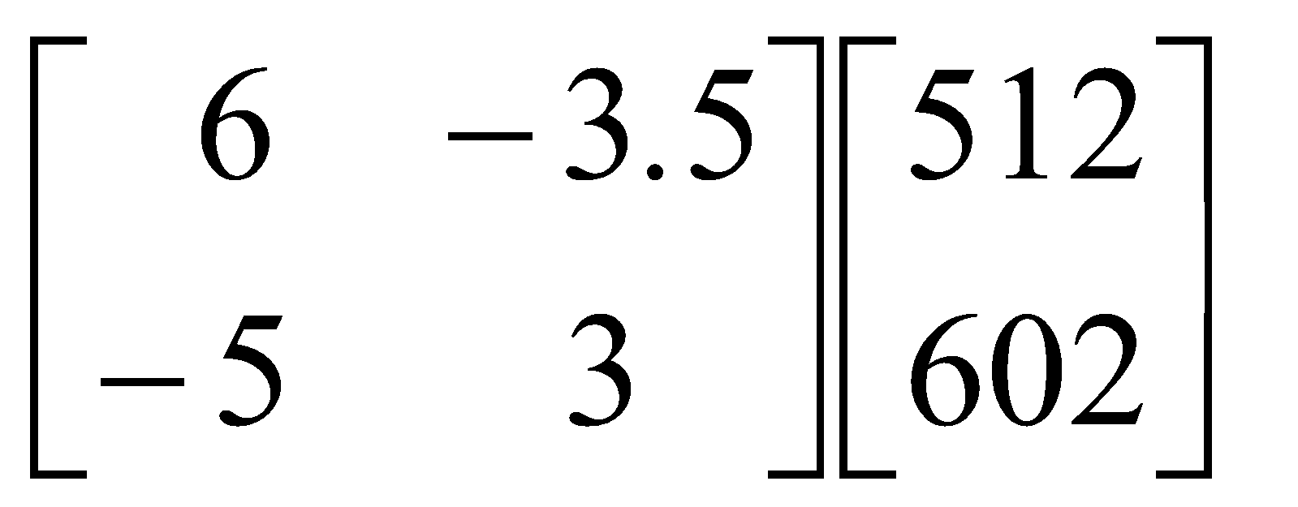

Question 8
Matrix X is multiplied by the inverse of matrix Y, that is, 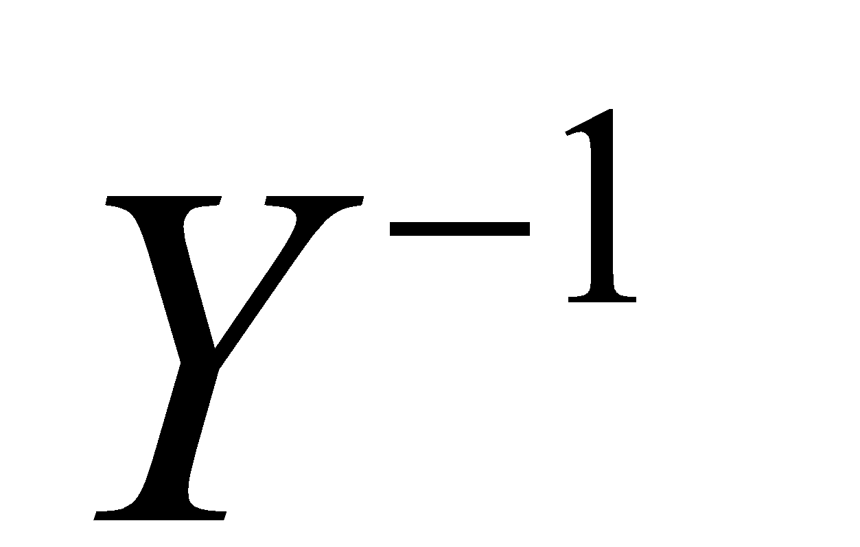.
The result is cI where c is a non-zero scalar and I is the identity matrix.
Matrix Y is equal to
- 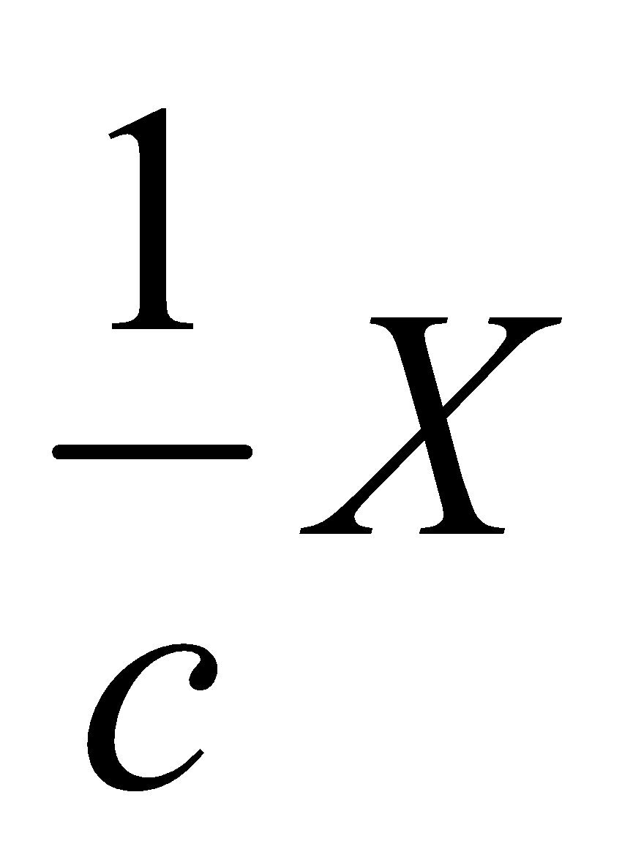
- 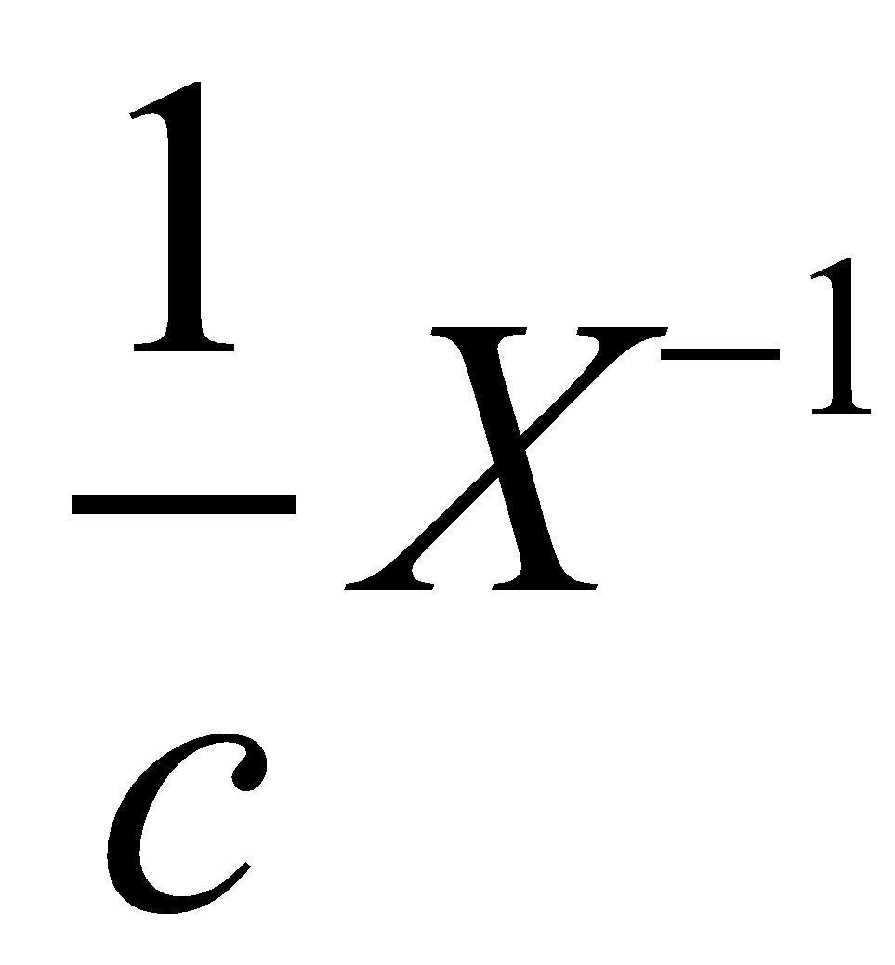
- 
- 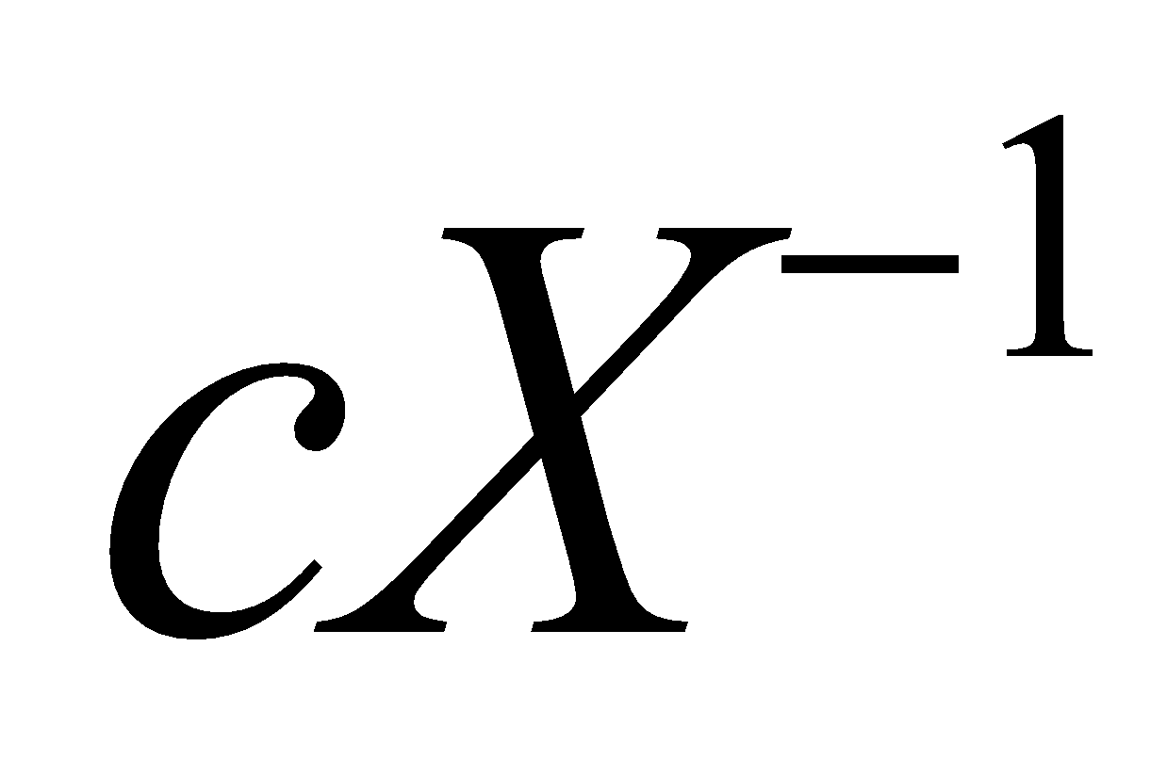
- 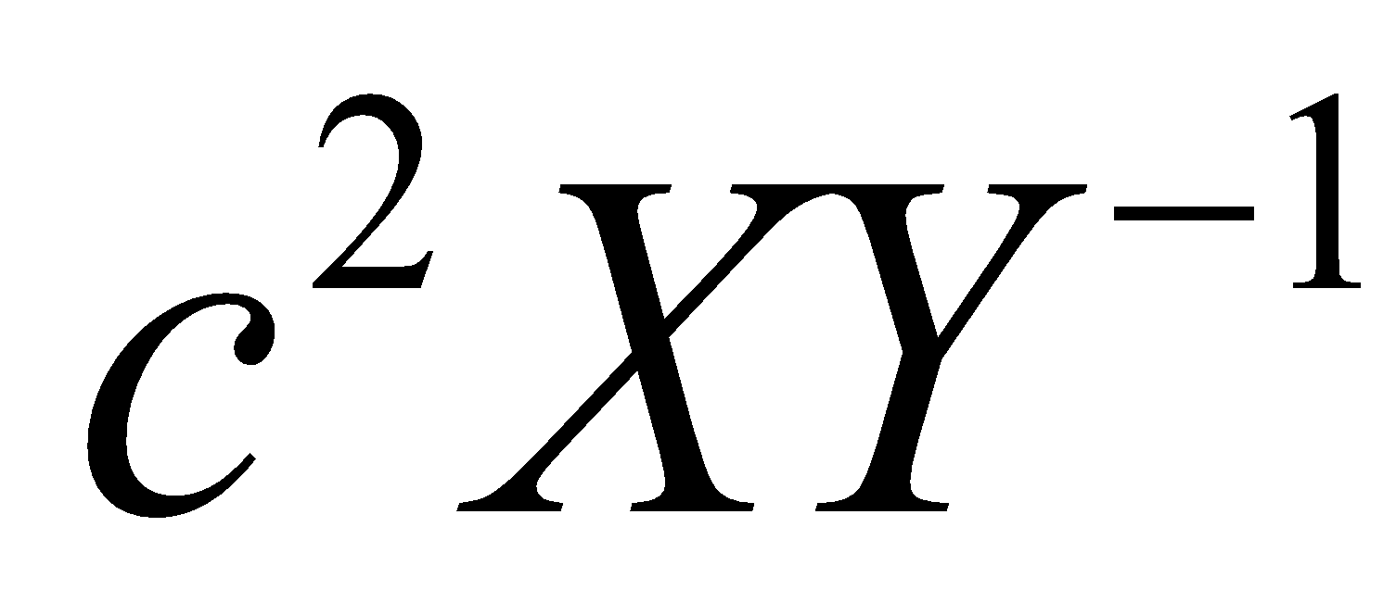
Module 2: Networks and decision mathematics

If you choose this module all questions must be answered.

Question 1

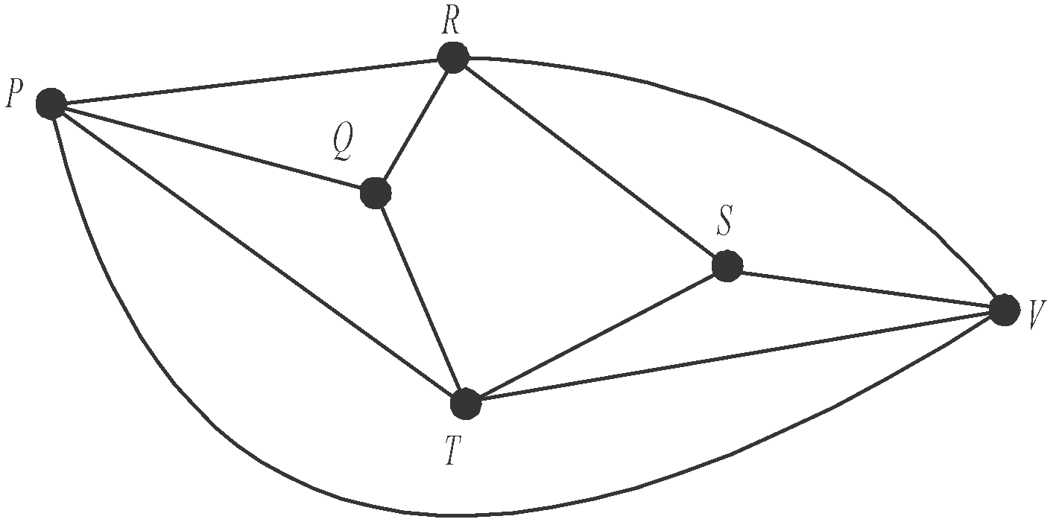
The graph below shows the laneways connecting six tourist sites P, Q, R, S, T and V in an old town.

A tourist completes an Eulerian trail.
The sites that could have been their starting or finishing vertices were

- P and V
- Q and S
- R and T
- S and P
- V and R

Question 2

A planar graph with four vertices, W, X, Y and Z, has an adjacency matrix shown below.

EMBED Equation.3

The number of faces (or regions) this planar graph has is

- 4
- 5
- 6
- 7
- 12
Question 3

The bipartite graph below shows the roles that each of four people are prepared to undertake on a committee.

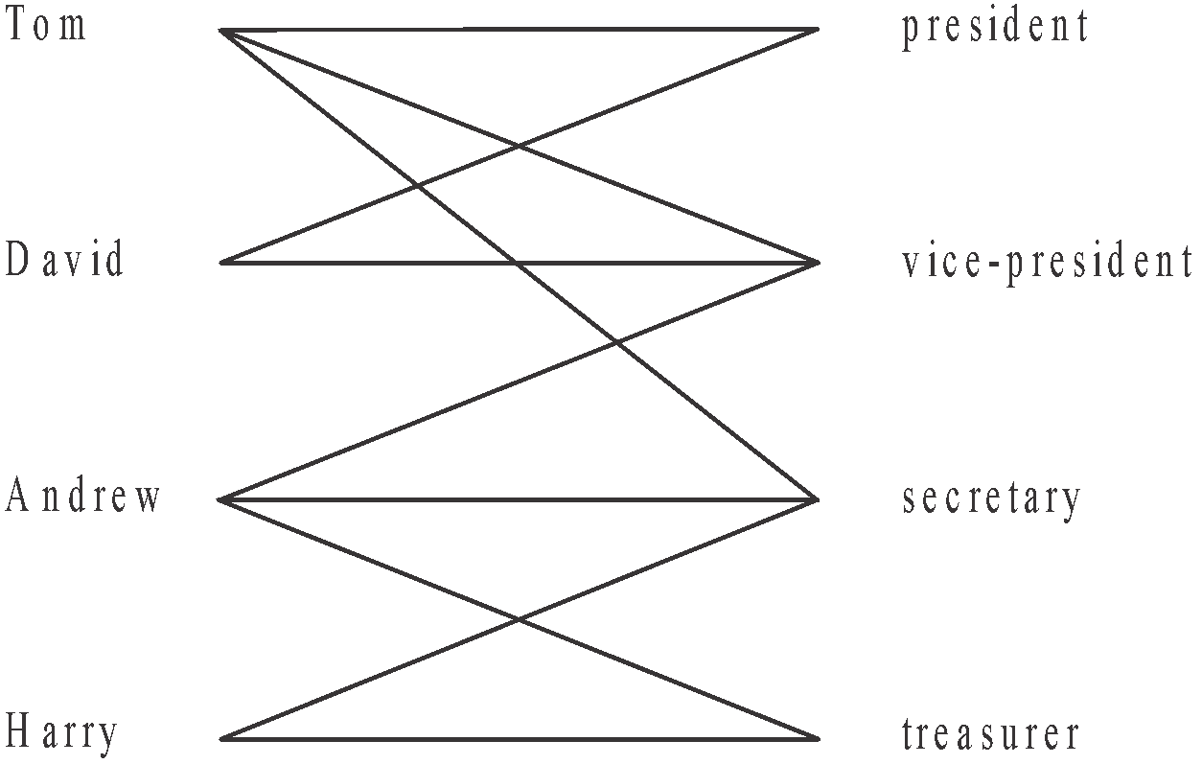

Each role must be filled and each person can only be allocated to one role.
A feasible allocation of roles is

President | David
Vice-president | Andrew
Secretary | Harry
Treasurer | Tom

President | Tom
Vice-president | Andrew
Secretary | Harry
Treasurer | David

President | David
Vice-president | Andrew
Secretary | Tom
Treasurer | Harry

President | Tom
Vice-president | Harry
Secretary | David
Treasurer | Andrew

President | Harry
Vice-president | Tom
Secretary | Andrew
Treasurer | David

Question 4

Four employees Bastian, Gayle, Robert and Dimitri are each to be allocated one task. There are four tasks that need to be allocated and the time, in hours, that each employee can complete each of the tasks is shown in the table below.

 | Bastian | Gayle | Robert | Dimitri
Task A | 3 | 4 | 2 | 3
Task B | 2 | 3 | 4 | 3
Task C | 6 | 5 | 7 | 8
Task D | 9 | 8 | 10 | 7

The minimum time, in hours, in which all four tasks can be completed is

- 10
- 12
- 14
- 15
- 16

Question 5

Water flows through a series of pipes from a pumping station to a catchment dam.

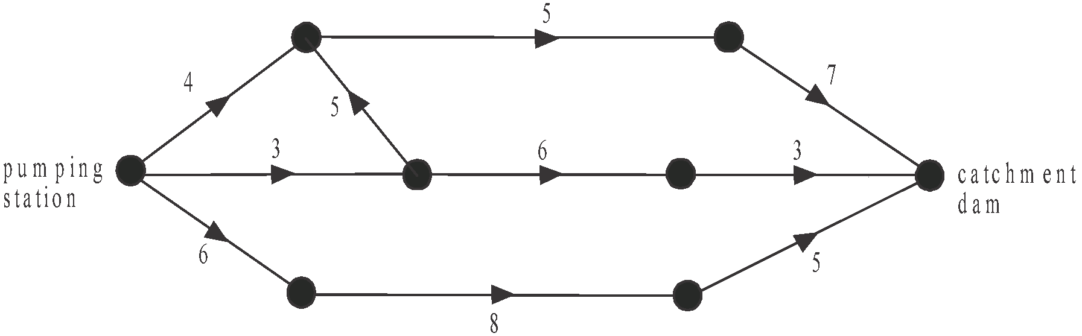

The arrows on the diagram indicate the direction of the flow.
The numbers on the edges indicate the number of megalitres of water that can flow per hour through each section of the pipes. The maximum flow of water, in megalitres per hour, between the pumping station and the catchment dam is

- 7
- 9
- 12
- 13
- 14
Question 6

Electrical wiring is to be laid that will connect nine offices. The cost, in dollars, of laying this wiring between various offices is shown on the network below.
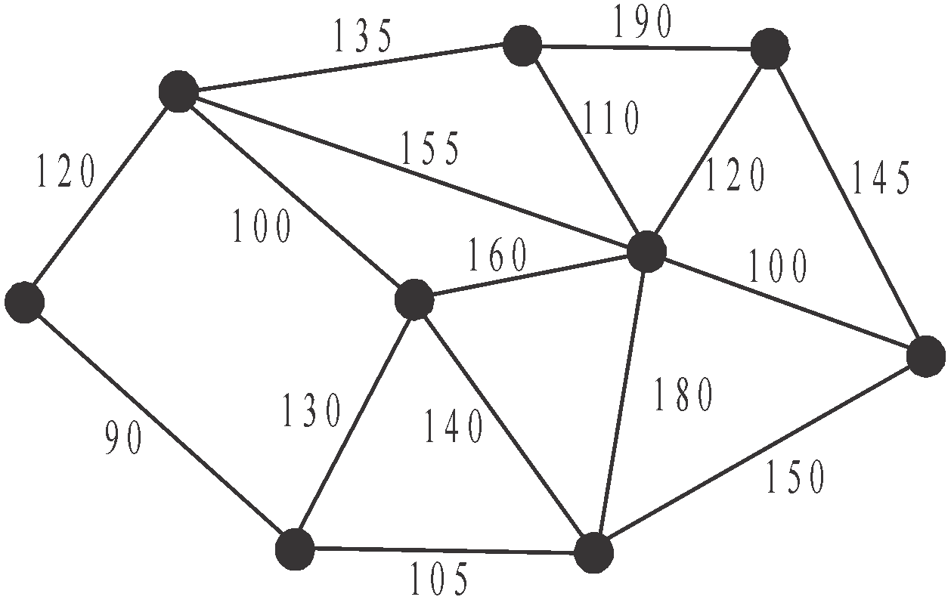

The minimum cost that will ensure that each office is connected is
- $880
- $890
- $910
- $930
- $970

Use the following information to answer Questions 7 and 8.

A project involves the completion, in the shortest possible time, of seven activities A, B, C, D, E, F and G. The edges of the directed graph below represent these activities.
Their completion times, in days, are also shown.
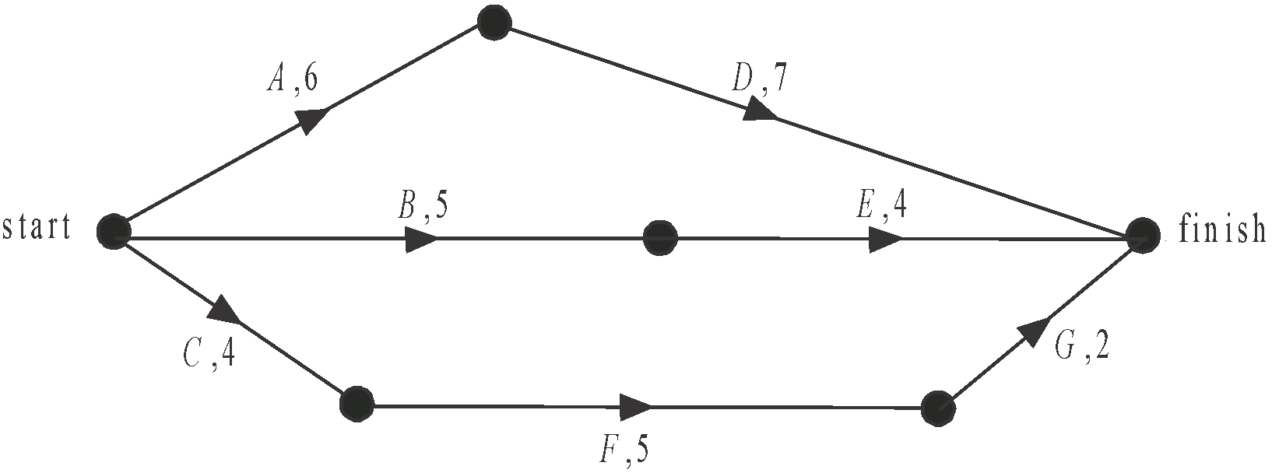

Question 7

The activities which have the greatest float time are
- A and D
- B and E
- C and F
- A, D and F
- C, F and G

Question 8

Activity A can have its completion time reduced by a maximum of 3 days at a cost of $250 per day. Activities B and C can have each of their completion times reduced by a maximum of 1 day at a cost of $150 per day. In order to achieve the largest reduction in the time taken to complete the project, the least cost will be
- $400
- $450
- $750
- $900
- $1050
Module 3: Geometry and measurement

If you choose this module all questions must be answered.

Question 1

A solid chocolate treat is in the shape of a hemisphere on top of a regular cone as shown below.
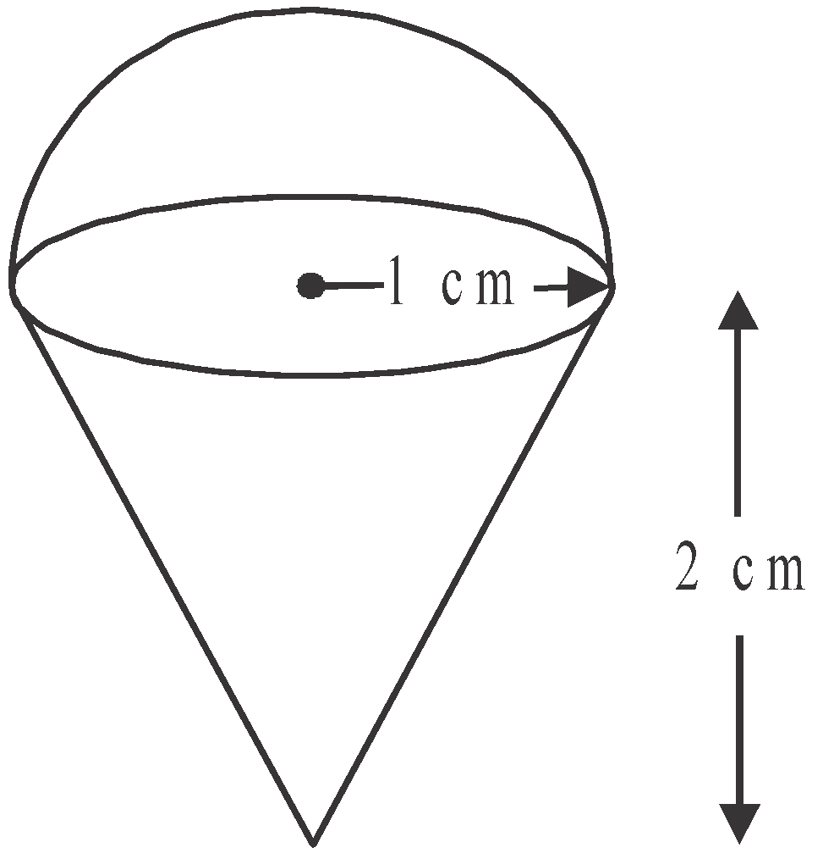

The hemisphere and cone each have a radius of 1 cm and the cone has a height of 2 cm.
The volume of chocolate, in cubic centimetres, in the treat is closest to

- 2.1
- 4.2
- 5.2
- 6.3
- 8.4

Question 2

A welcome mat is in the shape of a segment of a circle, with centre C, as shown below.

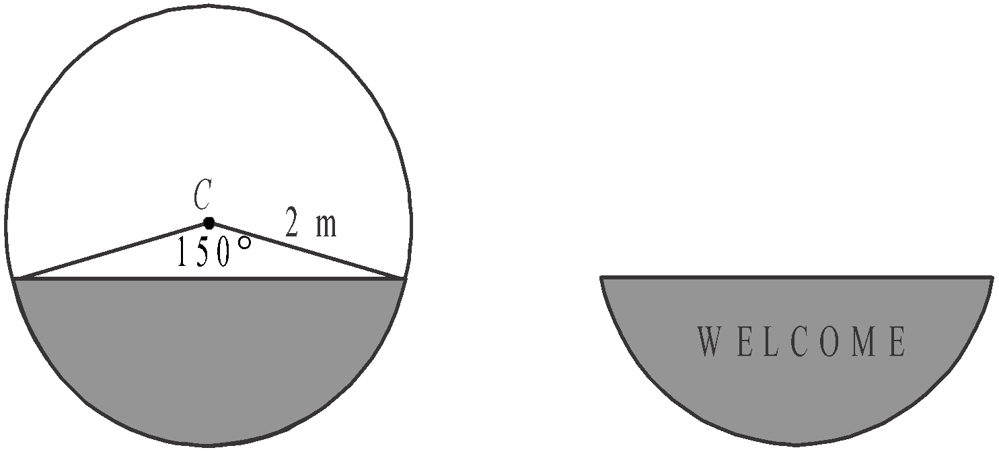

The area of the mat, in square metres, is closest to

- 1
- 1.2
- 4
- 4.2
- 5.2

Question 3

Triangle ABC is shown below where angle ABC equals 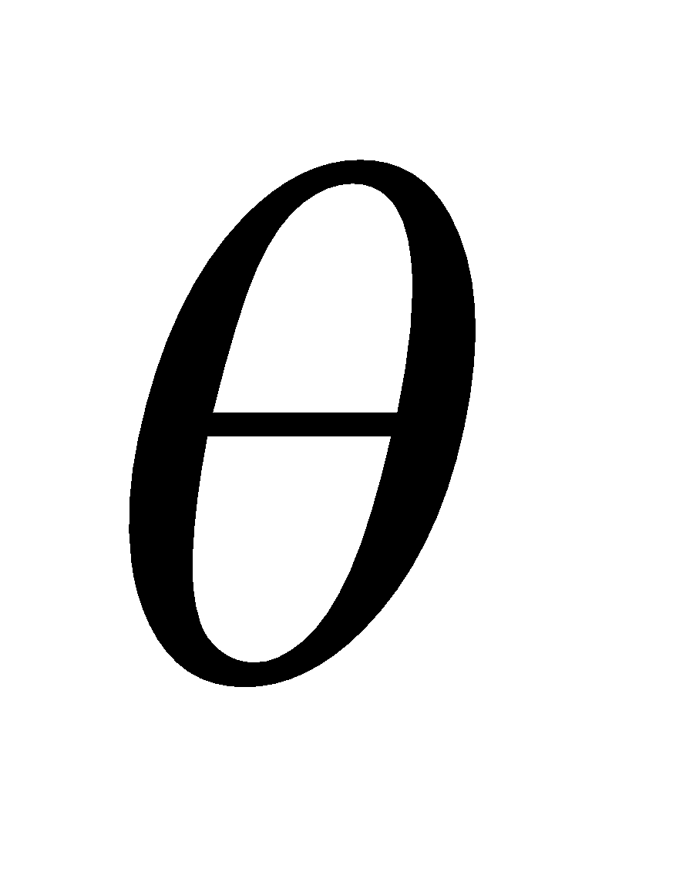.
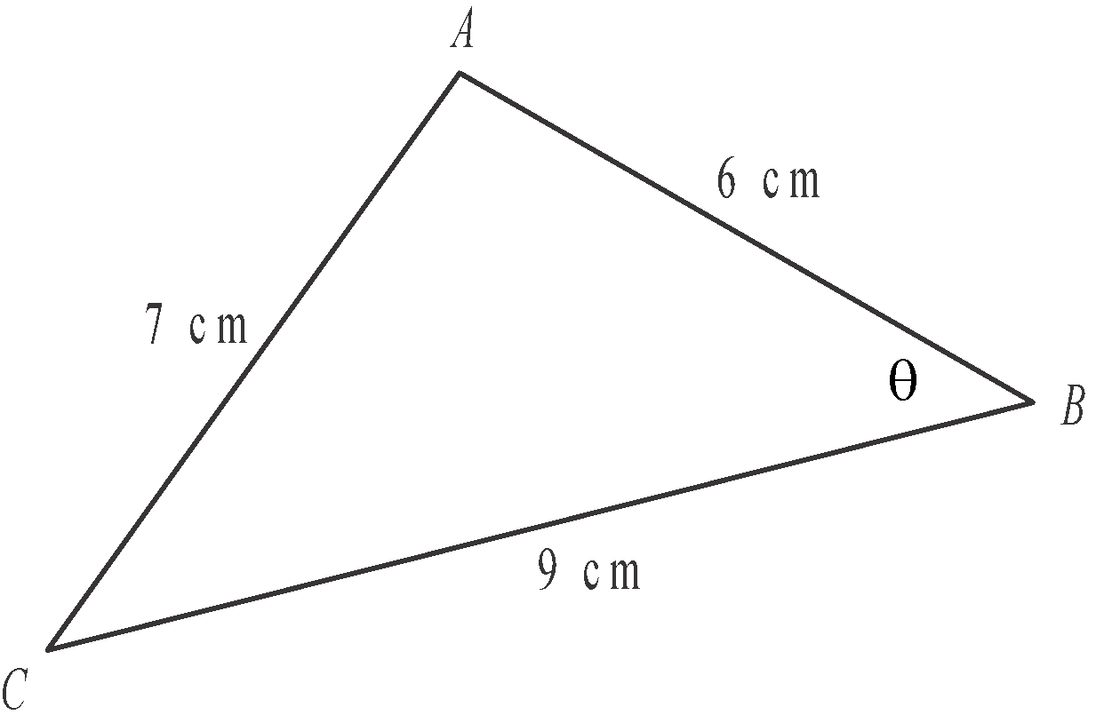

The equation that can be used to find the value of  is

- 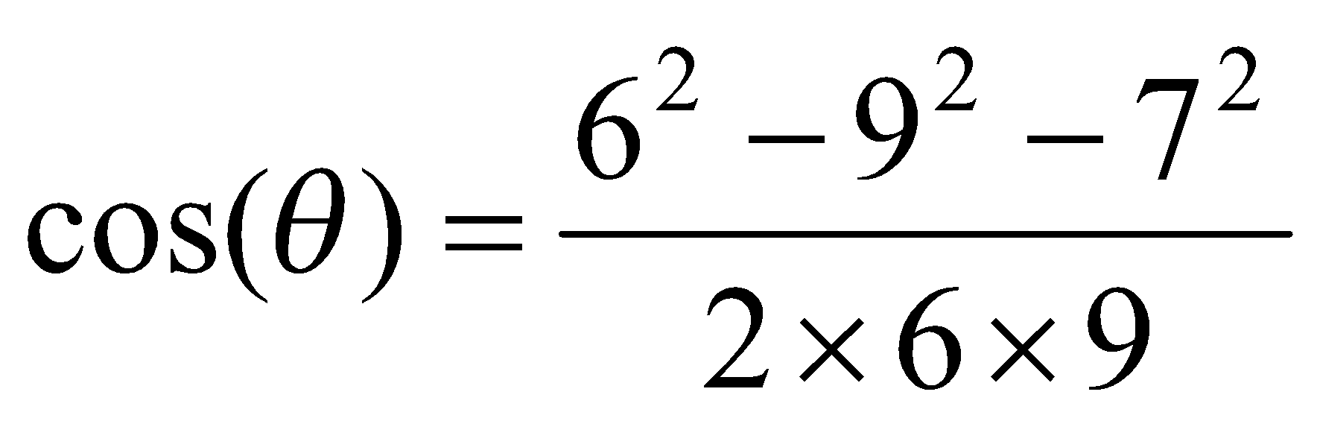
- 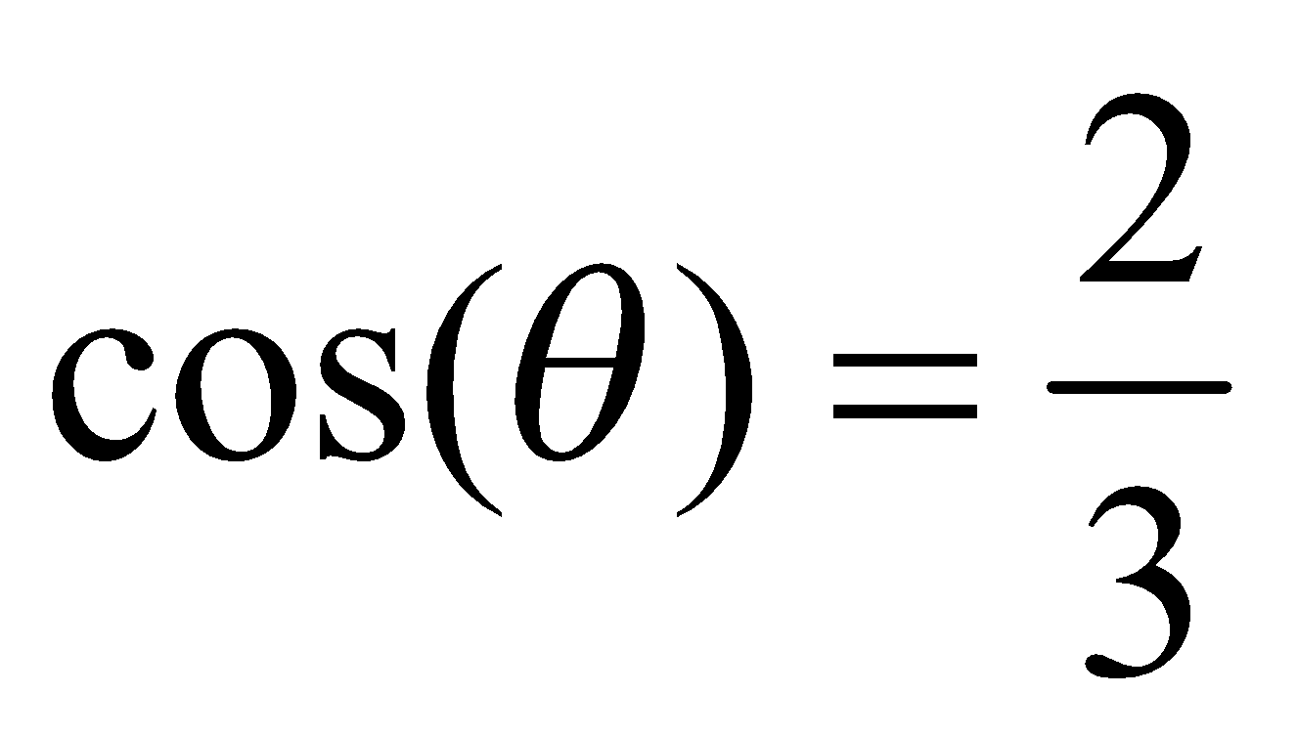
- 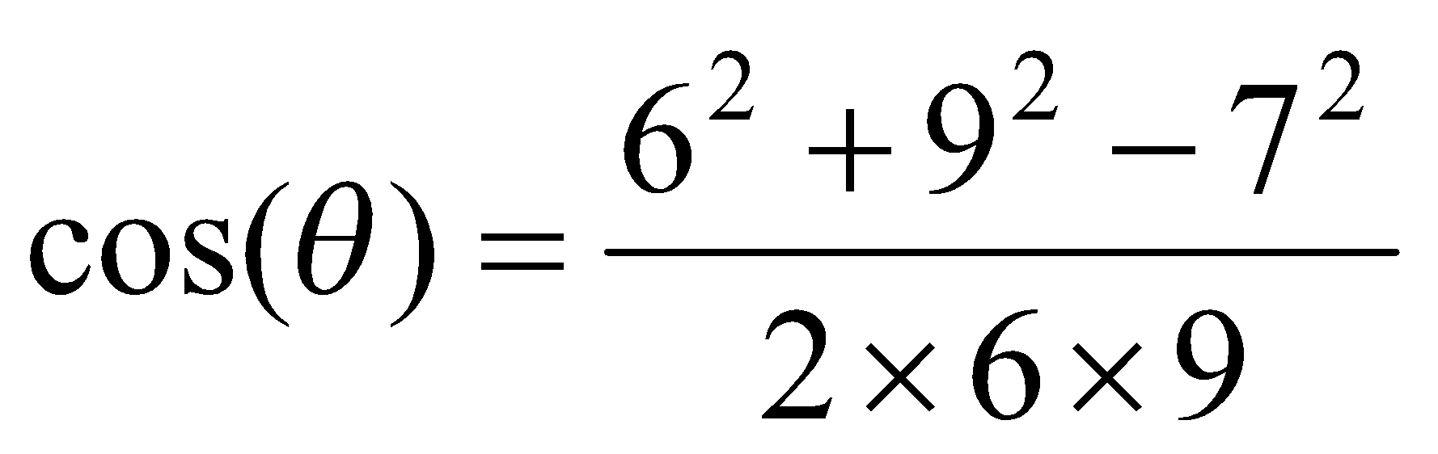
- 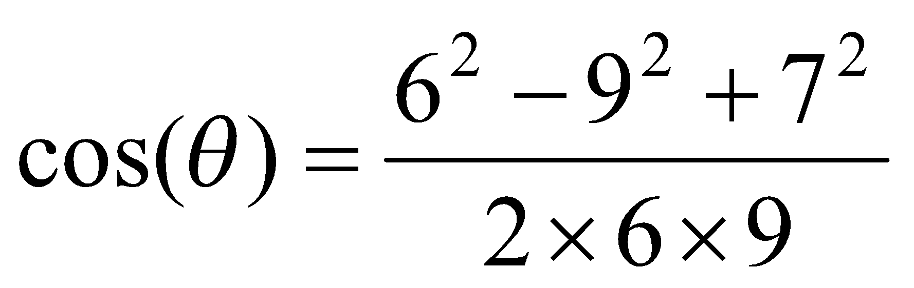
- 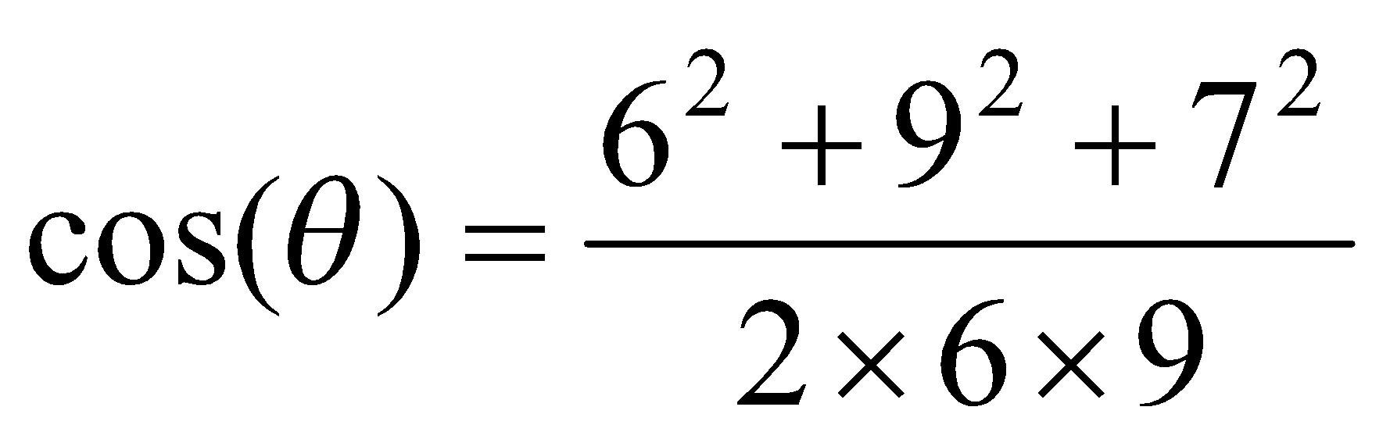

Question 4

Julie and Peter fly out of Melbourne at 11.30am on Tuesday. They arrive in Paris, which is nine hours behind Melbourne, at 6am on Wednesday (Paris time).
Their travel time, including stopovers, from Melbourne to Paris was

- 9.5 hours
- 18.5 hours
- 27.5 hours
- 28.5 hours
- 31.5 hours

Question 5

Joan is on a bearing of 070° from Paul and 60m from him. George is some distance due south of Paul.
The bearing of Joan from George must be

- less than 070°
- 070° exactly
- between 070° and 090°
- 110° exactly
- greater than 110°
Question 6

Two similar cones of radius 4 cm and r cm are shown below.

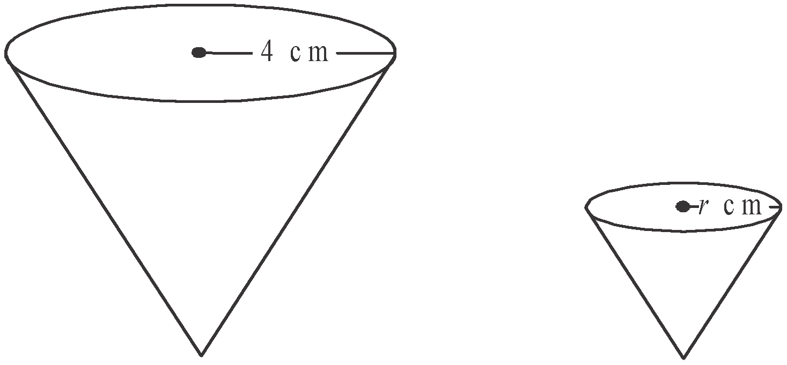

The volume of the larger cone is three times the volume of the smaller cone.
The value of r is closest to

- 0.8
- 1.9
- 2.1
- 2.5
- 2.8

Question 7

A regular rectangular pyramid, MNOPV, has a base with centre at C.
Also as shown below.
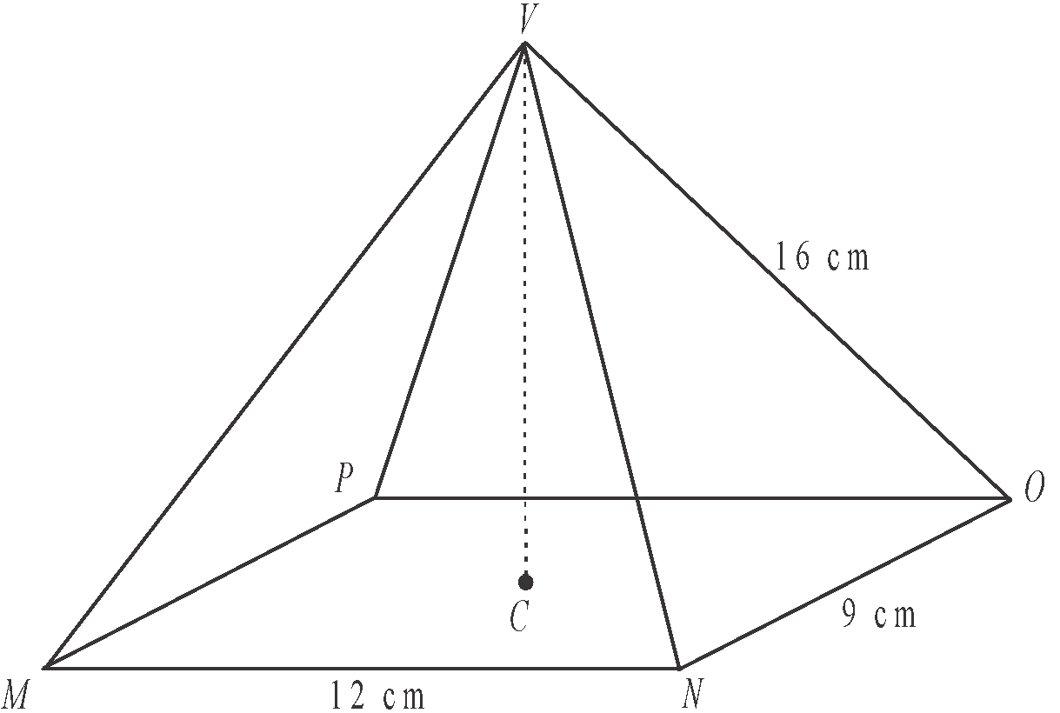

The height CV of the pyramid, in centimetres, is closest to

- 7.9
- 14.1
- 14.8
- 15.0
- 17.7

Question 8

The sphere below represents earth and has a radius of 6 400 km and its centre is at point C. The parallels of latitude of 0° (equator) and 42°S are also shown.
The vertical dotted line runs from the north pole to the south pole through point C.

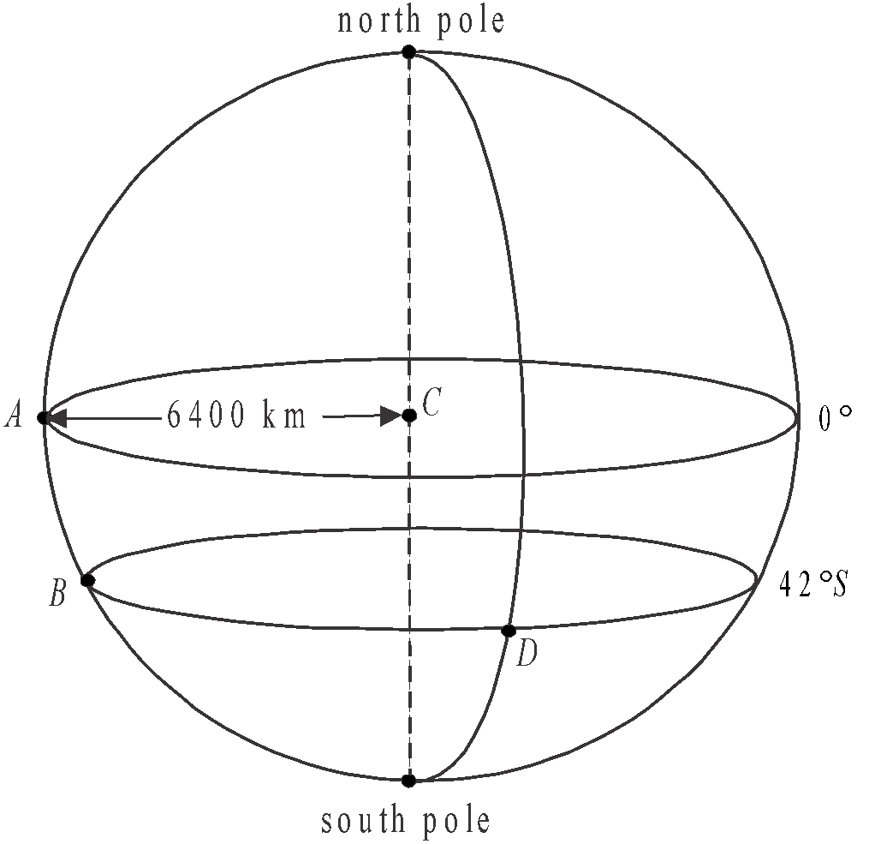

Point A lies on the equator and points B and D each have a latitude of 42°S.
Points A and B lie on the same meridian of longitude.
Point D lies on a meridian of longitude that is a further 160° east.
The distance, in kilometres, along the parallel of latitude between points B and D is closest to

- 3 486
- 4 691
- 4 756
- 13 282
- 17 872

Module 4: Graphs and relations

If you choose this module all questions must be answered.

Question 1

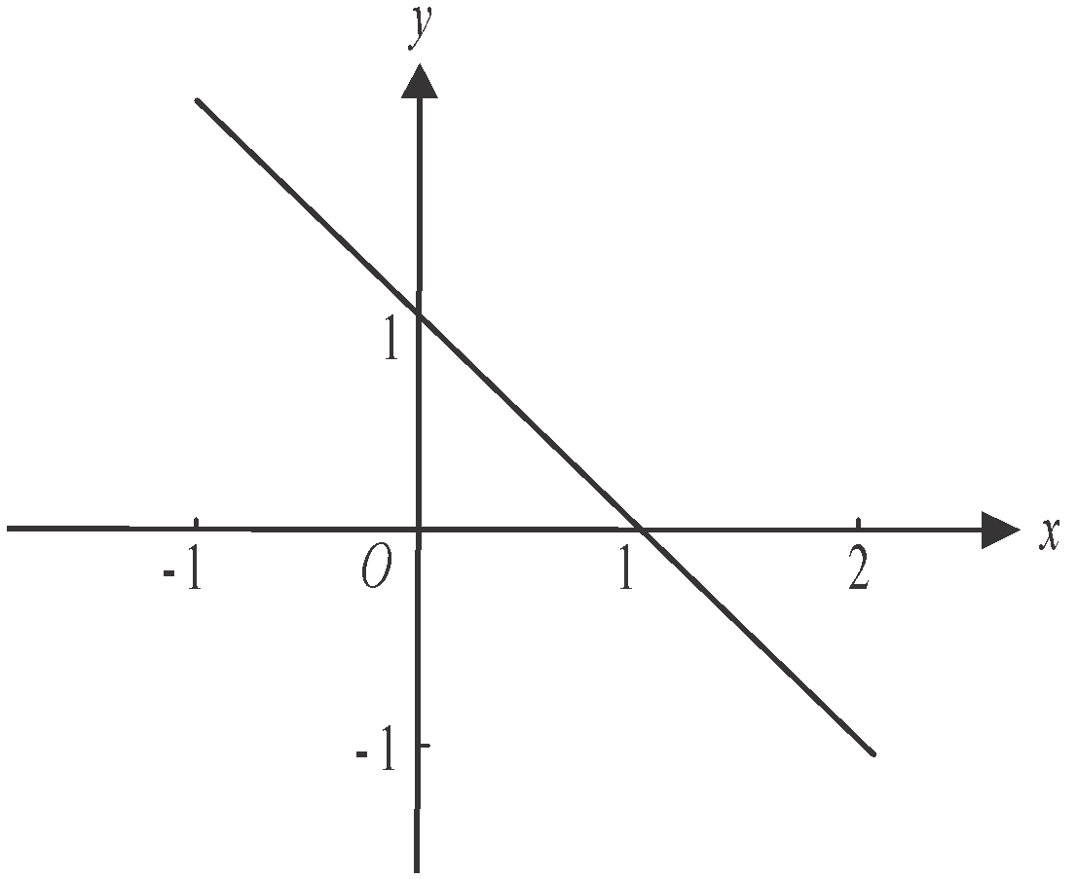

The equation of the line shown on the graph above is

- 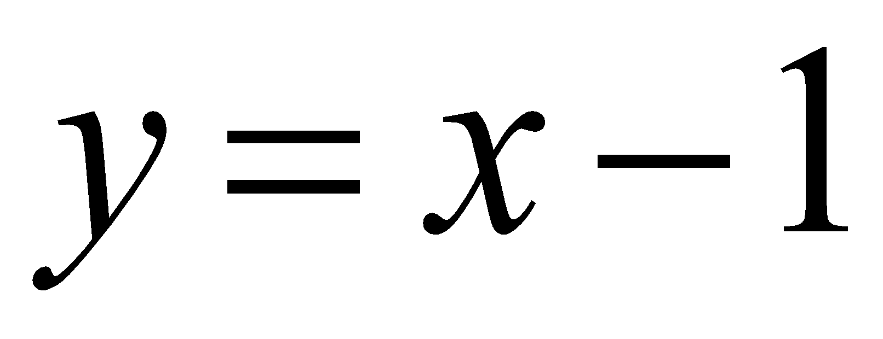
- 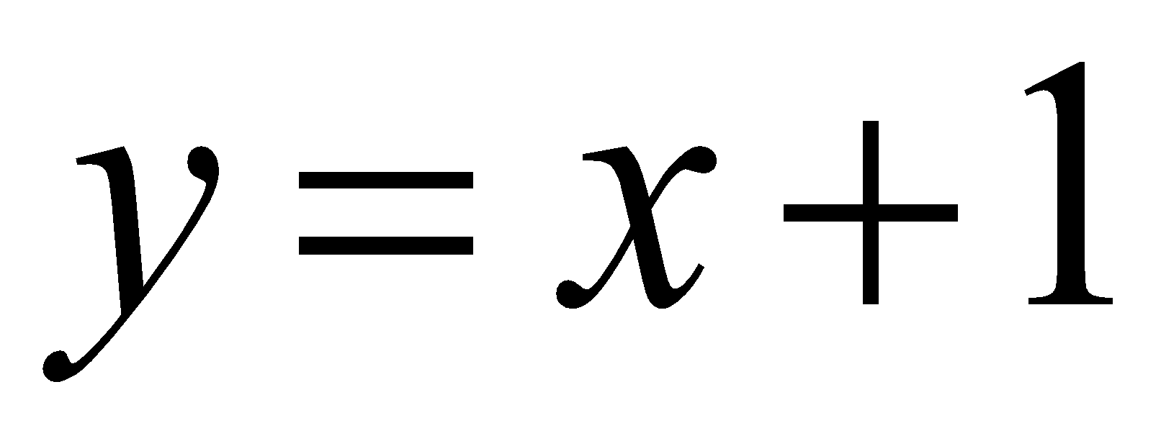
- 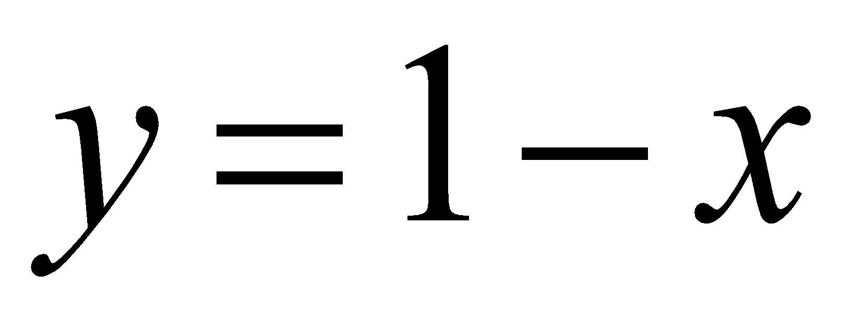
- 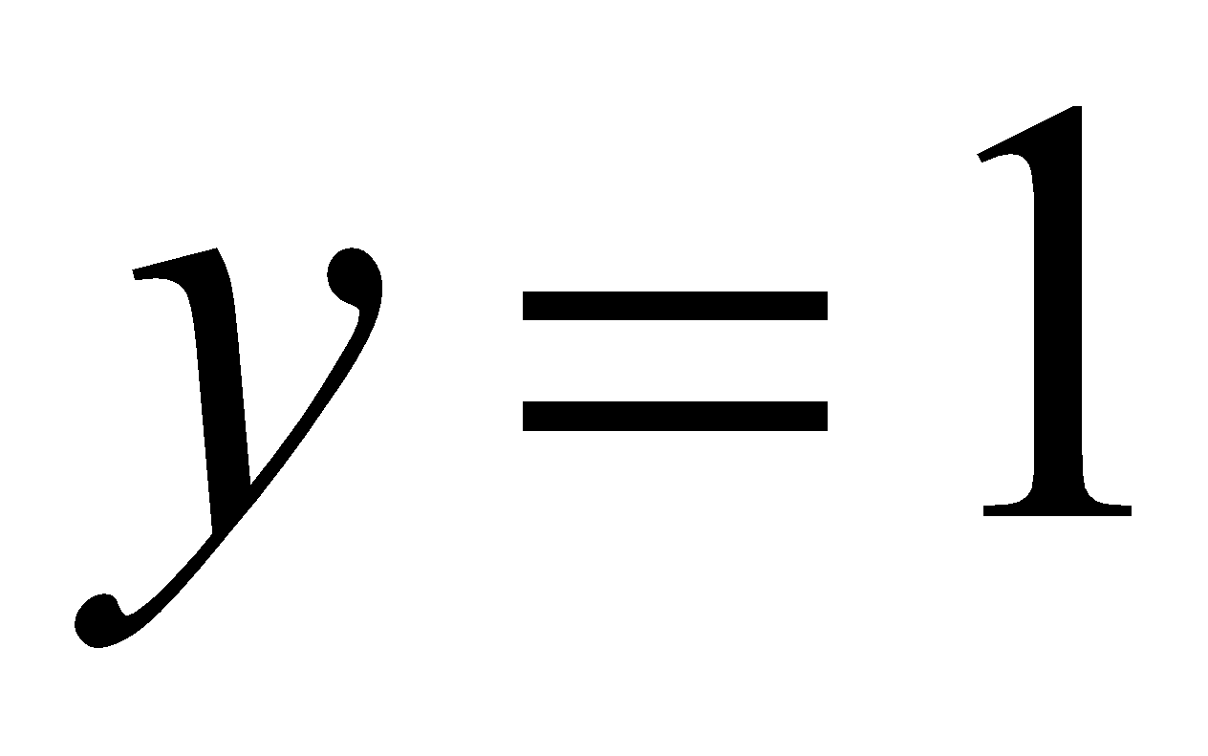
- 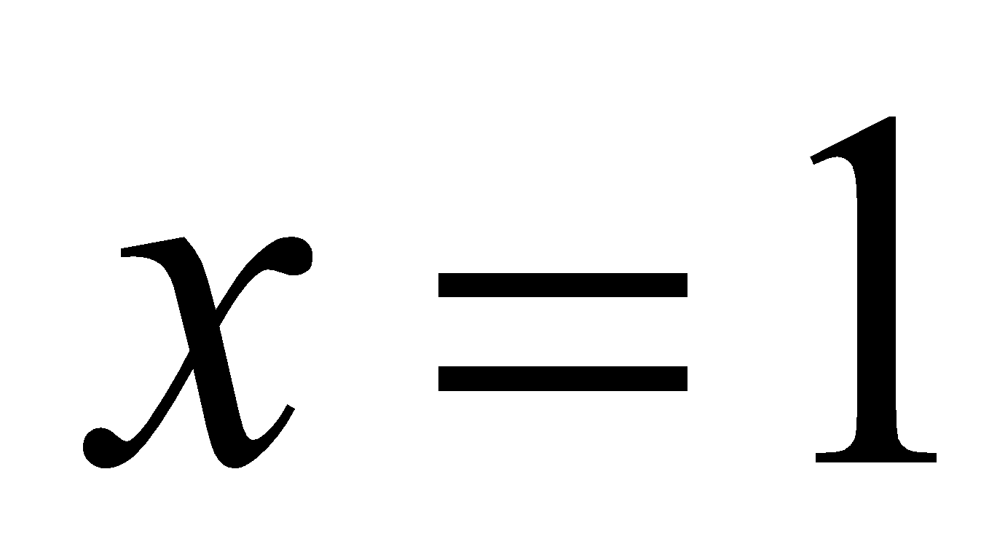

Question 2

The inequality that is satisfied by the point 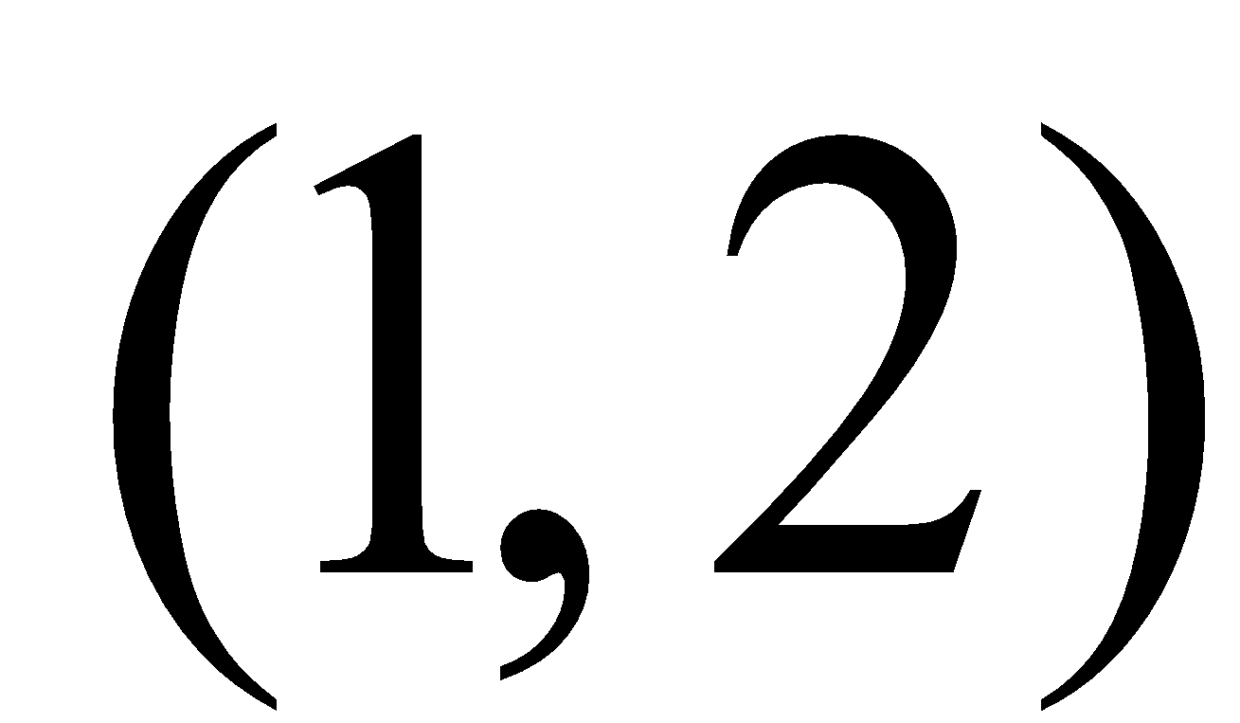 is

- 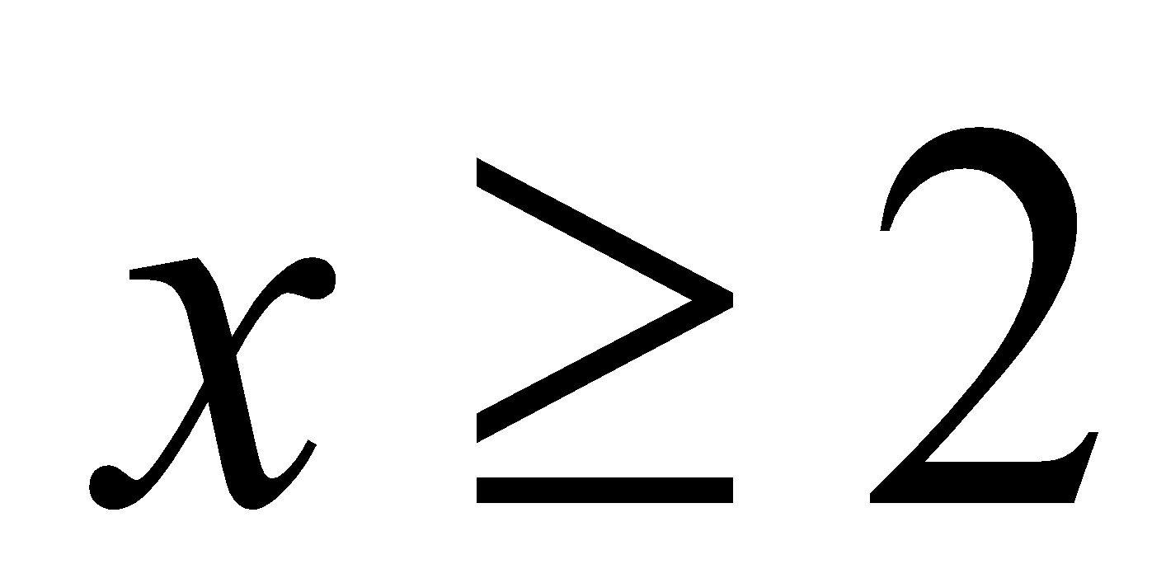
- 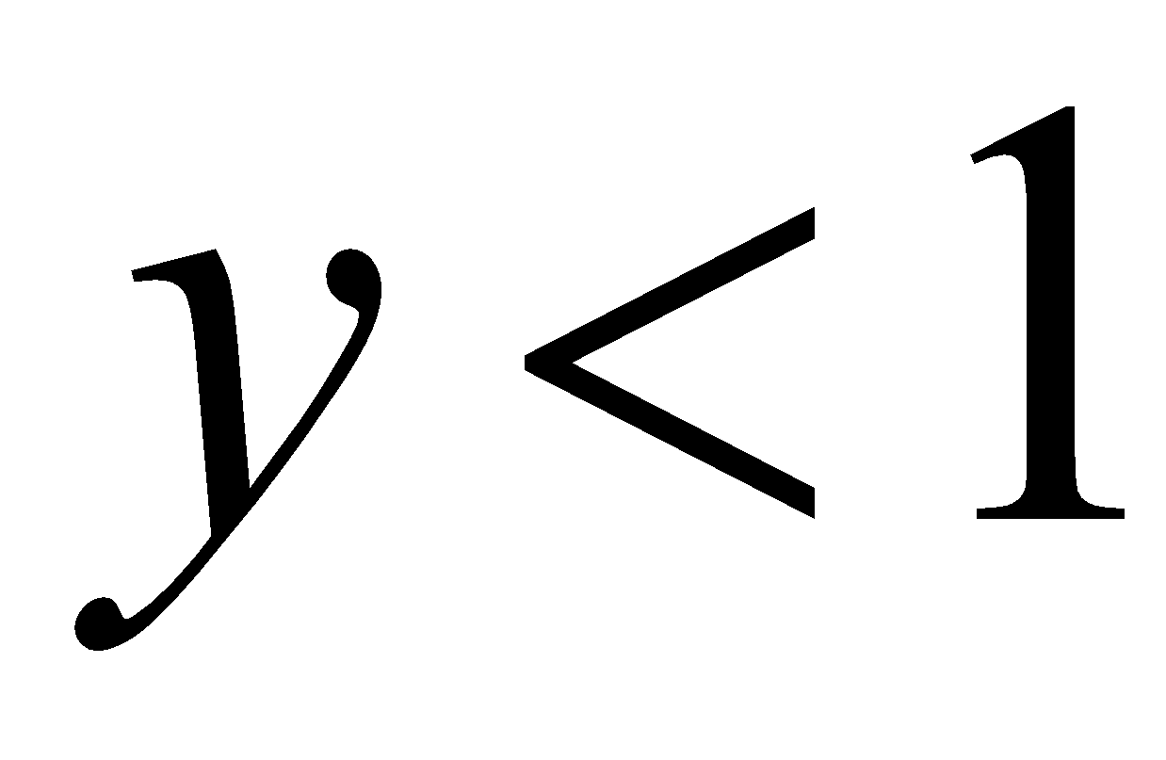
- 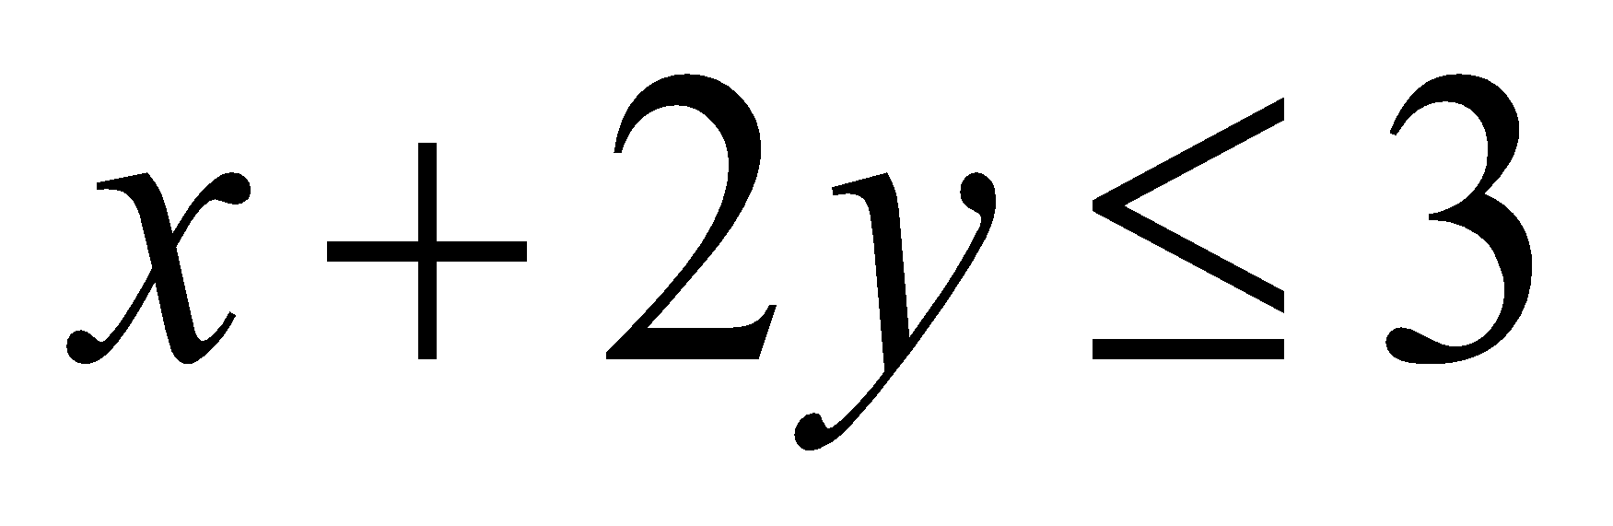
- 
- 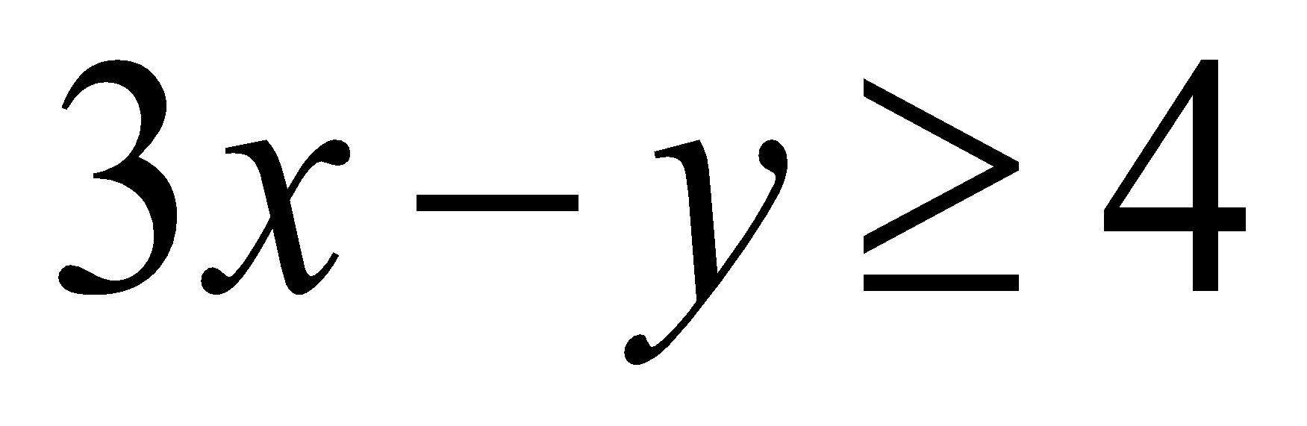

Question 3
The graph of 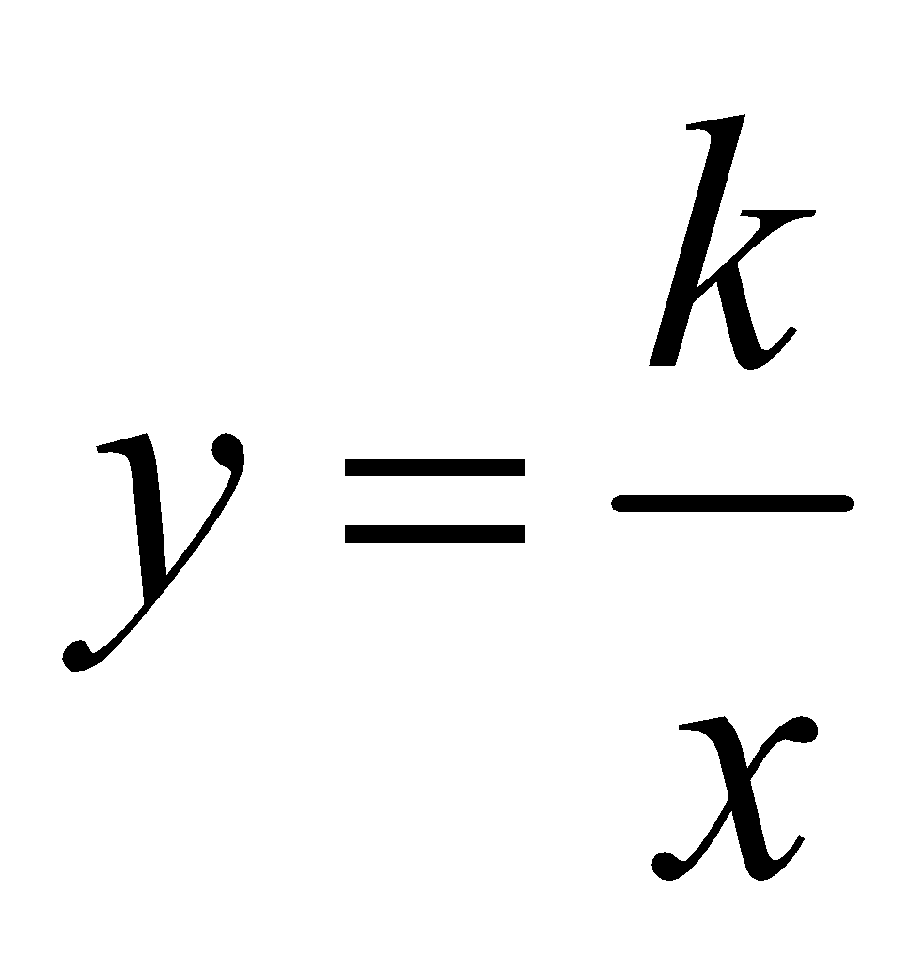 is shown below.
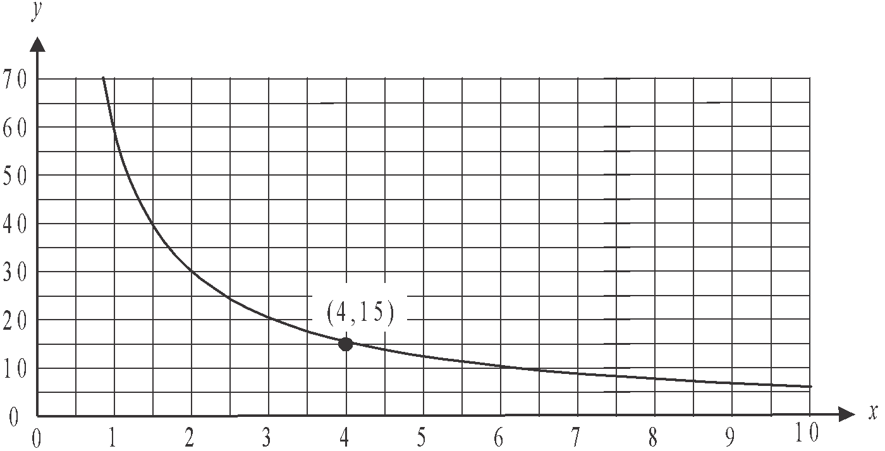

The point 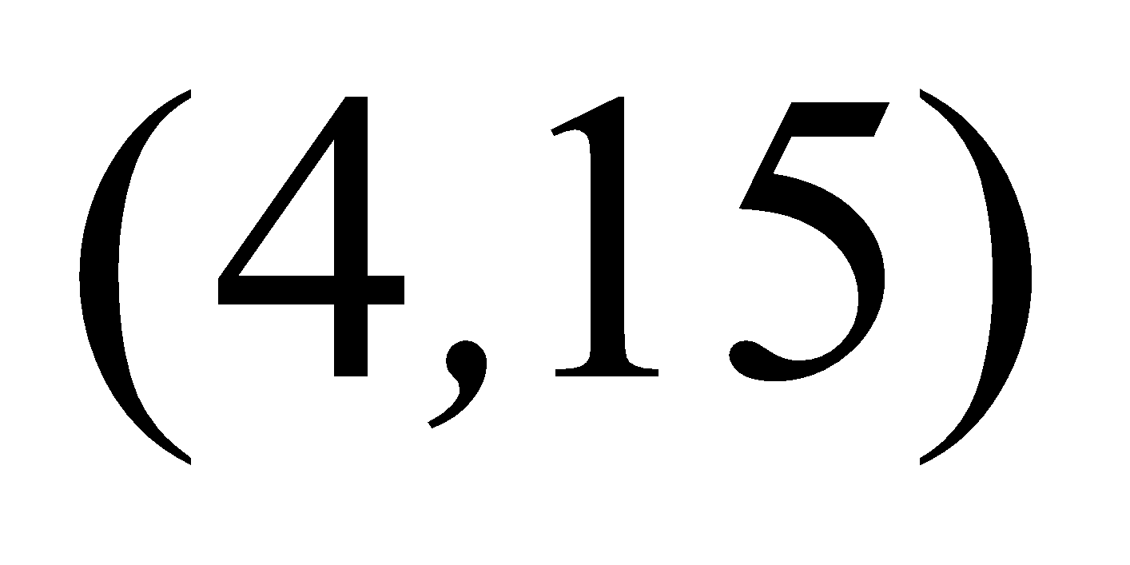 lies on the graph. The value of k is
- 
- 4
- 15
- 30
- 60

Question 4

The graph below has a shaded area which represents the feasible region for a linear programming problem.
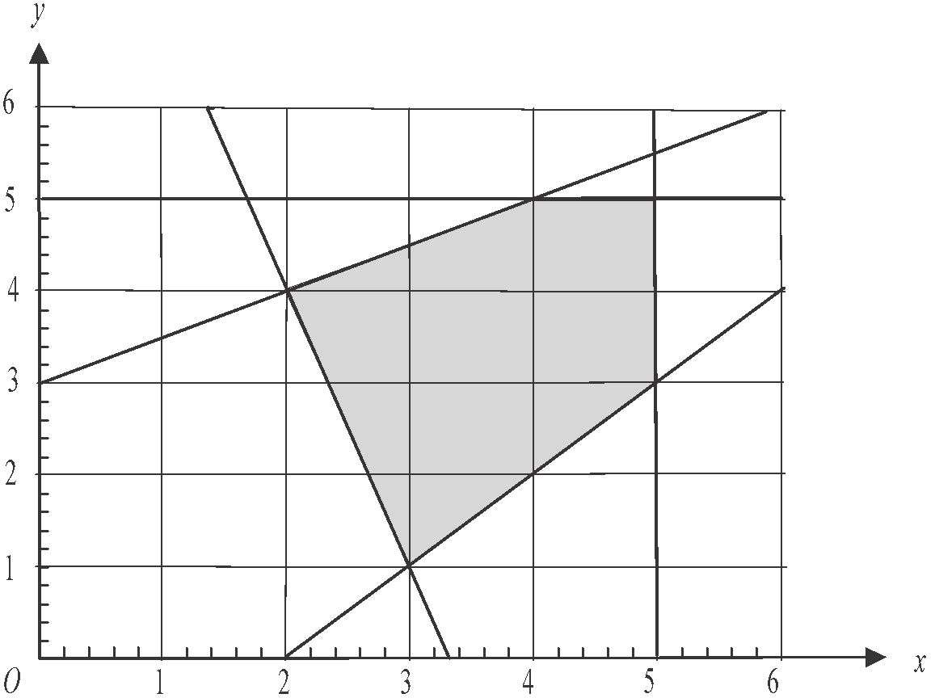

The minimum value of the objective function 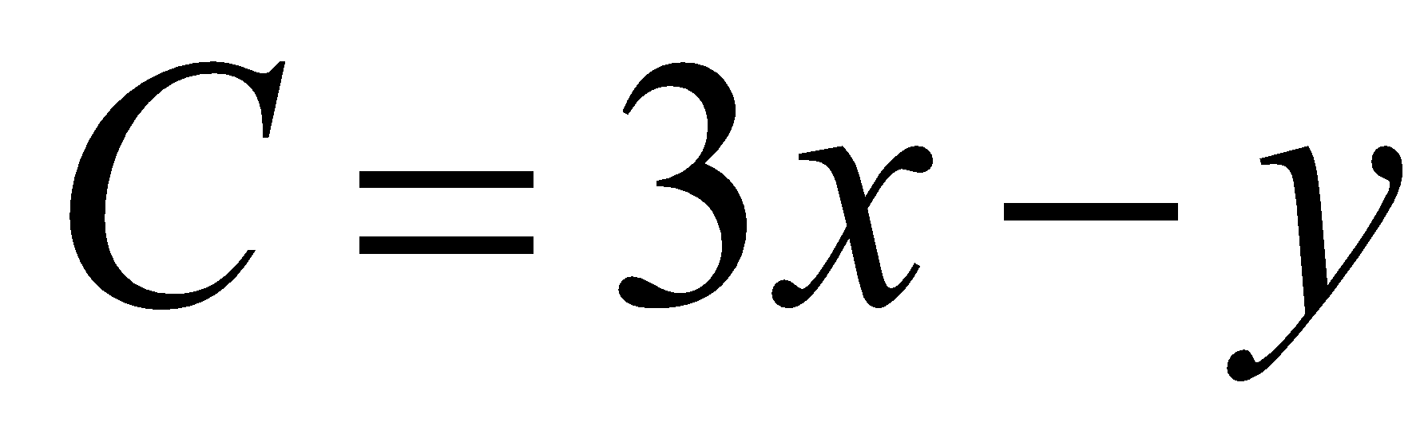 for this problem is
- 2
- 5
- 7
- 8
- 12

Question 5

Georgie has hired a venue for an event. She commits to a minimum number of 20 people attending for which the venue will charge $1500.
For every extra person who attends, up to a maximum of 40 people, an additional $100 will be added to the charge.
The graph below shows the charge C, in dollars, for holding the event for n people.

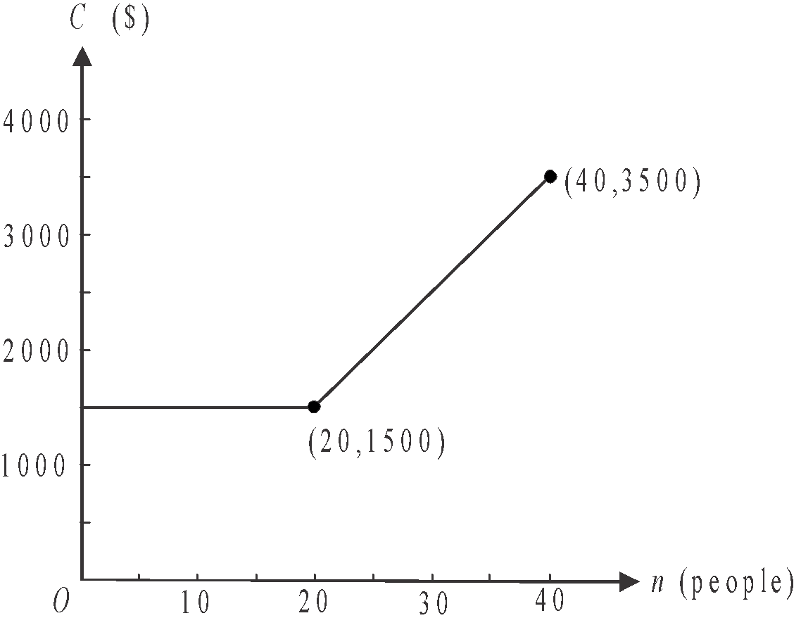

The rule that could be used to describe the graph above is

- 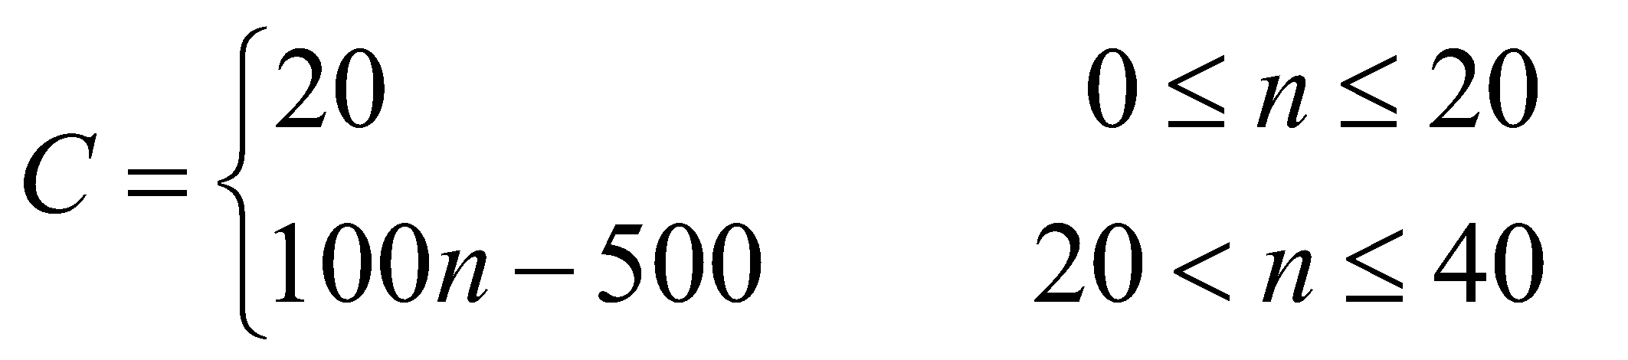
- 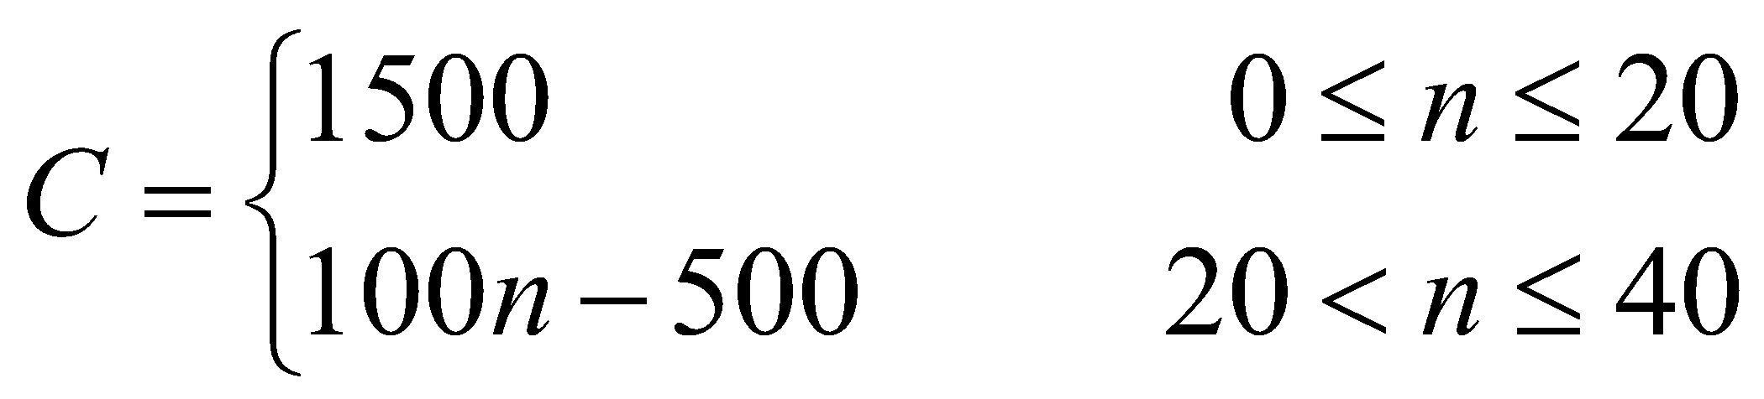
- 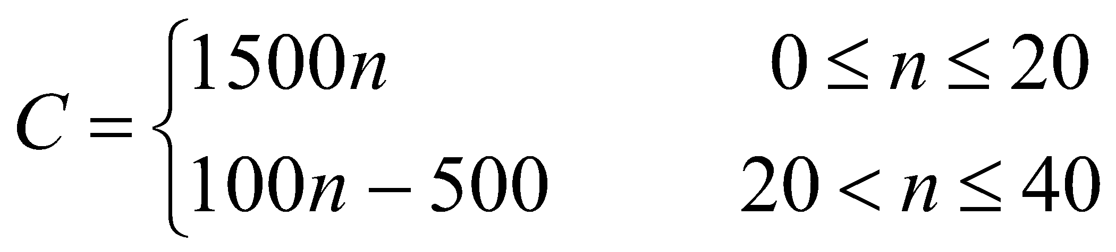
- 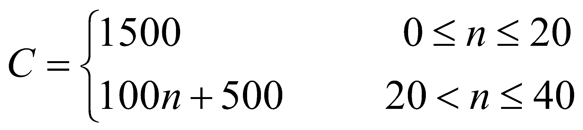
- 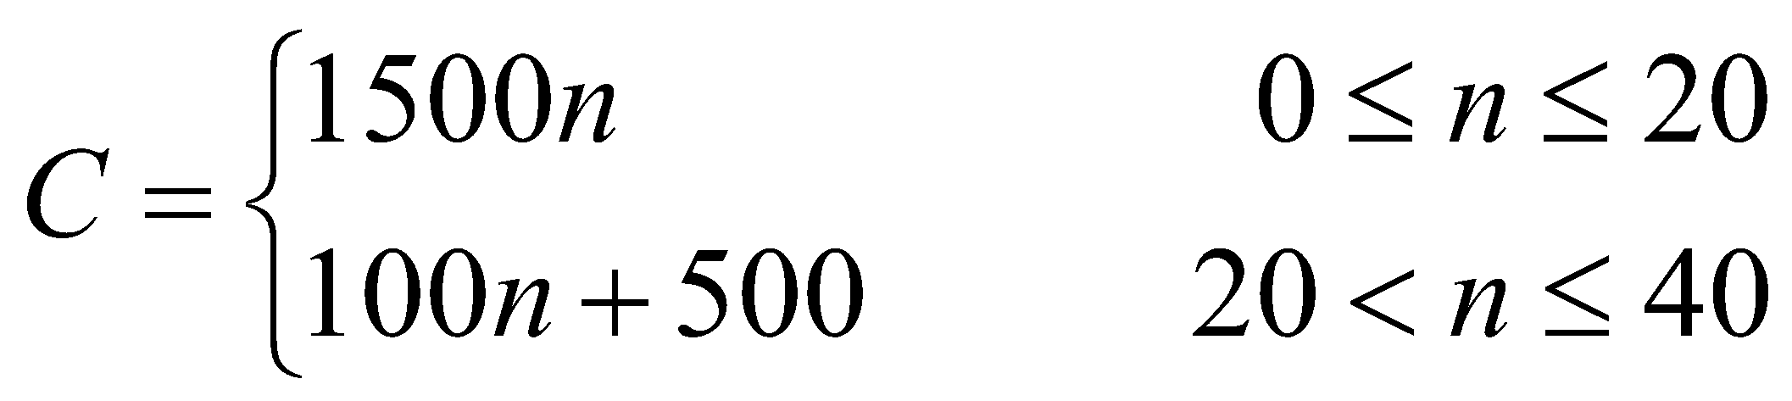

Question 6

The price, in dollars, of a stock listed on the Australian Stock Exchange over a ten day period is shown on the graph below.
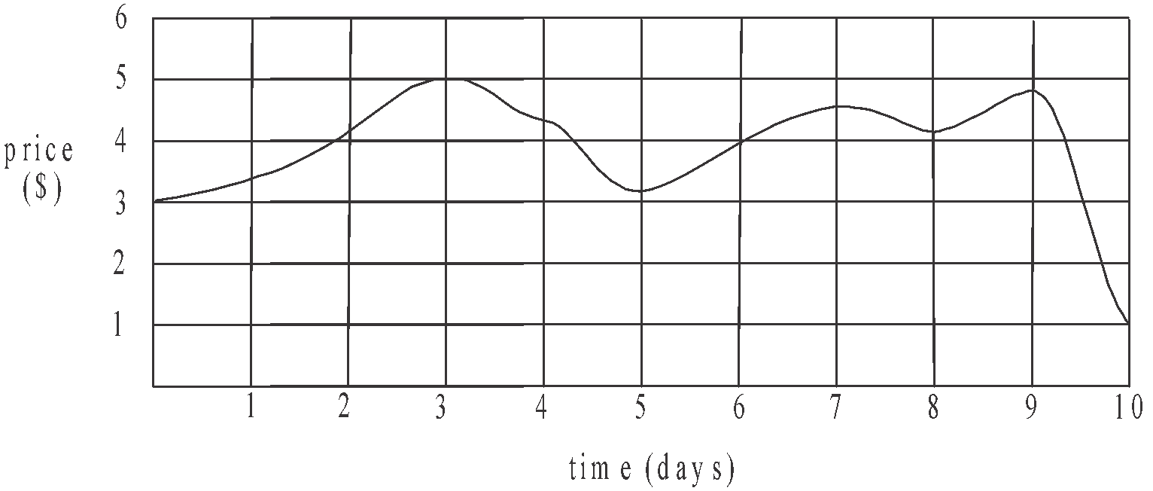

Which one of the following statements is true?

- The opening price of the stock was $4.
- The price of the stock reached its maximum on day 5.
- The price of the stock increased for exactly five out of the ten days.
- The price of the stock increased the most during day 9.
- The price of the stock on average, changed by $0.20 each day over the ten days.

Question 7

Peter tutors each of his students for one hour a week and charges them $65 each.
He has costs of $400 per week for rent plus $5 for each student he tutors in a week.
Last week Peter made a profit of $1220.
The number of students Peter tutored last week was

- 12
- 19
- 23
- 27
- 31

Question 8

A manufacturing company uses two machines A and B.
Machine B can operate for no more than three times as long as machine A.
The two machines can operate for up to 80 hours in total each week.
Machine A must operate for a minimum of 10 hours each week.
Machine B can only operate for a maximum of 50 hours each week.

Let x represent the number of hours that machine A operates for each week.
Let y represent the number of hours that machine B operates for each week.

The shaded region which indicates the feasible region for this set of conditions, is shown on graph

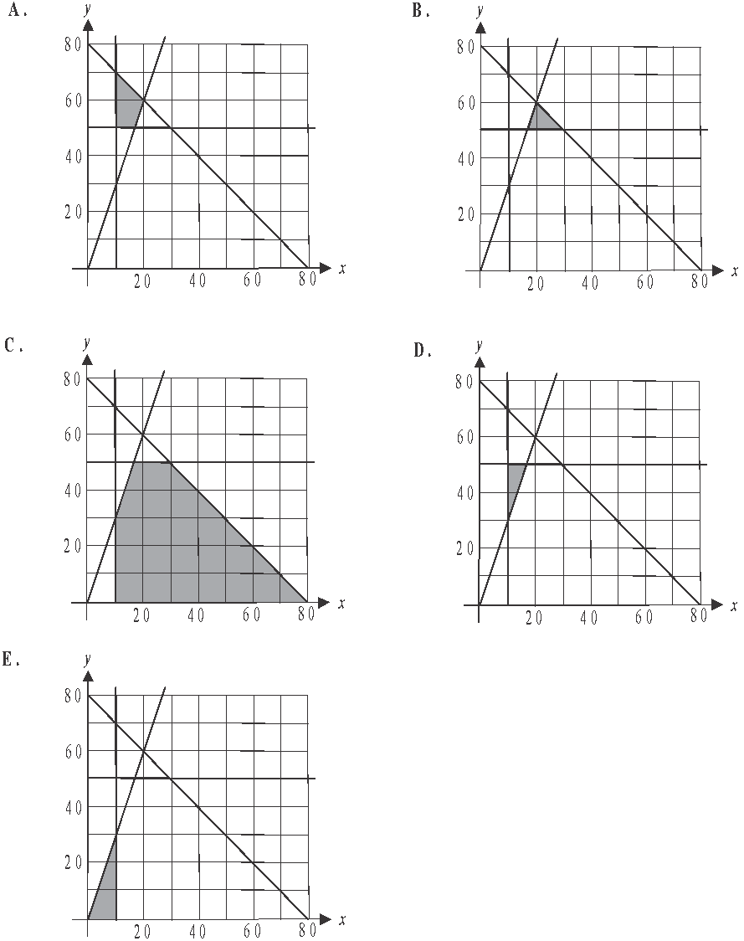

Further Mathematics formulas

Core - Data analysis

standardised score | 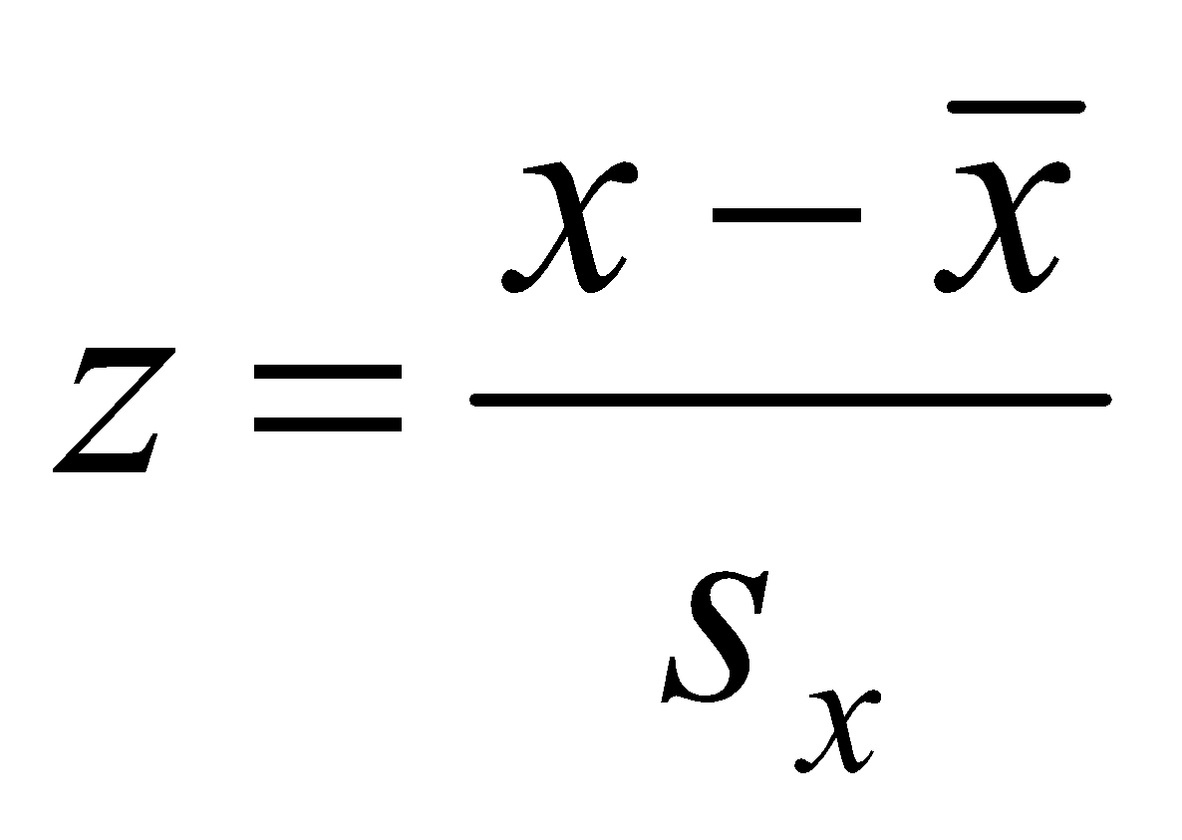
lower and upper fence in a boxplot | 
least squares line of best fit | 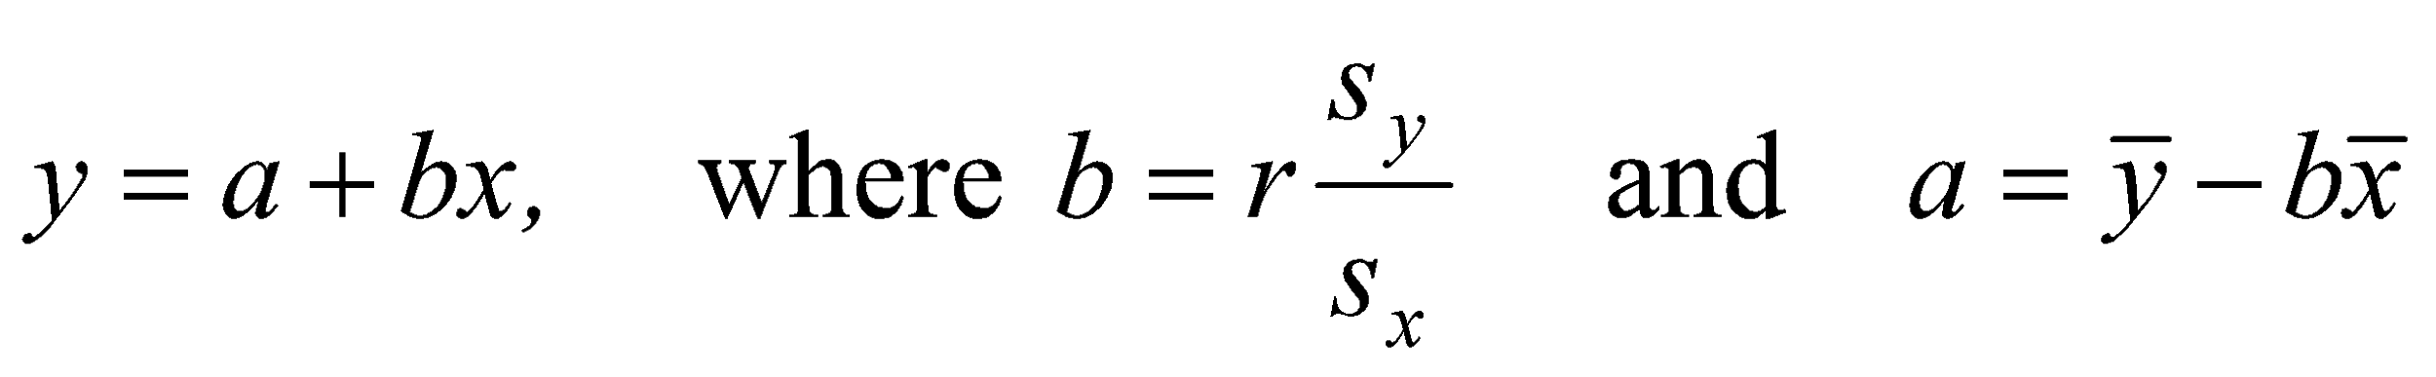
residual value | residual value = actual value – predicted value
seasonal index | seasonal index 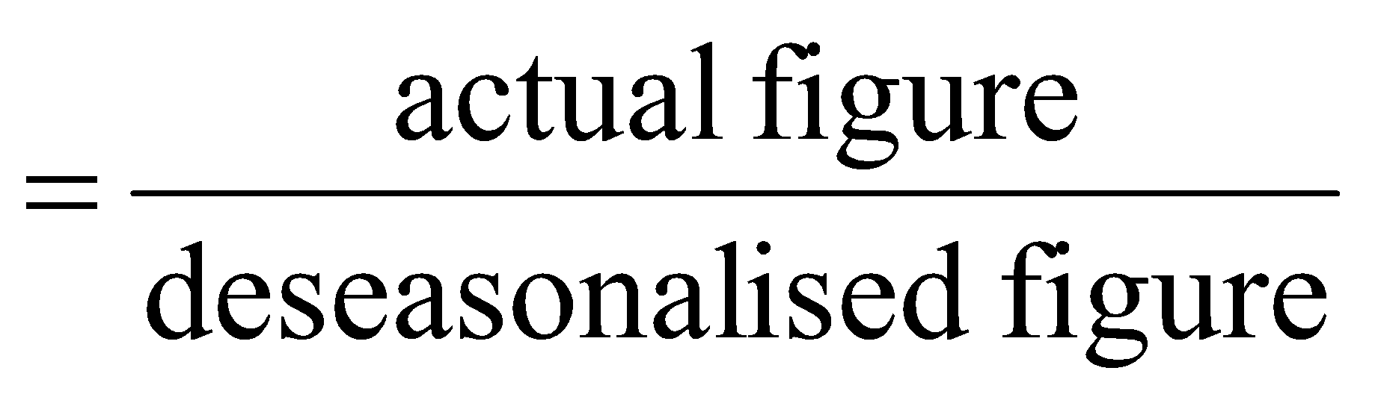

Core – Recursion and financial modelling

first-order linear recurrence relation | 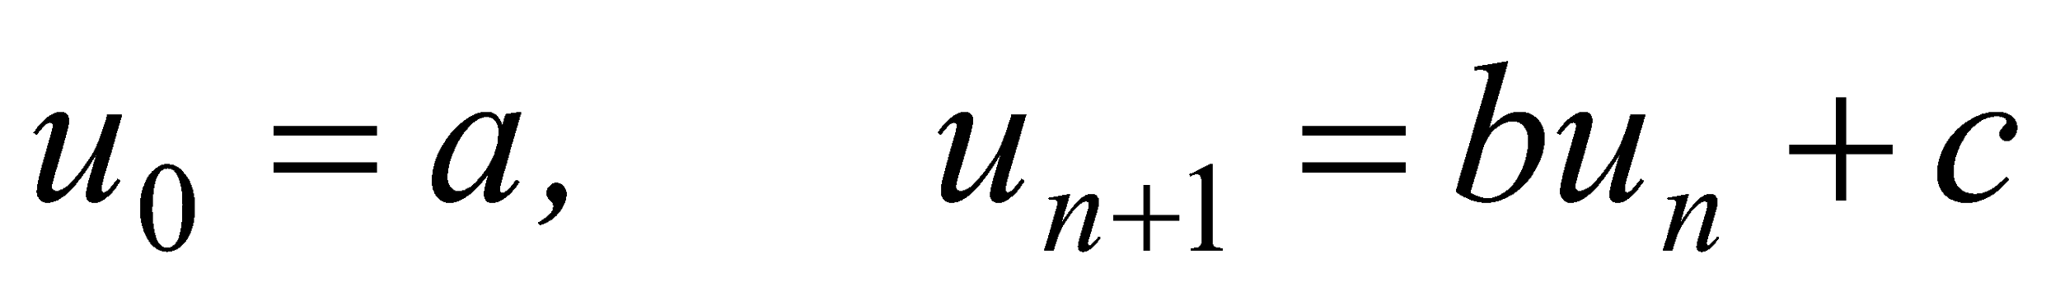
effective rate of interest for a  compound interest loan or investment | 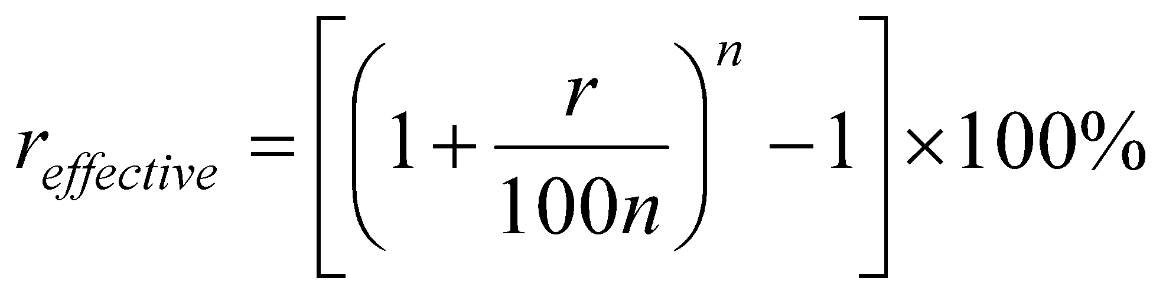

Module 1 - Matrices

determinant of a 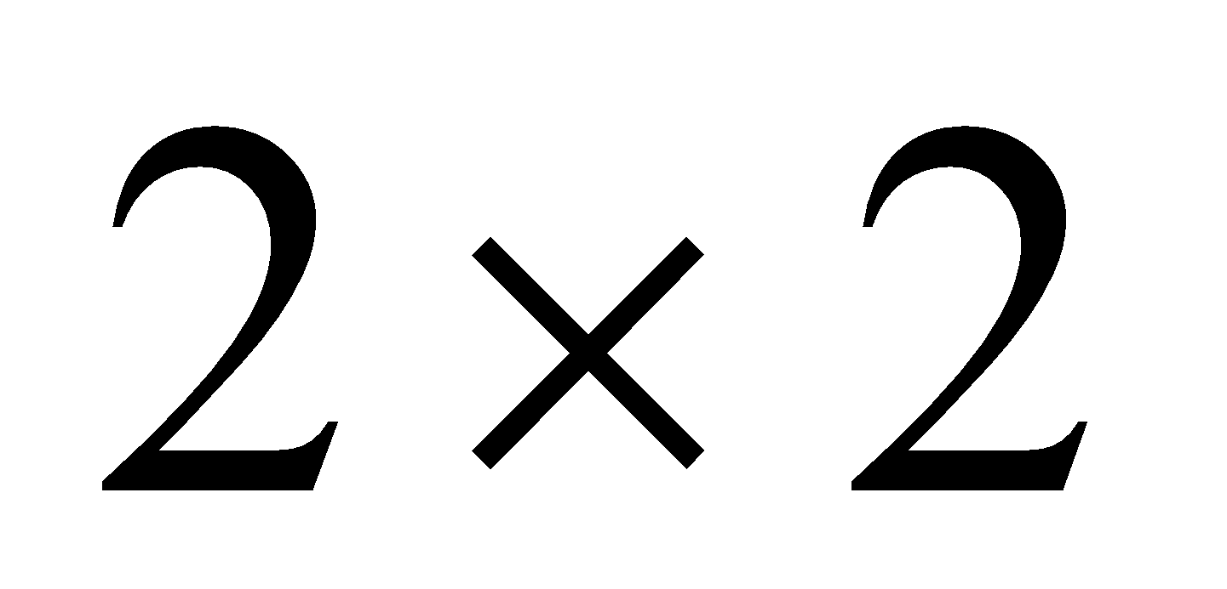 matrix | 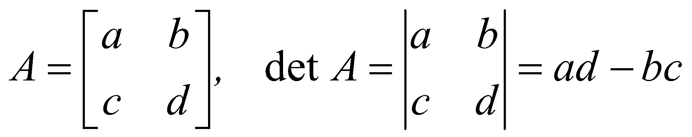
inverse of a  matrix | 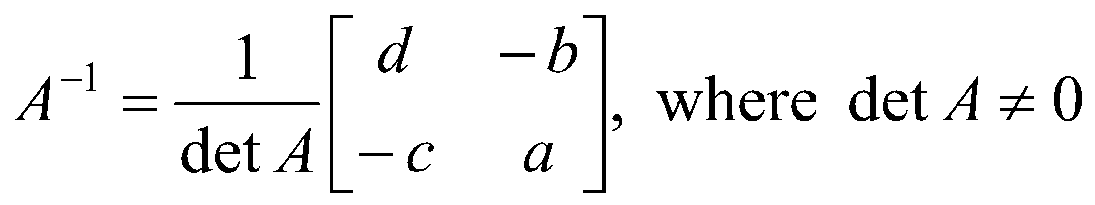
recurrence relation | , 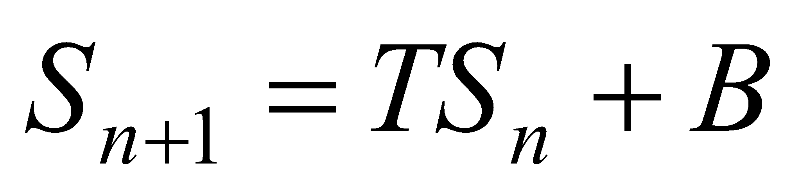

Module 2 - Networks and decision mathematics

Euler’s formula | 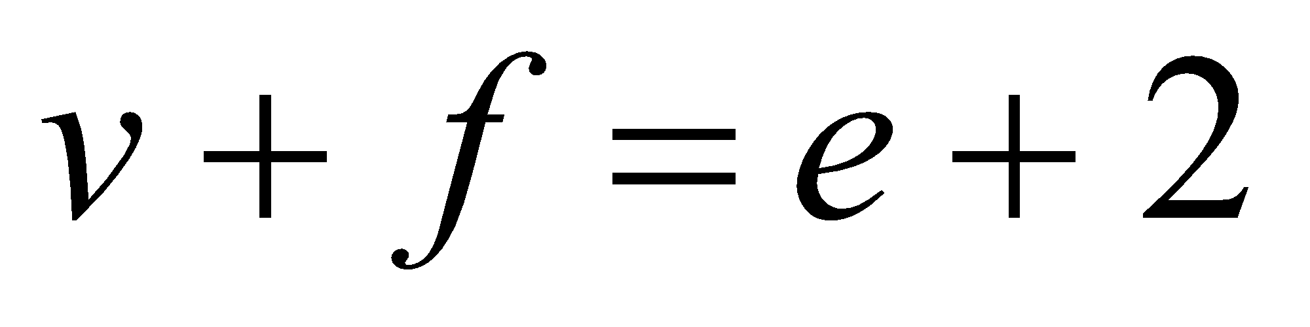

Module 3 – Geometry and measurement

area of a triangle | 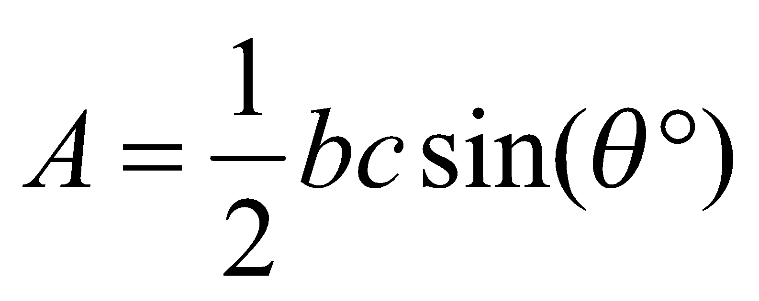
Heron's formula | 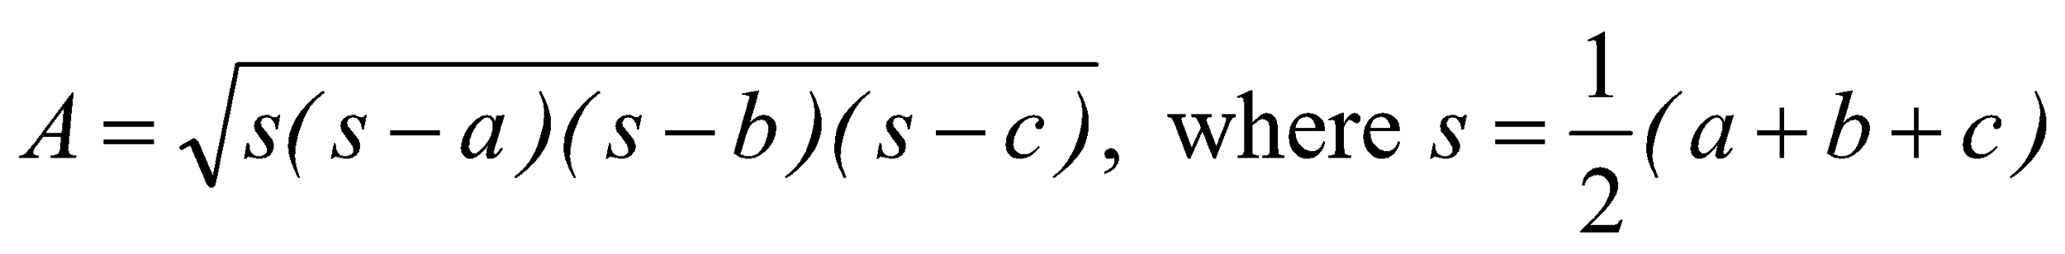
sine rule | 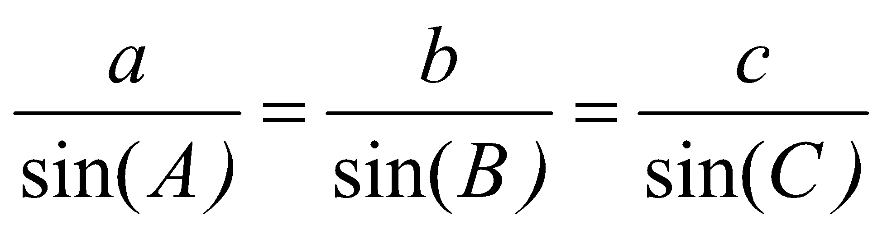
cosine rule | 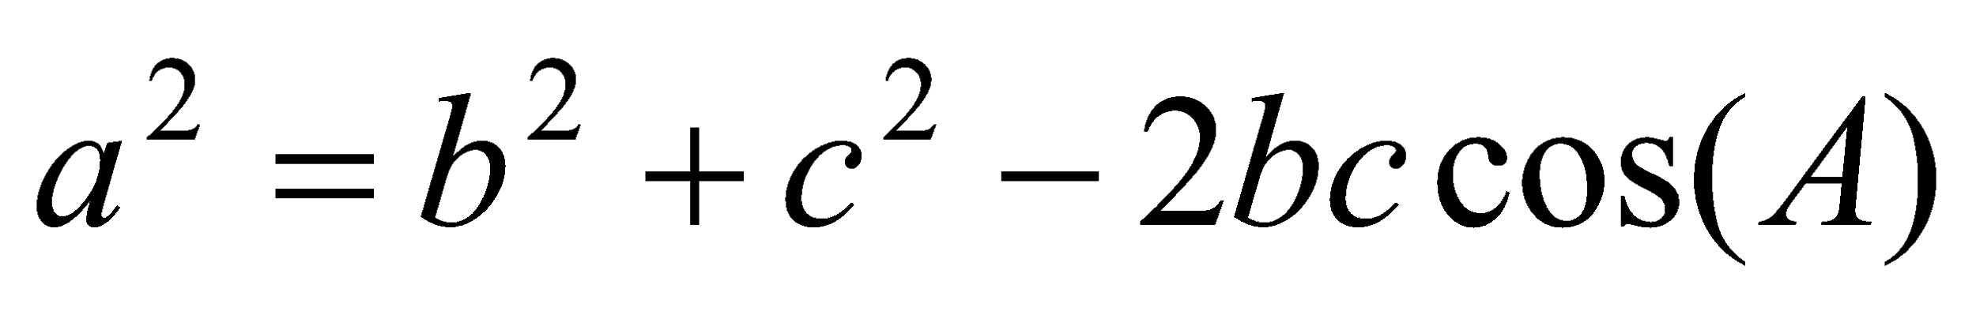
circumference of a circle | 
length of an arc | 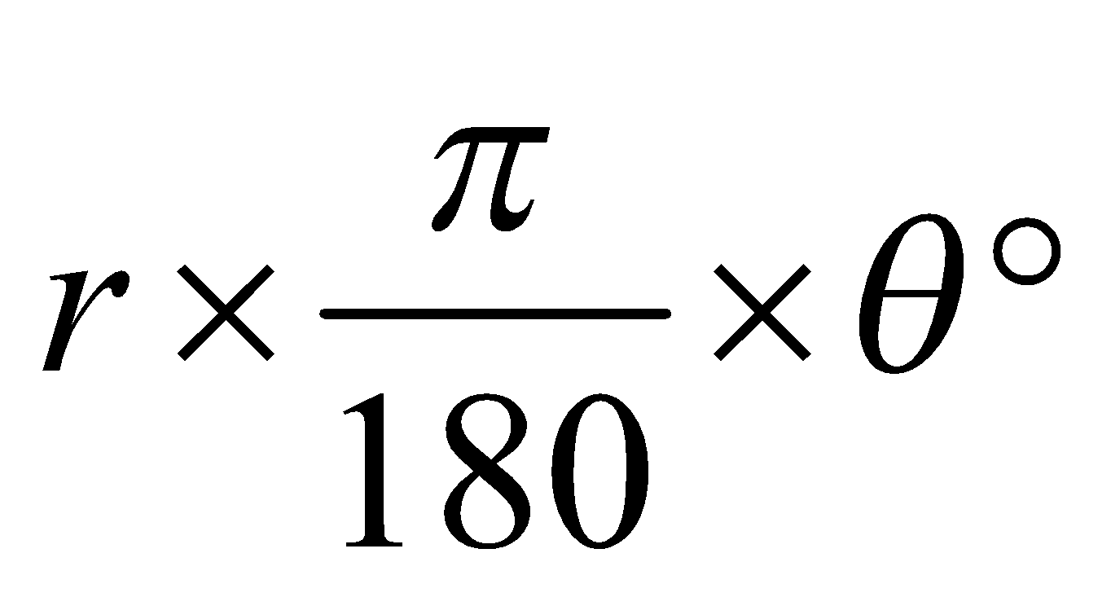
area of a circle | 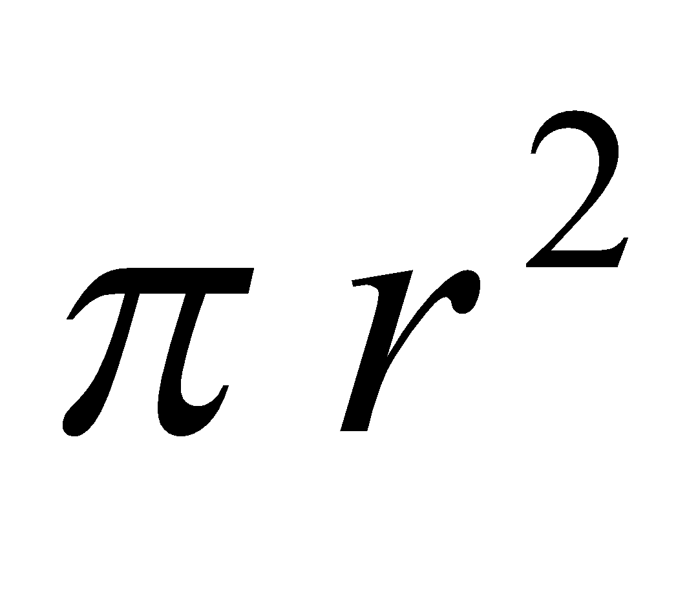
area of a sector | 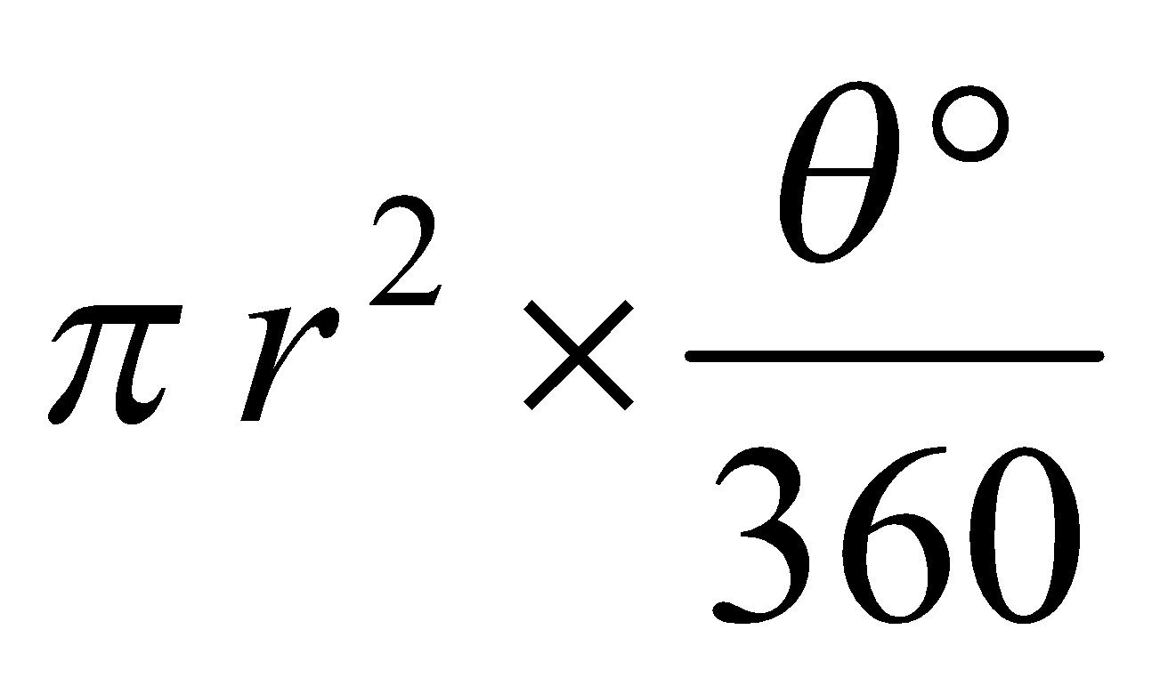
volume of a sphere | 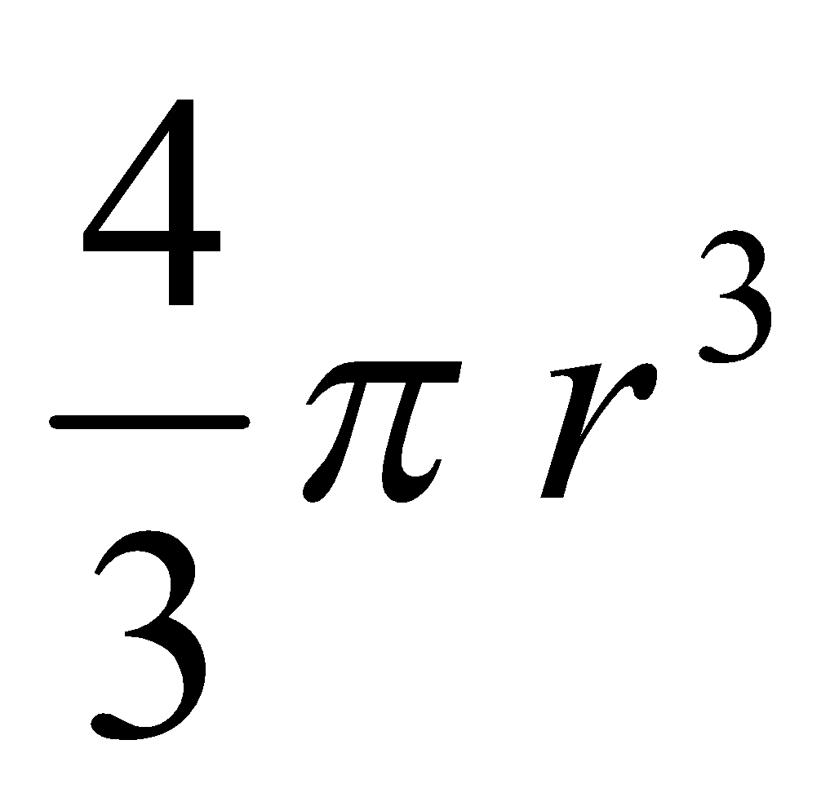
surface area of a sphere | 
volume of a cone | 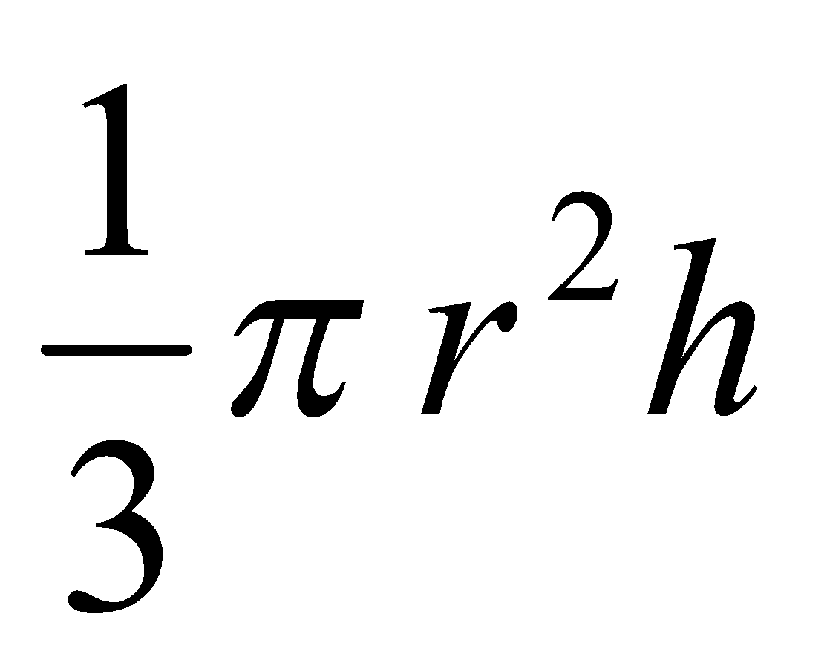
volume of a prism | 
volume of a pyramid | 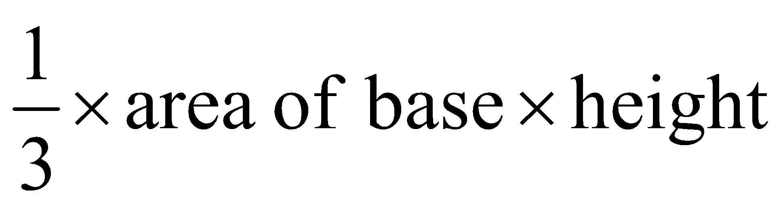

Module 4 – Graphs and relations

gradient (slope) of a straight line | 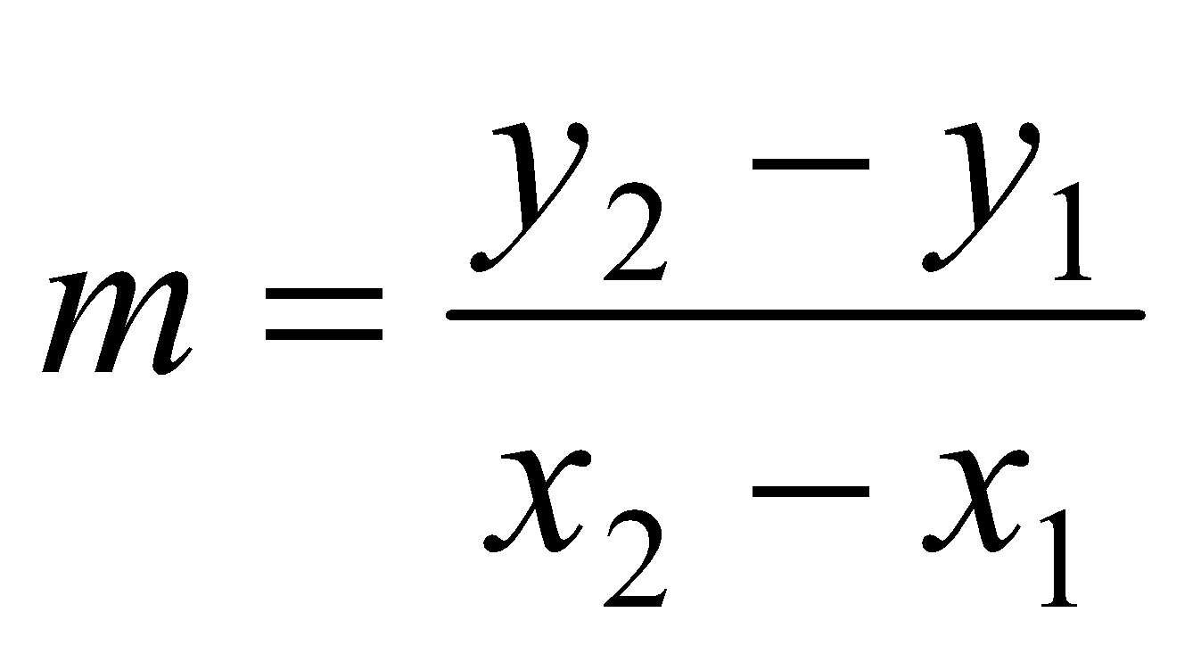
equation of a straight line | 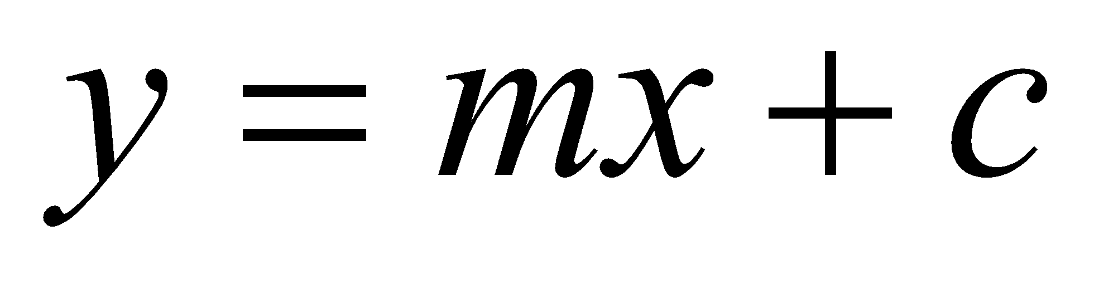

END OF FORMULA SHEET

Mathematics Formula Sheets reproduced by permission; © VCAA 2016. The VCAA does not endorse or make any warranties regarding this study resource. Current and past VCAA VCE® exams and related content can be accessed directly at www.vcaa.vic.edu.au


